

MEMBERSHIP STRATEGY

2022 - 2025
















Content

1
 | Context | Page 3
2 | Our Journey | Page 4
3 | Our Membership Community | Page 5
4 | Membership Recruitment | Page 6
51 | Membership Engagement | Page 7
6 | Delivering & Evaluating our Membership Strategy | Page 8
7 | Feedback | Page 9

Context

About the Trust

Stockport NHS Foundation Trust holds a unique position in the Stockport community as the provider of healthcare to its population. It offers a number of specialist services, including our highly rated stroke service, and plays a key partnership role within Greater Manchester, Stockport and East Cheshire.

The Trust aims to be a well-led organisation delivering safe, high-quality care for local people.

Strategic Vision & Values

Our Strategic Plan for 2020-2025 sets out a clear vision - developed in collaboration with our staff and our patients - to continue to improve the quality and performance of our services, while achieving financial sustainability.

Our Mission:

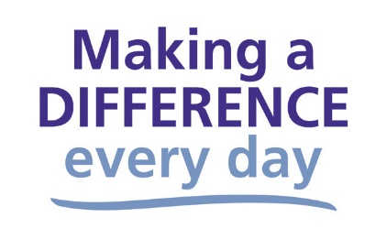

Our Values:

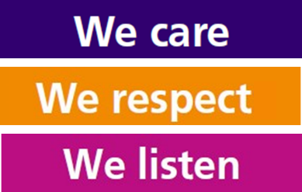

Our Strategic Objectives:

Stockport NHS FT aims to be:

- A great place to work

- Always learning, continually improving

- Helping people live their best lives

- Investing for the future by using our resources well

- Working with others for our patients and communities
Alignment of Plans

Our long-term Trust Strategy will be delivered through a range of medium-term business strategies, which set out the detail of how we will achieve our ambitions across our clinical divisions and enabling functions such as workforce, informatics and estates.

Each year, the Trust develops annual operational plans for our in year priorities, which align to national policy and delivery of our strategic objectives. This hierarchy of plans is set out in the figure below.

Purpose of this Strategy

As an NHS Foundation Trust, Stockport NHS Foundation Trust is locally accountable to its members. Members are the local people, patients and staff who wish to take an interest in their local hospital and community services and/or make a further contribution to how the Trust develops now and in the future. Members also elect the majority of the Council of Governors, who have a statutory duty to represent the interests of members and the public.

In view of this, the Council of Governors, supported by the Corporate Affairs team, wish to not only create plans to establish and maintain a representative membership with which to engage, but also to monitor the effectiveness of such plans to do this.

In doing so, this strategy will support the Trust’s values as well as the strategic objective of working with others for our patients and communities.

Our Journey

As with many Foundation Trusts, our membership plans were severely impacted by the pandemic, largely because of the limitations of social distancing, shielding and staff focusing on urgent operational issues. This strategy outlines the Trust’s aims for membership, whilst recognising ongoing operational challenges and the changing health and social care landscape within which the Trust operates. In this light, our guiding principles for our approach to membership will continue to be:

- Membership activities should be of value to members of the Trust, public and the organisation
- Membership activities should be prioritised to ensure achievability within the time and resources available.



A number of our public members will have had treatment at the Trust. It is important that the Trust’s approach to membership complements the continual gathering of patient experience that has been a feature of the Trust’s activities for many years, to better understand the experience of our patients, carers, friends and families. In this regard, the opportunity to become a member will continue to be promoted to both patients and public, and opportunities to align activities that will help shape future service delivery will be explored.



This strategy sets out the Trust’s aims, and the methods we intend to use, to maintain and develop a sizeable, representative and engaged membership that supports the Trust in achieving its strategic objectives and providing services that respond to the needs of our community. The strategy has been developed based on learning from previous Trust membership initiatives, good practice from other Foundation Trusts, and statutory and regulatory requirements, alongside consultation with the Council of Governors. The strategy will be supported by an annual plan, created through a Membership Development Group, which will set out key actions and initiatives to be undertaken each year to support implementation of the strategy.

Our Membership Community


Our members are our staff and members of the public from the diverse communities we serve both locally and beyond.

Public members

Public constituencies ensure that the Trust’s membership is open to all residents, aged 11 and above, of Stockport and the High Peak. As the Trust cares for patients that live outside these areas, membership is also open to people from any other area in England.

An opt-in approach to public membership will continue as we want our members to have chosen to become members and to be involved in the Trust’s work.
Staff members

Staff membership works on an ‘opt out’ basis. All Trust staff who hold have a permanent employment contract or who have worked for the Trust for at least 12 months will automatically become members unless they choose to ‘opt out’.

Members constituencies

The Trust membership is made up of the following constituencies:

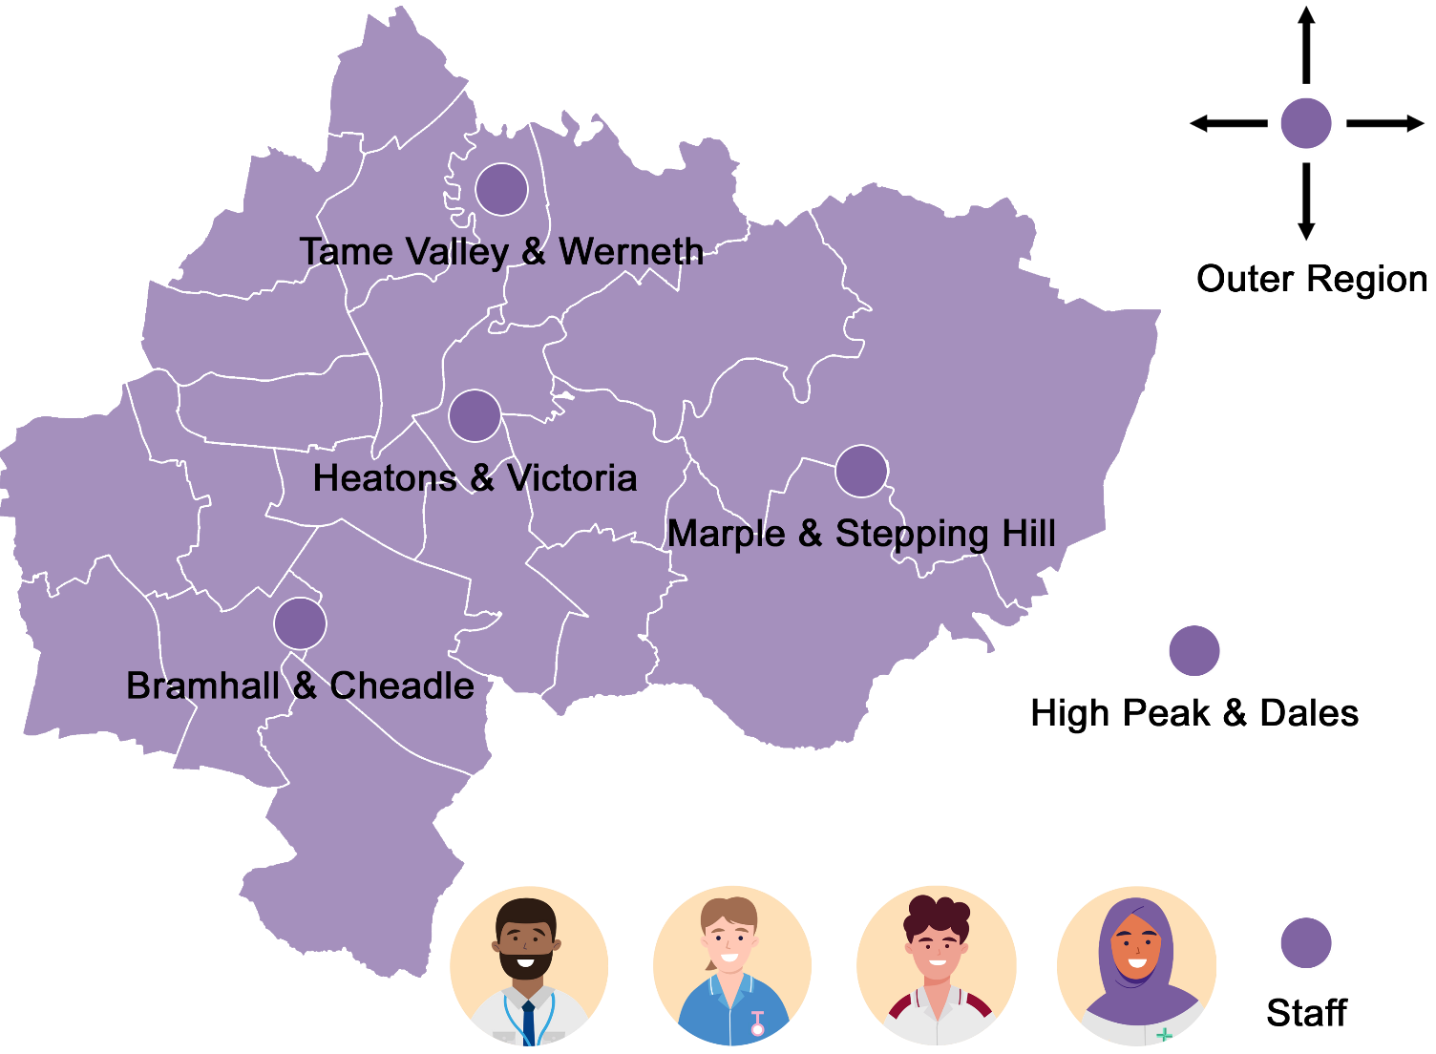

It is the role of the Council of Governors to represent the interests of members and the public. The composition of the Council of Governors reflects the above constituencies and members from each of the constituencies are able to vote for, or stand as, a governor to represent their constituency on the Council of Governors.

Membership Recruitment


Aim: To maintain a sizeable membership that is
representative of the communities the Trust serves.

Since its establishment in 2004, the Trust has built a sizeable membership, largely representative of the local population, with a combined public and staff membership of over 16,500 members.

Constituency | Number
Bramhall and Cheadle | 2,347
Tame Valley and Werneth | 1,848
The Heatons and Victoria | 1,951
Marple and Stepping Hill | 2,453
High Peak and Dales | 807
Outer region | 1,284
Staff | 5,945
Total | 16,635*

* As at 31 March 2022
In addition to geographical representation, we recognise the value of a membership community that is representative of the diverse populations we serve. Therefore, the Trust analyses its membership demographics annually to understand its composition and identify any groups that may be under-represented.

We are pleased that our analysis shows that, overall, the Trust’s membership broadly reflects the diversity of our local communities, however we know that there are some groups that are less well represented.

In this light, an overarching aim of the strategy is to maintain a sizeable membership that is representative of the communities the Trust serves.

Acknowledging the natural attrition of approximately 200-250 members in any given year, the Trust will proactively undertake activities to attract new members to this level.

This will be achieved through a range of activities including continued promotion of membership on the Trust’s hospital and community sites (e.g. virtual display boards) and internal communication channels (e.g. website, social media).

In parallel, information relating to membership will be regularly reviewed, and refreshed where required, to ensure the benefits of membership are clearly articulated and visible to support in recruiting new members to the Trust.

Furthermore, we will explore and develop targeted initiatives to recruit members from the least well represented groups, as identified via the annual membership database demographic analysis.

With respect to staff, new staff will be informed of membership via the Trust’s induction and made aware that their interests are represented by staff governors.



Membership Engagement


Aim: To develop an active and engaged membership

Foundation Trusts are based on the principle of local accountability and an active and engaged membership helps to anchor the Trust to its local community.

We recognise that there will be wide variation in terms of the level of engagement that members wish to have. Through meaningful engagement, members should feel both informed about the Trust and supported to engage in issues affecting the future of the Trust should they so wish. An engaged membership will also help to support governors in representing the interests of members and the public.

In order to engage members, the Trust will implement a number of methods/opportunities spanning the engagement continuum, from informing to involving, consulting and collaborating.

Methods for doing so have and may continue to include:

- Quarterly members’ newsletter
- Social media
- Internet / Intranet
- Annual Members’ Meeting
- A variety of feedback methods for members to offer their views (e.g. membership office email)
- Members’ seminars / events
- Established links to Patient Interest Groups / Patient Participation Groups
- Established links to partner organisations (e.g. HealthWatch)
- Established links to Community & Voluntary Sector Organisations
- Task & Finish Groups
- Co-Design Events
In addition, we will work closely with the Patient Experience team to explore and align activities that engage members and will help shape future service delivery.

Governors will have opportunity to engage and gather the views of members via the methods identified in this strategy and we will continue to promote the work of the Trust’s governors as representatives of members. Governors will feed this information back to the Trust via the Council of Governors.


Delivering & Evaluating our Membership Strategy



Implementation

To achieve the aims of the Membership Strategy, a Membership Development Group, including governors and the Corporate Affairs team, will develop an annual plan that sets out how the Membership Strategy will be implemented in practice. This will include specific action to be taken in year with respect to both membership recruitment and engagement, alongside key outcome measures.

All members of the Council of Governors will be expected to be involved in the implementation of the strategy and will be supported in this by the Corporate Affairs team.

Evaluating Success

Progress against the delivery of the strategy will be monitored by the Corporate Affairs team on a regular basis and reported to the Membership Development Group and the Council of Governors.

In addition, progress against the strategy will be included in the Trust’s annual report, including plans for the year ahead.

The principal ways in which we will evaluate success of the strategy, and will be reported to the Council of Governors, include:
- Profile of the Trust’s membership:
- Membership totals within all constituencies
- Comparison of the Trust’s public membership demographics to those within the local population
- Membership attendance at engagement activities
- Membership Feedback - Portfolio of Evidence
- Council of Governor electoral performance including:
- Percentage of elections contested;
- Average number of candidates per seat;
- Voter turnout relative to other Trusts.

Feedback

To provide feedback on this strategy of request further information please contact the Corporate Affairs team on:

Address: | Stockport NHS Foundation Trust  Stepping Hill Hospital  Poplar Grove  Hazel Grove  Stockport  SK2 7JE
Telephone: | 0161 419 5166
Email: | membership@stockport.nhs.uk
You can also find further information regarding membership and the Council of Governors on the Trust’s website:

Website: | https://www.stockport.nhs.uk/ - Membership & Governors.

