
This Leaflet is also available online
www.stockport.nhs.uk/patientinformationleaflets
GEN 129-11

PATIENT PERSONAL BELONGINGS
AND
VALUABLES POLICY

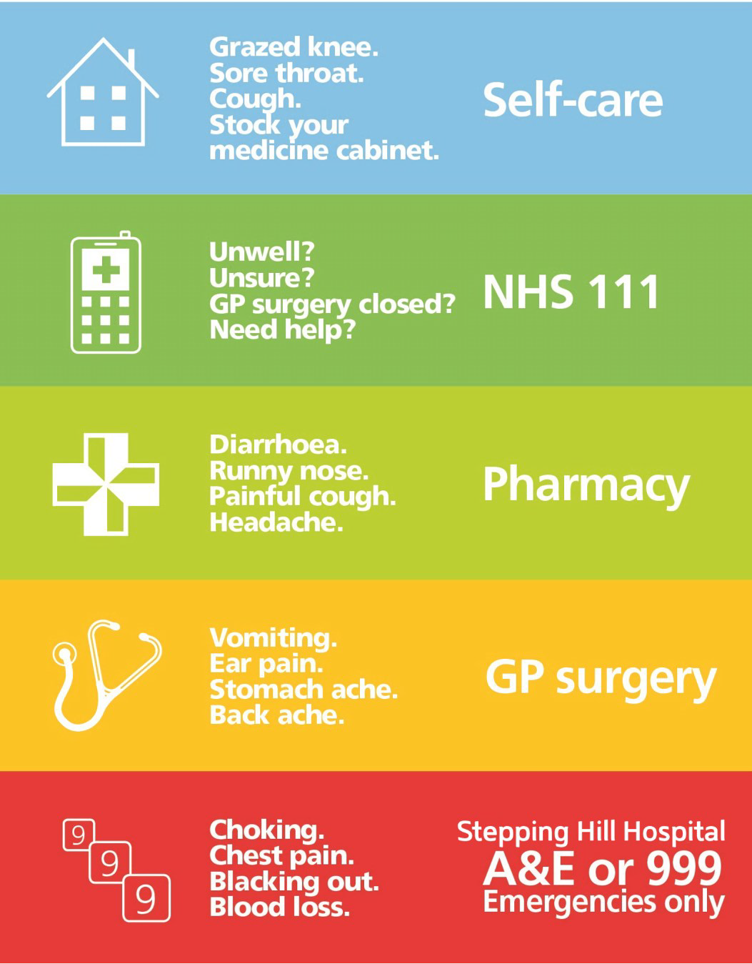

PATIENT EXPERIENCE

Supporting our Smokefree Trust
In order to look after the health of our staff, patients and visitors, we ask you politely not to smoke while you are on the hospital grounds.

If you would like support and advice to quit smoking, our Pharmacy shop on the main corridor can help you with further information, so just pop along and have a chat with a Pharmacy stop smoking advisor.

Alternatively, the following Advice and Services are available to you:
Stockport Stop Smoking Service, ABL Health stockportwellness@ablhealth.co.uk | 0161 870 6492 For confidential stop smoking advice and support.
NHS Choices & National Smokefree Helpline
www.nhs.uk/live-well/quit-smoking | 0300 123 1044
Stop Smoking Midwife
Contact our Hospital Switchboard on 0161 483 1010
and ask for the Stop Smoking Midwife

Patient Information Leaflet

If you require the leaflet in large print, another language, an audio tape or braille, Please contact:
Patient and Customer Services
Tel: 0161 419 5678 Email: PCS@stockport.nhs.uk
PIL No | GEN12911 | Pub Date | Sept 2024 | Rev Date | Sept 2026

Keeping Your Valuables Safe During Your Hospital Stay
Stockport NHS Foundation Trust
What You Need to Know
We take great care to safeguard your personal belongings while you are an inpatient. This leaflet explains what you should and shouldn’t bring into the hospital and how valuables are managed.
Bringing Personal Belongings
✅ Please only bring essential items, as storage space is limited.
✅ Mark your belongings with your name, when possible, to ensure they are easily identified.
✅ Smaller items such as glasses, hearing aids, and dentures can be stored in a Property Box at your bedside—please ask a staff member for oneing Valuables Securely
🔒 Deposited Items: Valuables handed over to the Trust for safekeeping are securely stored in the Cashiers Office safes (off-ward).
🔄 Returning Valuables: Stored valuables will be returned only to you or an immediate family member, as directed.
🛑 Minimal Items for Carers: If caring for a patient who has difficulty making decisions, limit their personal items to ensure their belongings are safeguarded.

Items You Should NOT Bring
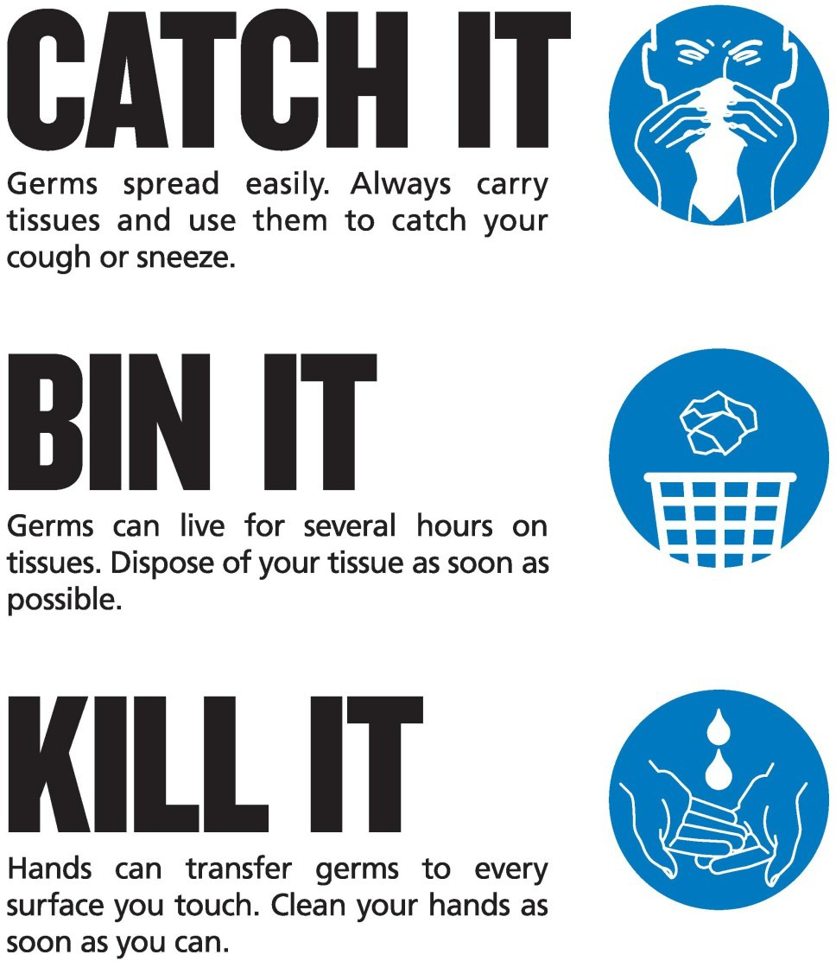
❌ Keys
❌ Electronic devices (phones, laptops, tablets)
❌ Bank cards
❌ Jewellery
💰 Money for Refreshments: You may bring a
modest amount of cash for small purchases like
newspapers or snacks.
🔒 Higher amounts of money can be stored for
safekeeping

Liability & Disclaimer
⚠️ The Trust does not accept liability for any lost,
stolen, or damaged items unless formally
deposited for safekeeping.
📜 Patient Property Disclaimer: You will be asked
to sign a disclaimer upon admission, documenting
any valuables with you.
🔄 Before Leaving the Hospital:
- Ensure all property left for safekeeping is
Returned in the expected condition.
- Report any discrepancies immediately upon
Receiving your property, issues cannot be
addressed later.

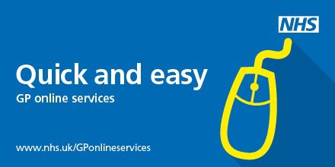
. Collecting Stored Property
📍 Location: Trust Cashiers Office
🕒 Hours: Monday–Friday
- Morning: 08:30am – 1:00pm
- Afternoon: 2:00pm – 4:00pm

For any assistance, please ask a staff member.
Thank you for helping us keep your belongings
secure!

