Stockport NHS Foundation Trust
Gender pay gap report (for publication):

Gender Pay Gap Report 2023-2024

1. Introduction
Gender pay gap legislation requires all employers of 250 or more employees to publish their gender pay gap as at 31st March each year. This report details Stockport NHS Foundation Trust’s position as at 31st March 2024.
As at 31st March 2024, the Trust employed 6,099 staff in a range of roles, including administrative, medical, allied health professionals and managerial roles. The Trust uses the national job evaluation framework for Agenda for Change (AfC) staff to determine appropriate pay bandings; this provides a clear process of paying employees equally for the same or equivalent work. The national pay grades used in the Trust have a set of points for pay progression, linked to length of service and performance.
Gender pay gap legislation requires the Trust to report:
- Mean gender pay gap
- Median gender pay gap
- Mean bonus gender pay gap
- Median bonus gender pay gap
- Proportion of males receiving a bonus payment and proportion of females receiving a bonus payment
- Proportion of males and females when divided into four quartiles in comparison to the number of employees in terms of a) Lower b) Lower middle c) Upper middle and d) Upper quartile.
Mean calculation: – this is calculated by adding up the hourly rates of pay of all men, and of all women, and dividing that by the number in each group. The mean gender pay gap is calculated based on the difference between mean male pay and mean female pay:

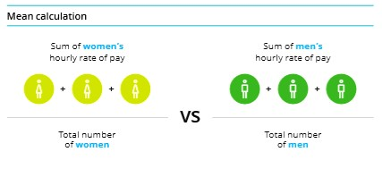

Median calculation: – the median is the figure that falls in the middle of a range when the wages of all relevant employees are lined up lowest pay to the highest pay. The median gender pay gap is calculated based on the difference between the middle employee in the range of male wages and the middle employee in the range of female wages:

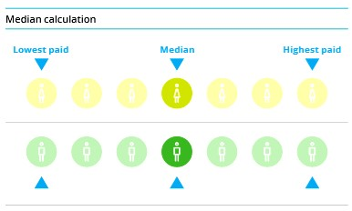
This report includes the statutory requirements of the gender pay gap legislation but also provides further context to demonstrate our commitment to equality.

2. Gender Profile of the Organisation
The Trust’s workforce comprises of 77% women and 23% men.
Gender | Headcount | %
Female | 4669 | 76.6
Male | 1430 | 23.4
Grand Total | 6099 | 100.0%

3. Gender Profile by Banding
The chart below shows the proportion of men and women across the Trust, at each Agenda for Change (AfC) pay band, and the proportion of men and women within medical and dental staffing terms & conditions.
Distribution of men and women across the workforce.
90%
80%
70%
60%
50%
40%
30%
20%
10%
0%
90%  80%  70%  60%  50%  40%  30%  20%  10%  0% |  |  |  |  |  |  |  |  |  |  |  |  |  |  |  |  |  |  |  |  |  |  |  |  |  |  |  |  |  |  |  | 55.6 | % |  |  |  |  | 41.7 | %
90%  80%  70%  60%  50%  40%  30%  20%  10%  0% |  |  |  |  | 64.4 | % |  |  |  |  |  |  |  |  |  |  |  |  |  |  |  |  | 79.8 | % |  | 68.3 | % |  | 73.3 | % |  |  |  |  | 71.4 | %
90%  80%  70%  60%  50%  40%  30%  20%  10%  0% |  | 82.8 | % |  |  |  |  | 81.6 | % |  | 88.6 | % |  | 83.9 | % |  | 86.3 | % |  | 83.3 | %
90%  80%  70%  60%  50%  40%  30%  20%  10%  0% |  |  |  |  |  |  |  |  |  |  |  |  |  |  |  |  |  |  |  |  |  |  |  |  |  |  |  |  |  |  |  | 44.4 | % |  |  |  |  | 58.3 | %
90%  80%  70%  60%  50%  40%  30%  20%  10%  0% |  |  |  |  | 35.6 | % |  |  |  |  |  |  |  |  |  |  |  |  |  |  |  |  |  |  |  | 31.7 | % |  | 26.7 | % |  |  |  |  | 28.6 | %
90%  80%  70%  60%  50%  40%  30%  20%  10%  0% |  | 17.2 | % |  |  |  |  | 18.4 | % |  | 11.4 | % |  | 16.1 | % |  | 13.7 | % |  | 16.7 | % |  | 20.2 | %
90%  80%  70%  60%  50%  40%  30%  20%  10%  0% | Band 1 |  |  | Band 2 |  |  | Band 3 |  |  | Band 4 |  |  | Band 5 |  |  | Band 6 |  |  | Band 7 |  |  | Band 8A |  |  | Band 8B |  |  | Band 8C |  |  | Band 8D |  |  | Band 9 |  |  | Medical & Dental
Women | 82.8% |  |  | 64.4% |  |  | 81.6% |  |  | 88.6% |  |  | 83.9% |  |  | 86.3% |  |  | 83.3% |  |  | 79.8% |  |  | 68.3% |  |  | 73.3% |  |  | 55.6% |  |  | 71.4% |  |  | 41.7%
Men | 17.2% |  |  | 35.6% |  |  | 18.4% |  |  | 11.4% |  |  | 16.1% |  |  | 13.7% |  |  | 16.7% |  |  | 20.2% |  |  | 31.7% |  |  | 26.7% |  |  | 44.4% |  |  | 28.6% |  |  | 58.3%
100%
Men Women

The Trust’s workforce comprises of predominantly female employees across all bandings apart from medical and dental where 58.3% are male in comparison to 41.7% female.
4. Gender Pay Gap Analysis

Indicator 1: Average gender pay gap as a mean average
In comparison to 2023, the overall gender pay gap has increased from 16.96% to 17.81%. It is higher than the whole UK economy figure of 13.1%. There is a significant difference in the gender pay gap between medical staff and non-medical staff (AfC) group. By considering those staff groups separately, we can see that the gender pay gap has increased in the medical workforce, however, has decreased in the AfC grades, where the overall AfC pay gap now favours women.

 | Female |  | Male |  | Difference £ |  | Difference %
 | 2023 | 2024 | 2023 | 2024 | 2023 | 2024 | 2023 | 2024
Mean  hourly rate | £17.82 | £18.88 | £21.46 | 22.97 | £3.64 | £4.09 | 16.96% | 17.81%
Mean  hourly rate medical | £36.30 | £37.00 | £43.36 | £45.08 | £7.06 | £8.08 | 16.28% | 17.92%
Mean  hourly rate nonmedical | £17.05 | £17.84 | £16.15 | £16.94 | -£0.90 | -£0.90 | -5.57% | -5.31%

The chart below shows the difference in average hourly salaries for the majority of the Trust’s workforce (those on AfC pay and conditions). The mean average gap between the pay of men and women favours women, with a consistent pay gap that has widened slightly in the last 12 months. The gap between the average salaries of men and women, is not impacted by the percentage of men and women overall, but rather by the difference of the average hourly pay of men and women.

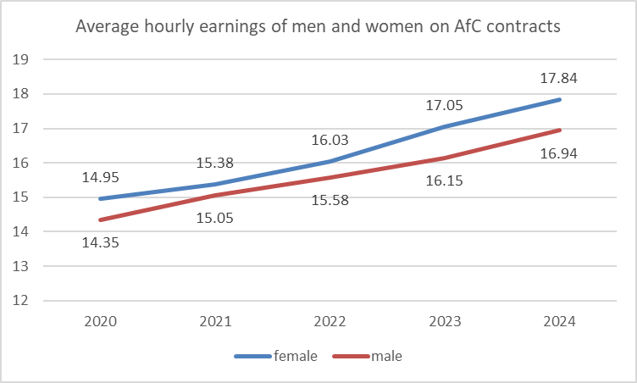

Analysis has been undertaken to establish the gender pay gap within each of the staff groups on Agenda for Change pay scales. The results are presented in the table below:

Staff Group | Average Male | Average Female | Difference | Pay Gap
Additional Scientific and Professional | 22.63 | 21.14 | 1.49 | 6.58%
Additional Clinical Services | 13.88 | 13.68 | 0.2 | 1.44%
Admin and Clerical | 17.6 | 15.05 | 2.55 | 14.49%
AHP | 20.79 | 21.43 | -0.64 | -3.08%
Estates and Ancillary | 13.93 | 12.99 | 0.94 | 6.75%
Healthcare Sciences | 21.5 | 21 | 0.5 | 2.33%
Nursing and Midwifery | 21.1 | 21.05 | 0.05 | 0.24%

Analysis shows that the widest gender pay gap is amongst the admin and clerical staff group, largely driven by the gender distribution in the senior manager roles within the Trust. Within the AHP staff group, the negative gap is a reflection that the gender pay gap favours women in those areas.

Indicator 2: Average gender pay gap as a median average
The median average rates of pay show that the gender pay gap has decreased significantly since last year and now favours women across the organisation as a whole.

Median Hourly Rate | Female | Male | Difference (£) | Difference (%)
2021 | £14.61 | £15.18 | £0.58 | 3.97%
2022 | £15.00 | £16.03 | £0.03 | 0.2%
2023 | £16.01 | £16.84 | £0.83 | 5.18%
2024 | £17.68 | £17.45 | -£0.23 | -1.3%

Indicator 3: Average bonus gender pay gap as a mean average
The Trust does not operate a bonus scheme. It complies with the Medical terms and conditions in running an annual Clinical Excellence Award (CEA) scheme which has been used to calculate indicators 3 to 5. CEAs are only eligible for employees working as a Consultant (Medical role) and are not usually automatically paid. Under normal circumstances, consultants are required to apply if they wish to be considered for a Clinical Excellence Award subject to National qualifying guidelines.
However, in 2020, NHS Employers and the negotiation partners the British Medical Association (BMA) and HCSA received government approval to recommend that employers distribute funds equally among all eligible consultants as a one-off, non-consolidated, nonpensionable payment in 2020, instead of running an annual awards round, as a response to the pandemic. All consultants were therefore awarded a CEA payment. This has been replicated each year since 2020.
The table below shows that there is a 34.00% gap between male and female CEA payments.

Mean Bonus Pay | Female | Male | Difference (£) | Difference (%)
2021 | £7126.10 | 11428.70 | £4302.59 | 37.65%
2022 | £5340.54 | £8586.19 | £3245.65 | 37.80%
2023 | £5898.00 | £8586.47 | £2688.47 | 31.31%
2024 | £5,731.98 | £8,684.56 | £2,952.59 | 34.00%

Indicator 4 - Average bonus gender pay gap as a median average

Median Bonus pay | Female | Male | Difference (£) | Difference (%)
2021 | £5670.33 | £9086.02 | 3415.99 | 37.60%
2022 | £3817.03 | £3817.03 | 0 | 0%
2023 | £4590.00 | £4590.00 | 0 | 0%
2024 | £4,748.84 | £4,748.84 | 0 | 0%
The median difference in bonus pay between men and women is now 0%, with the median level of pay awarded through the CEA scheme is £4,748.84 equally for both men and women.

Indicator 5: Proportion of males and females receiving a bonus payment
Of the total workforce, 9.09% of men received a bonus and 1.58% of women received a bonus in 2023. However, as bonuses paid within the Trust are exclusive to consultant medical and dental staff via the Clinical Excellence Awards, it is appropriate to only analyse the consultant medical and dental workforce.
In 2023 the consultant and medical workforce comprised of 64% male and 36% female.
The table below shows that all eligible consultants received a CEA in 2024.

2024 | CEA Eligible Consultant Workforce by Gender |  | 2024 Bonuses Awarded
Gender | Headcount | % | Headcount | % of Gender Eligible
Male | 134 | 63.51% | 134 | 9.09%
Female | 77 | 36.49% | 77 | 1.58%
Total | 211 |  | 211

Indicator 6: Proportion of males and females when divided into four quartiles in comparison to the number of employees in terms of a) lower b) lower middle c) upper middle and d) upper quartile
Given there is a greater representation of female employees in almost all bands in the Trust, it is not surprising that females feature at higher in % across all quartiles. However, there is a notable increase of women in the upper middle quartile and men in the upper quartile, compared to the rest of the workforce.

 | 70.10% |  |  |  |  | 29.90%
 | 8 | 4.07% |  |  |  |  | 15.93%
 | 76.2 | 9% |  |  |  | 23.71%
 | 75.66 | % |  |  |  | 24.34%
Upper Quartile
Upper Middle Quartile
Lower Middle Quartile
Lower Quartile
0% 20% 40% 60% 80% 100%
Female % Male %

5. Reducing the Gender Pay Gap
The gender pay gap is not a measure of equal pay, but is influenced by the distribution of men and women in the workforce. The gender pay gap at the Trust is driven by the make-up of the medical workforce. The UK medical workforce faces a persistent gender pay gap, with women earning less than their male counterparts.
The reasons for the gender pay gap in the medical workforce relate to the composition of the medical workforce, and in particular, the consultant workforce. This composition is affected by:
- Unequal representation in consultant roles: Women are underrepresented in senior and leadership positions within the medical profession, particularly in specific specialties such as vascular surgery, neurosurgery and cardiothoracic surgery.
- Part-time work and career breaks: Women are more likely to work part-time or take career breaks for childcare or other responsibilities, leading to lower total earnings compared to full-time male colleagues. This is particularly the case within medical staff, where women may take longer to complete their training due to having time out to have children.
- Horizontal gender segregation: Women are over-represented in specialities such as general practice within the UK, which in itself distorts the makeup of the consultant workforce within the Trust.
- Discrimination and bias: Gender bias may exist in promotion decisions, performance evaluations, and pay negotiations, disadvantaging women and hindering their career advancement.
The Trust’s Equality, Diversity and Inclusion Strategy 2022-2025 aims to address the issues identified by the data in this report and in previous reports. The following table identifies some of the key actions contained within the strategy that aims to address the issues identified. The actions will be monitored by the EDI Steering Group and will be reported up through the People Performance Committee as part of the regular reporting on EDI actions.

What we will do: | How we will know we have made an impact:
Undertake focus group sessions with female specialist grade doctors to understand the | We will have a better understanding of the barriers and impacts that shape the makeup of the medical workforce.
potential barriers to promotion, as a means of reducing the gender pay gap.
Profiling recently promoted/appointed female consultants who can describe their professional journey. | When a greater proportion of women are successful at appointment to Consultant.
Extending the ‘Mend the Gap Review’ recommendations for medical workforce to the wider workforce. | When the non-medical gender pay gap begins to fall.
Identify gender distribution within talent leadership pools, and take appropriate positive action to promote leadership opportunities for women at the Trust. | When the pay gap in the admin and clerical staff group begins to narrow.

6. Conclusion
In summary, the report highlights that our mean gender pay gap has increased from 16.96% to 17.81%. The median pay gap has reduced to -1.3%, which now favours women.
Desegregating the medical and non-medical workforce shows that the organisation-wide gender pay gap is driven by the gender pay gap within the medical workforce, which stands at 17.92%
Addressing the gender pay gap in the medical workforce can only be achieved when the medical workforce, and in particular, the gender balance in the consultant workforce is gender balanced.
Within the overall AfC data, there exists a negative gender pay gap, favouring women. However, analysis shows that the widest gender pay gap is amongst the Admin and Clerical staff group, largely driven by the gender distribution in the senior manager roles within the Trust. Within the AHP staff group, the negative gap is a reflection that the gender pay gap favours women in those areas.
There has been an increase in the mean bonus pay gap from 31.31% to 34.00%. The median gender pay gap for bonus payments now stands at 0%.
A national review is underway in respect of the CEA payments, which in itself may impact on the bonus pay gap that exists within the medical workforce.

