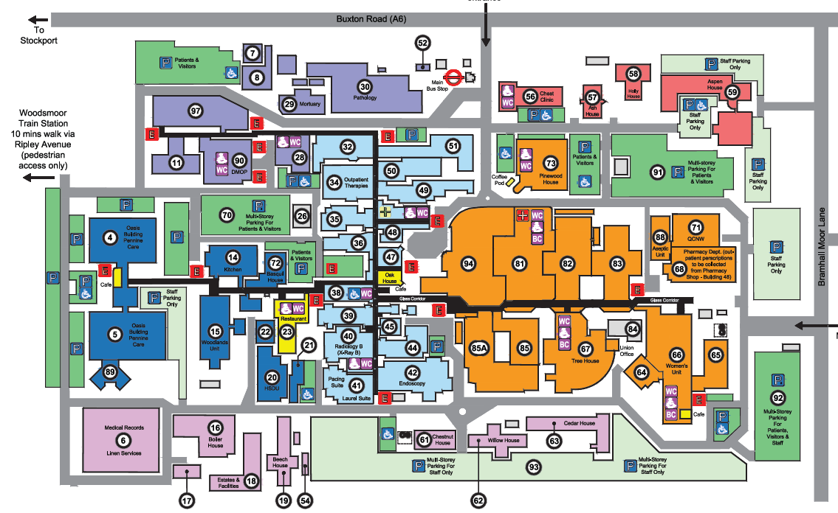
Car Parking Allocation – all car parks open 24 hours 7 days unless otherwise shown
Green – indicates the Patient and Visitors parking bays and GREEN permit holders
Purple – indicates where staff only parking zones behind barriers will be allocated – PURPLE and ORANGE Permit Holders
Blue – indicates disabled spaces

DMOP Multi Storey
Staff Only
P&V – Ground Floor only
Staff – First floor only
Mon – Friday 7am – 6pm
Daytime only

