**SHH Endoscopy Unit Barrett’s surveillance guidelines– 2016 Based on BSG guidelines from 2013**

**Definition of Barrett’s.**

Barrett’s oesophagus is defined as an oesophagus in which any portion of the normal distal squamous epithelial lining has been replaced by metaplastic columnar epithelium, which is clearly visible endoscopically (≥1 cm) above the GOJ and confirmed histo-pathologically from oesophageal biopsies.

The proximal limit of the longitudinal gastric folds with minimal air insufflation is the easiest landmark to delineate the GOJ and is the suggested minimum requirement.

Endoscopic reporting should be performed using a minimum dataset including a record of the length using the Prague criteria (circumferential extent (C), maximum extent (M) of

endoscopically visible columnar-lined oesophagus in centimetres and any separate islands above the main columnar lined segment noted)

*Therefore anyone who has a columnar lined shorter than 1 cm should be discharged from further surveillance.*

**Endoscopic surveillance for Barrett’s Oesophagus**

For a given patient, whether or not surveillance is indicated should be determined on the basis of an estimate of the likelihood of cancer progression and patient fitness for repeat

endoscopies, as well as patient preference.

Adherence to a quadratic, 2 cm biopsy protocol in addition to sampling any visible lesions is recommended for all patients undergoing surveillance.

Surveillance is generally not recommended in patients with intestinal metaplasia (IM)

at the cardia or in those with an irregular Z-line regardless of the presence of IM

For patients with Barrett’s oesophagus shorter than 3 cm without IM or dysplasia, a repeat endoscopy with quadratic biopsies is recommended to confirm the diagnosis. If repeat endoscopy confirms the absence of IM, discharge from surveillance is encouraged as the risks for endoscopy probably outweigh the benefits

Patients with Barrett’s oesophagus shorter than 3 cm, with IM, should receive endoscopic surveillance every 3–5 years

Patients with segments of 3 cm or longer should receive surveillance every 2–3 years

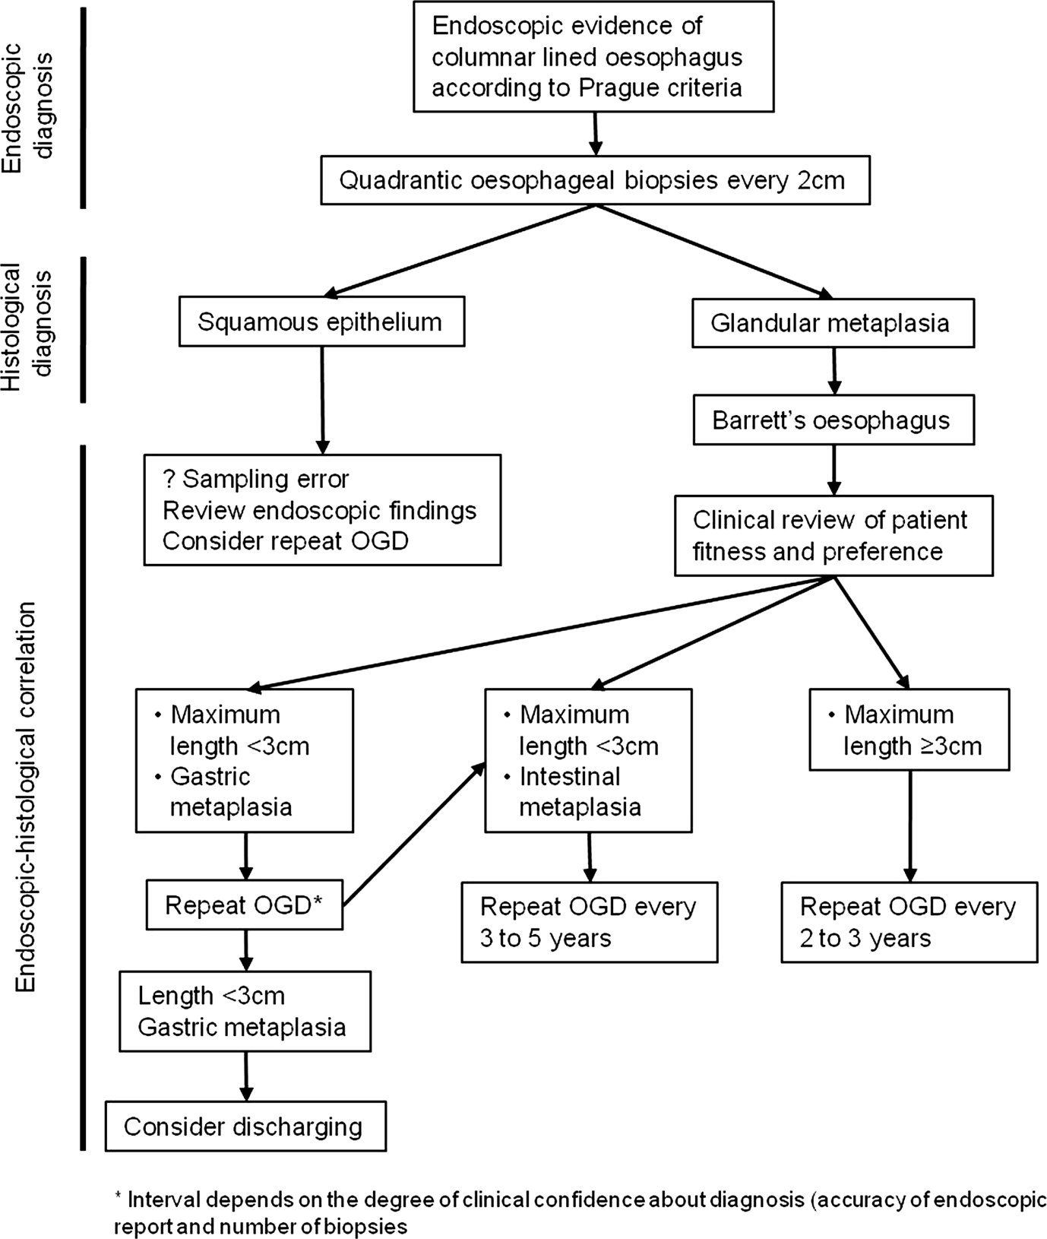

*For new diagnosis of Barrett’s: Patients should be invited for clinic review to be informed about their new diagnosis of Barrett’s oesophagus and to discuss their preference and suitability regarding endoscopic surveillance*

*For patients already undergoing Barrett’s surveillance:*

*Any patient over 75 or those under 75 but with significant co-morbidity should be invited for clinic review to discuss pros and cons of surveillance.*

*Any patient under 75 (without significant co-morbidity): histology results and endoscopy reports should be reviewed.*

*Those without intestinal metaplasia on biopsy on 2 consecutive examinations should be discharged, regardless of whether columnar lined oesophagus (Barrett’s) was visible endoscopically. If intestinal metaplasia was absent on only one examination a further gastroscopy should be offered to check for a sampling error if clinically appropriate. Those with intestinal metaplasia should continue with endoscopic surveillance.*

*In the absence of definite surveillance intervals for Barrett’s patients, I suggest we offer screening every 5 years for those with Barrett’s <3cm and every 3 years for Barrett’s ≥ 3cm.*

*Any patient with dysplasia either low or high grade should be referred to the UGI MDT for discussion. Any patient who is “indefinite for dysplasia” should be offered a repeat gastroscopy in 6 months after optimising their anti-acid medication.*

**Miss Natasha Henley Upper GI Consultant Surgeon**

June 2016 for review June 2018