Patient safety incident response policy
Effective date: 01st April 2024
Estimated refresh date: 01st April 2027
 | NAME | TITLE | SIGNATURE | DATE
Author | Natalie Davies | Deputy Director of Quality Governance
Reviewer | Patient Safety Group | n/a |  | January 2024
Authoriser | Quality Committee | n/a |  | March 2024

Contents
Scope 5
Our patient safety culture 6
Addressing health inequalities 8
Engaging and involving patients, families and staff following a patient safety incident 10
Patient safety incident response planning 14
Resources and training to support patient safety incident response 14
Our patient safety incident response plan 16
Reviewing our patient safety incident response policy and plan 17
Responding to patient safety incidents 19
Patient safety incident reporting arrangements 19
Maternity and Neonatal Investigations 20
Patient safety incident response decision-making 21
Responding to cross-system incidents/issues 21
Timeframes for learning responses 22
Safety action development and monitoring improvement 23
Table 1 - Safety Action Development process 23
Table 2 – Human Factors Intervention Matrix (HFIX) 24
Safety improvement plans 24
Oversight roles and responsibilities 26
Complaints and appeals 31
Document Launch and Dissemination 31
Dissemination 32
References and Associated Documentation 32
Document Information 33
Appendices 34
Appendix 1 – NHSE Just Culture Guide 34
Appendix 2 – After Action Review (AAR) Template 35
Appendix 3 – Hot Debrief Tool Template 38
Appendix 4 – Multidisciplinary Team (MDT) Tool Template 41
Appendix 5 – Swarm Huddle Template 44
Appendix 6 – Patient Safety Incident Investigation (PSII) Template 48
Appendix 7 – Learning Response Guide 65
Appendix 8 – Safety Action Reporting Template 68

Purpose
This policy supports the requirements of the NHS Patient Safety Incident Response Framework (PSIRF) and sets out Stockport NHS Foundation Trust’s approach to developing and maintaining effective systems and processes for responding to patient safety incidents and issues for the purpose of learning and improving patient safety.
The PSIRF advocates a co-ordinated and data-driven response to patient safety incidents. It embeds patient safety incident response within a wider system of improvement and prompts a significant cultural shift towards systematic patient safety management.
This policy supports development and maintenance of an effective patient safety incident response system that integrates the four key aims of the PSIRF:
- compassionate engagement and involvement of those affected by patient safety incidents
- application of a range of system-based approaches to learning from patient safety incidents
- considered and proportionate responses to patient safety incidents and safety issues
- supportive oversight focused on strengthening response system functioning and improvement.

Scope
This policy is specific to patient safety incident responses conducted for the purpose of learning and improvement across Stockport NHS Foundation Trust. This includes all of the services the Trust provides as listed in our Patient Safety Incident Response Plan (PSIRP).

Incident responses under this policy follow a systems-based approach. This recognises that patient safety is an emergent property of the healthcare system: that is, safety is provided by interactions between components and not from a single component of the system. Various system-based tools should be used when responding to a patient safety incident considering the work system, following Systems Engineering Initiative for Patient Safety (SEIPS). These tools will be used to support learning from patient safety events. Responses do not take a ‘person-focused’ approach where the actions or inactions of people, or ‘human error,’ are stated as the cause of an incident.

Responses do not take a ‘person-focused’ approach where ‘human error’ or actions or inactions of people, are stated as the cause of an incident. There is no remit to apportion blame or determine liability, preventability, or cause of death in a response conducted for the purpose of learning and improvement.
This policy relates specifically to patient safety incident responses. Other processes that lie outside the scope of this policy are listed below:
- Claims handling
- Human resources investigations into employment concerns
- Professional standards investigations
- Coronial inquests
- Criminal investigations
- Safeguarding concerns
- Information Governance issues
- Investigating and responding to complaints
- Estates and Facilities

The principle aims of each of these responses differ from those of a patient safety response and are outside the scope of this policy. Information from a patient safety response process can be shared with those leading other types of responses, but other processes should not influence the remit of a patient safety incident response.

Our patient safety culture

The Trust supports a just culture and recognises the importance of embedding this approach in line with the NHS Just Culture guide (Appendix 1). This ensures consistent, constructive, and fair treatment of all staff members who have been involved in a patient safety incident.

The Trust encourages an open and honest culture where all staff members feel empowered to report incidents that have, or may lead to, harm to patients or staff. All Trust staff have access to the Incident Reporting system (Datix) and can refer to the ‘Incident Reporting policy for guidance.

In addition, staff members are encouraged to report examples of good practice on Datix as this provides opportunities to share learning across the Trust, improving the standard of care delivery to our patients.

The Trust acknowledges that staff may find the review and investigation of a patient safety incident stressful and recognises the importance of staff being appropriately supported and offered access to any Staff Counselling Services. The key aims set out to include:
- To value, support and protect staff.
- To provide support in the ‘best interests’ of the individual concerned.
- To provide individuals with appropriate and relevant information necessary for them to provide a positive input into a learning response or investigation.
- To minimise negative effects on staff caused by involvement in learning responses and investigations.
- To reduce instances of staff leaving or being absent from the profession due to poor experiences of investigations.
- To reduce instances of inappropriate suspension/exclusion of staff.
- To protect patients and improve service provision.

Patient Safety Partners
The Patient Safety Partner (PSP) is a new role developed by NHS England to work within Trusts as a key element to successfully implementing the PSIRF. Patient Safety Partners (PSPs) are intended to be actively involved in the design of safer healthcare at all levels within the organisation. Stockport NHS Foundation Trust has not yet rolled out the role of PSP and will explore this in 2024/25. The Trust is currently engaging internal and external stakeholders to identify how the PSPs can be introduced to support the delivery of the PSIRF at the Trust.

The roles of PSPs will be centred on ensuring proportionate responses to patient safety events and being an integral member of the team responding to a patient safety event.

PSPs will undertake the mandatory Patient Safety training modules accessible on ESR and will be supported by the Deputy Director of Quality Governance and the Patient Safety Manager. Each PSP will bring their own experience and expertise to contribute to patient safety responses and will be encouraged to present their ideas and solutions with equal merit.

PSPs will be invited to share their findings and views and have some oversight of recommendations and actions implemented following the conclusion of an incident response.

Due to the Trust’s commitment to safety and continuous improvement, it is expected that the role of PSPs will naturally evolve over time. Any changes to the role will be discussed and agreed with the PSP as and when these occur.

Addressing health inequalities
When the National Patient Safety Strategy was updated in 2021 a greater emphasis was rightly placed upon reducing inequalities. Healthcare inequalities are unfair and avoidable differences in health across the population, and between different groups within society. These include how long people are likely to live, the health conditions they may experience and the care that is available to them.

Healthcare inequalities ‘are not inevitable and can be significantly reduced. Avoidable health inequalities are unfair and putting them right is a matter of social justice’ (The Marmot Review 2010). When healthcare inequalities increase the risk of harm to patients in healthcare or cause harm, they are then defined as patient safety inequalities.

The Trust will seek to better understand healthcare inequalities across the organisation and seek to improve by:
- Reviewing the collection of health inequalities data for incidents and complaints reported within its risk management system.
- Creating an action plan on how we will improve the collection of data so that we have better insight.
- We will engage with staff, patients and loved ones in line with the NHS England guide to ‘Engaging and involving patients, families and staff following a patient safety incident.’
- Using the data collected to identify areas for improvement.

When developing safety actions, the Trust will ensure the wider team is engaged during development, and where possible, involving those affected by the patient safety incident.

The Trust will ensure staff involved in investigating and responding to patient safety incidents complete relevant training required supporting the system-based approach. This will be through both internal and external offerings. Staff will also be encouraged to continue to embed and expand their knowledge and training via continuous professional development (CPD). This will be recorded and monitored via appraisals.
The Trust will show respect to patients, families, advocates, and staff. They will be treated with dignity and compassion, and the Trust will seek to understand their views and ensure they are appropriately involved in learning responses.

Engaging and involving patients, families and staff following a patient safety incident

The PSIRF recognises that learning and improvement following a patient safety incident can only be achieved if supportive systems and processes are in place. It supports the development of an effective patient safety incident response system that prioritises compassionate engagement and involvement of those affected by patient safety incidents (including patients, families, and staff). This involves working with those affected by patient safety incidents to understand and answer any questions they have in relation to the incident and signpost them to support as required.

Patients and families involved in patient safety events will be treated with respect, compassion, and dignity at all times. Their needs will be prioritised and respected and the Trust will ensure full details of the patient safety incident are shared. Support to patients and families will be led by a designated Engagement Lead who will be a single point of contact for the patient and/or family. Engagement Leads will understand that all patient safety incident responses are different, and they should be flexible to adapt to individual needs. Engagement Leads will be required to agree the timings and structure of engagement with the patient and/or family, and ensure these agreed timings are adhered to. Engagement Leads will be open and transparent throughout the investigation, ensuring communications and materials shared with those affected by the patient safety incident are clear and describe the process and purpose.

The Trust will ensure the Duty of Candour process is fully followed as appropriate and as detailed in the Duty of Candour policy, which is accessible on the intranet.

Staff members involved in patient safety events will be appropriately supported to share their experience without fear of retribution or blame being apportioned. Staff will also be provided with additional support such as access to the Staff Psychology and Wellbeing Service (SPAWS) and Occupational Health (OH) and given opportunities to discuss and debrief following a patient safety incident. If a staff member feels under-supported and that they have been treated unfairly, they should speak to their direct line manager in the first instance. If this does not resolve the issue, staff will be encouraged to contact the Freedom to Speak Up Guardian or the Deputy Director of Quality Governance.

The investigation process should be a collaborative and open process with all those involved being provided with opportunity to be listened to and share their experience. Engagement Leads will support and guide patients, families and staff through the patient safety learning response process and ensure those involved are treated fairly with each person’s contribution having equal importance.

Engagement Leads should also consider the impact of the response type on those affected by the incident, weighing the needs of patients, families, and staff against the opportunity for learning. The reason for choosing a specific response should be clearly articulated with those involved.

The Trust’s Patient Advice and Liaison Service (PALS) is also available to patients and carers to report any concerns or issues. The Trust will act on these concerns as outlined in our Complaints policy and make improvements where appropriate.

The Trust recognises that patients and families may require other forms of support that can offer assistance and guidance to those affected by patient safety incidents. A list of sources is provided below which patients and families can be signposted to. (This is not an exhaustive list, and other providers may be available that patients or families may prefer to contact).

- Learning from Deaths Information: https://www.england.nhs.uk/publication/learning-from-deaths-information-for-families/ - Provides an explanation of what happens after a bereavement (including when a death is referred to the coroner) and how families and carers should comment on care received.
- Bereavement following Suicide - www.supportaftersuicide.org.uk Specifically for those bereaved by suicide, the Help is at Hand booklet offers practical support and guidance who have suffered loss in this way.
- Mental Health Homicide Support - https://www.england.nhs.uk/london/our-work/mental-health-support - This information has been developed by London region independent investigation team in collaboration with the Metropolitan Police. It is recommended that, following a mental health homicide or attempted homicide, the principles of the duty of candour are extended beyond the family and carers of the person who died, to the family of the perpetrator and others who died, and to the other surviving victims and their families.
- Child Death Support - Child Bereavement UK (www.childbereavementuk.org) and The Lullaby Trust (www.lullabytrust.org) offer support and practical guidance for those who have lost at a child at any age.
- Complaints Advocacy - www.voiceability.org - The NHS Complaints Advocacy Service can help navigate the complaints process, attend meetings, and review information provided during the complaints process.
- Healthwatch – www.healthwatch.org - An independent statutory body that provides information to help make a complaint. Local lists in each area can be found on their website.
- Parliamentary and Health Service Ombudsman (PHSO) – www.ombudsman.org.uk - The PHSO makes final decisions on complaints for patients and families when the resolution provided by NHS in England has not been deemed to be fair.
- Citizens Advice Bureau – www.citizenadvice.org.uk - Provides UK citizens with information about healthcare rights, including how to make a complaint about care received.
- Action against Medical Accidents (AvMA) – www.avma.org.uk – Charity to support people affected by avoidable harm in healthcare.

Patient safety incident response planning

The PSIRF supports organisations to respond to incidents and safety issues in a way that maximises learning and improvement, rather than basing responses on arbitrary and subjective definitions of harm. Beyond nationally set requirements, organisations can explore patient safety incidents relevant to their context and the populations they serve rather than only those that meet a certain defined threshold.

Resources and training to support patient safety incident response
All staff leading Learning Responses (LRs) and Patient Safety Incident Investigations (PSIIs) will be expected to:
- Apply human factors and systems thinking principles to gather qualitative and quantitative information from a wide range of sources.
- Summarise and present complex information in a clear and logical manner and in report form.
- Manage conflicting information from different internal and external sources.
- Communicate highly complex matters and in difficult situations.

In line with PSIRF guidance, PSIIs and After Action Reviews will be led by staff members with recognised seniority and influence within the Trust. NHSE guidance recommends staff at band 8a or above; however suitably trained staff within the Trust at band 6 and 7, meeting the training requirements outlined below and with support, can lead Learning Responses. These staff members will be required to have completed or be working towards the following courses:

- Level 1 Essentials in Patient Safety (via ESR)
- Level 2 Access to Practice (via ESR)
- HSIB Level 2 – A Systems Approach to Learning from Patient Safety Incidents (self-paced online course) or equivalent

Support to staff members new to undertaking and facilitating PSIIs and Learning Responses will be provided by Senior Divisional Management teams, Divisional Governance teams, the Patient Safety Manager, and the Risk Management team.

Learning responses will not be led by a staff member who was involved in the patient safety incident, or by those who directly line manage those staff. Learning responses will not be undertaken by staff working in isolation; a learning response team will be established and subject matter experts with relevant skills will be involved to provide additional expertise and advice.

Ensuring compassionate and appropriate support for those affected by incidents is a priority and the Trust has identified the following training requirements for staff members who are assigned to the Engagement Lead role. These staff members will have completed or be working towards:
- Level 1 Essentials in Patient Safety (via ESR)
- Level 2 Access to Practice (via ESR)
- HSIB – Engaging and Involving those affected by Patient Safety Incidents (virtual)

Learning Response Leads and Engagement Leads will be required to undertake regular continuous professional development regarding responding to incidents, and network with other Leads at least annually to maintain their expertise and knowledge. They will also be required to contribute to a minimum of two learning responses per year.

Support will be available to staff within the Trust via the assigned Engagement Lead for the investigation. In addition, all Trust staff have access to the Freedom to Speak Up Guardian who can be contacted to discuss any concerns, and the SPAWS where 1:1 sessions are available for staff to discuss any issues regarding their psychological or emotional health. The SPAWS also has offers for managers to assist them in supporting team members. Additionally, the OH team is there to support staff engagement and work with the PSIRF to ensure psychological safety.

Our patient safety incident response plan
Our plan sets out how the Trust intends to respond to patient safety incidents over a period of 12 to 18 months. It explains how we will learn from patient safety incidents reported by staff, patients, and their loved ones. This is the first PSIRP developed by the Trust, and it is intended this plan will be reviewed following a 12-month period, with a refreshed and updated PSIRP agreed by Board within eighteen months. The plan is not a permanent set of rules that cannot be changed. We will remain flexible and consider the specific circumstances in which each patient safety incident occurred and the needs of those affected, as well as the plan.

As part of the PSIRP, the Trust has completed a review of its patient safety incident profile. This means that we have reviewed our patient safety data – both quantitative and qualitative, and engaged with our stakeholders to better understand what our patient safety priorities should be. Data sources include patient safety incident reporting on Datix, reviewing complaints and claims received, Inquest outcomes, Mortality Review outcomes, Getting It Right First Time (GIRFT) outcomes, and a review of the patient safety risks within the Trust risk register. Each data source was interrogated to understand themes and trends to support the agreement of patient safety priority for the Trust.

Alongside the review of our patient safety data, we sought engagement from our stakeholders to agree the priorities to be included in our PSIRP. These stakeholders included:
- Trust staff and team members
- Patients, families, and carers
- NHS Greater Manchester Integrated Care Board (ICB)
- Council of Governors

The Trust also undertook a review of its patient safety improvement profile, which included all improvement and service transformation work across the organisation to fully understand the totality of activity currently planned or taking place which will improve patient safety. Each of these is detailed in the PSIRP.
Following the review of the data and the stakeholder engagement, the Trust identified five local incident priority types that will be the focus of our first PSIRP:
- Nutrition and Hydration
- Pressure Ulcers
- Delayed Diagnosis of Cancer
- Deteriorating Patients
- Maternity and Neo-natal related incidents outside of the scope of MNSI

The Trust acknowledges that although these are our local priorities and will be the focus of the resource until the next review of the PSIRP, new insight may be gained over time which requires additional responses to be agreed and undertaken.

Reviewing our patient safety incident response policy and plan
Our patient safety incident response plan is a ‘living document’ that will be appropriately amended and updated as we use it to respond to patient safety incidents. We will review the plan every 12 to 18 months to ensure our focus remains up to date; with ongoing improvement work our patient safety incident profile is likely to change. This will also provide an opportunity to re-engage with stakeholders to discuss and agree any changes made whilst the plan has been in place.

Updated plans will be published on our website, replacing the previous version.

A rigorous planning exercise will be undertaken every four years and more frequently if appropriate (as agreed with our Integrated Care Board (ICB)) to ensure efforts continue to be balanced between learning and improvement. This more in-depth review will include reviewing our response capacity, mapping our services, a wide review of organisational data (for example, PSII reports, improvement plans, complaints, claims, staff survey results, inequalities data, and reporting data) and wider stakeholder engagement.

Responding to patient safety incidents

Patient safety incident reporting arrangements
The reporting of patient safety incidents and examples of Good Care will be reported on our Risk Management System Datix, by the person or team that identified the event. This should take place as soon as practicable and possible after the event.

Once an incident or episode of good care has been reported this will be viewed by the relevant Divisional Governance team. The team will review the incident and ensure adequate information has been provided. This will include but may not be limited to:
- Description of the incident
- Record of immediate actions taken
- Ensure adequate patient/staff identifiable information is included, and in the appropriate sections
- Accurate Division and location of incident
- Appropriate grading of harm (physical & psychological)

Following review by the Governance team, a decision will be made as to which Lead/Manager is best placed to undertake the initial review.

The Trust has weekly Incident Review Group (IRG) meetings which reviews incidents that have been reported across the organisation from the previous week. This Group will continue following the implementation of PSIRF. This meeting reviews all incidents that fall into the categories below, although may develop with time following new learning and insight:
- Moderate harm (for escalation to PSIRG)
- Low harm
- Near misses
- Safeguarding Incidents
- Security Incidents
- Staffing Incidents
- Healthcare Associated Infection Incidents
- Transfer & Discharge Incidents

Panel members at IRG will discuss the incidents and agree where appropriate the most appropriate patient safety learning response to ensure a proportionate response is provided, and that the level of harm, both physical and psychological, is accurate in line with NHSE Guidance.

The Trust will also hold a regular Patient Safety Incident Review Group (PSIRG). This Group will review all patient safety incidents that IRG escalates as requiring additional focus – where they are deemed to require a more in-depth response, such as a Patient Safety Incident Investigation (PSII) and thematic review, and those where considerable opportunity for learning is identified.

Some incidents may be commissioned and conducted by external, independent reviewers reporting to the Trust. Examples of these may be Care Quality Commission (CQC), Health and Safety Executive, NHS Security Specialist and Practitioner Performance Advice (PPA – formerly NCAS). These investigations should be considered for incidents of high public interest or attracting media attention.

Maternity and Neonatal Investigations
The Maternity and Newborn Safety Investigations (MNSI) programme is part of a national strategy to improve maternity safety across the NHS in England. All NHS trusts are required to inform the MNSI about certain patient safety incidents that happen in maternity care (detailed in the national priorities). This enables the MNSI to carry out an independent investigation and make safety recommendations for improvement at local levels and for the whole maternity healthcare system in England. These investigations do not place blame on individuals or seek to investigate individual members of staff.

When an incident is referred to the MNSI, the Trust will report this on the investigation management system, HIMS. MNSI will collect information and interview staff, and the Trust will support this investigation. Once the investigation is complete, the report will be shared with us. All MNSI investigations will be reviewed at Patient Safety Incident Review Group.

Patient safety incident response decision-making
When an incident has been reported on Datix, this will be assigned to the most appropriate Manager or Lead of that service/department by the relevant Divisional Governance team.

The nature of the event will determine the level of learning response that is required. The recommended learning response is also detailed in our PSIRP for National and Local priorities. Additionally, this highlights where the Trust is required to collaborate with or contribute to investigations undertaken by external bodies such as Serious Hazards of Transfusion (SHOT), Medicines and Healthcare products Regulatory Agency (MHRA) and others.

The Trust acknowledges the requirement to be reactive in responding to patient safety incidents. A learning response may still be appropriate and required for incidents that have not been identified on the PSIRP but still signify a level of risk. When such an event is reported, the Divisional Governance team will determine the most appropriate response, and if escalation to PSIRG is required. This supports the Trust’s continued focus on improvement to ensure patient safety and high standards of care delivery to our patients.

Responding to cross-system incidents/issues
The Risk Management Team will identify incidents reported by external organisations where the Trust is required to review or provide input to a learning response and ensure this is added to Datix. These will be reviewed by the relevant Division. Where a joint investigation is required, the learning response type will be reviewed locally, and then discussed with the other organisation to agree Terms of Reference (ToR) and method of response. Where required cross-system incidents will be escalated to Patient Safety Incident Review Group based on opportunity for significant learning.

Timeframes for learning responses
The Trust will utilise various learning response templates when reviewing and investigating patient safety events, as listed below, and referenced in Appendices 2 – 6. A Trust guide has been designed which details all of the learning responses (LRs) and when and how these should be used (Appendix 7).
- Hot Debrief Template
- Multi-Disciplinary Team (MDT) Review Tool
- After Incident Review (AIR) Template
- Swarm Huddle Template
- Patient Safety Incident Investigation (PSII)

When an incident has been reported on Datix, it will be reviewed by the Divisional Governance team to determine who is best placed to complete the initial review.

Learning responses must be started as soon as possible after the patient safety event is identified. Timeframes for completion of responses should be agreed with patients and families, with regular updates provided as appropriate.

The timeframe for completion of a PSII will be agreed at PSIRG by members of the Group and following consultation with patients or family members involved in the investigation. It is expected that timescales will vary dependent on the PSII, however the Trust will work to an initial 60-day timeframe with flexibility as required. The maximum time period for completion will be six months. In exceptional circumstances, a longer timeframe may be required for completion of a PSII. In this case, any extended timeframe should be agreed between the Trust and those affected.

Safety action development and monitoring improvement
The Trust will use learning from incident responses to inform improvements by identifying safety actions that reduce risk, improve patient safety and the potential for harm. Areas for improvement set out where improvement is needed without defining how that improvement is to be achieved. Safety actions developed in response to an area of improvement will depend on factors and constraints outside the scope of a learning response. A collaborative approach with relevant teams and groups is required throughout the safety action development process.
The Trust will follow the safety action development process as outlined by NHS England in the Safety Action Development guide (2022), which is available on the NHSE website.

Table 1 - Safety Action Development process
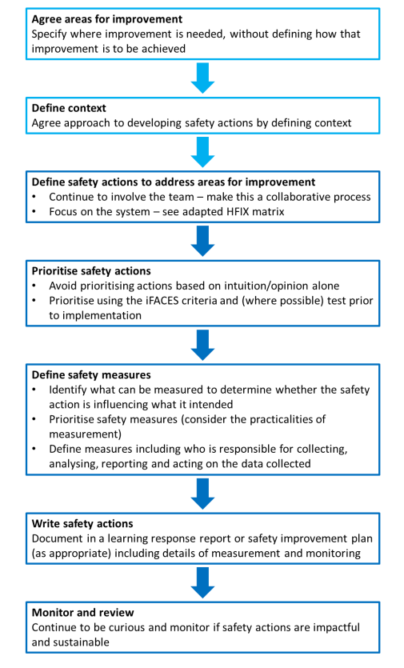

Areas of improvement will be linked to the outcomes of the learning response or review, and the reason for changes being implemented will be clearly defined and communicated as the safety actions are developed and implemented.

The Human Factors Intervention Matrix (HFIX) can also be used to guide thinking as to how areas of improvement can be translated into safety actions in order to reduce risk.

Table 2 – Human Factors Intervention Matrix (HFIX)
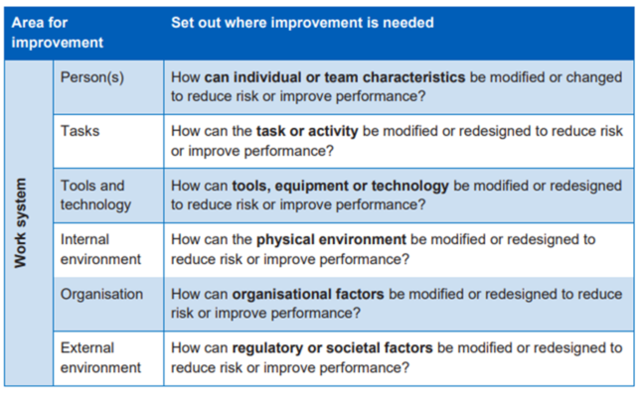
Safety Actions will be recorded on the Safety Action reporting template (Appendix 8). The actions will be assigned to a designated action owner and monitored by the relevant group/individual that has responsibility for monitoring and oversight.

Safety improvement plans
Safety Improvement Plans will be implemented following findings from learning responses and investigations into patient safety events and incidents. The Trust will consider how plans will be developed dependent on the patient safety event and the insight gathered.

These may include individual safety improvement plans that focus on a specific service or process, and broader plans for improvements where overarching system issues have been identified.
Progress on these plans will be monitored via PSIRG and relevant Steering Groups as appropriate, to receive assurance on progress and recommend the need for future improvement plans and shared learning.

Oversight roles and responsibilities

The leadership and management functions of the PSIRF oversight are wider and more multifaceted compared to previous response approaches under the Serious Incident Framework. Oversight under PSIRF will focus on monitoring improvement in the safety of care and should ensure learning focuses on identifying the system factors that contribute to a patient safety incident, not apportioning blame.

The Board
The Trust Board is responsible for identifying executive lead(s) for PSIRF (nominated as the Chief Nurse and Medical Director) who will:
- Ensure the organisation meets national patient safety incident response standards
- Ensure PSIRF is central to overarching safety governance arrangements
- Quality assure learning response outputs with full PSIIs shared at Board

Chief Nurse
The Chief Nurse will, as far as is reasonably practical, ensure that:
- This procedure is implemented throughout the Trust.
- Relevant information from learning responses and investigation reports are reported to the Trust Board.
- Ensure that all staff involved in an incident, complaint or claim receives adequate support.

Medical Director
The Medical Director will:
- Report lessons learnt and actions planned following completion of patient safety incident learning responses to the quality meeting with the principal commissioning body currently Stockport ICB.
- Will ensure that all staff involved in an incident, complaint or claim is adequately supported.

Deputy Director of Quality Governance
The Deputy Director of Quality Governance will:
- Ensure training is provided for relevant staff members, as specified in the national requirements for PSIRF.
- Advise and support managers and staff in the patient safety incident review process for incidents or co-ordinate.
- Advise and support managers in the production of learning responses and action plans resulting from investigations.
- Ensure appropriate communication and liaison with relevant managers and staff across the Trust.
- Ensure good communication channels exist, via the Trust’s Risk Management Structure to support learning from learning responses and investigations.
- Present the overdue patient safety incident report to the Patient Safety Group monthly and assist in the development of appropriate action plans.
- Produce the monthly report for presentation to the Patient Safety Group.
- Produce a quarterly report for presentation to Patient Safety Group and Quality Committee.
- Advise and support managers and staff in the investigation process for incidents and claims.

Corporate Quality Governance Team
The Corporate Quality Governance Team is responsible for:
- Tracking all patient safety incident investigations (PSIIs)
- Liaising with the Integrated Care Board (ICB)

Divisional Directors
The Divisional Directors will:
- Ensure that they have a clear structure and operational procedures in place within their own divisional group for the investigation of patient safety events and completing learning responses.
- Ensure that there is a designated person(s) responsible for investigations of the same.
- Ensure that all action plans developed following learning responses and investigations are monitored for completion at the quality board meeting.
- Ensure that all staff within their Division receives adequate support and guidance following a patient safety incident or investigation including ensuring adequate support when there is a requirement for staff to attend court.

Divisional Associate Medical Directors
The Divisional Associate Medical Directors & Divisional Nurse Directors will undertake the following responsibilities:
- Ensure that this policy is implemented within their area of responsibilities.
- Ensure sufficient resources are applied to this policy (for example, human and time resources).
- Ensure that incident learning responses and PSII reports, and subsequent action plans are presented to divisional boards, or equivalent divisional meetings.
- Ensure that action plans resulting from learning responses and patient safety investigations are monitored.
- Ensure appropriate and timely communications are undertaken with the Risk and Safety Department.
- Ensure staff are adequately supported throughout the process of a learning response or investigation into a patient safety incident.

Divisional Nurse Directors / Divisional Director of Nursing & Therapy / Divisional Director of Midwifery & Nursing
The Divisional Nurse Directors, Divisional Director of Nursing & Therapy and Divisional Director of Midwifery & Nursing will:
- Ensure that this policy is implemented within their area of responsibilities.
- Ensure sufficient resources are applied to this policy (for example, human and time resources).
- Ensure that incident learning responses and PSII reports, and subsequent action plans are presented to divisional boards, or equivalent divisional meetings.
- Ensure that action plans resulting from learning responses and patient safety investigations are monitored.
- Ensure appropriate and timely communications are undertaken with the Risk and Safety Department.
- Ensure staff are adequately supported throughout the response or investigation into a patient safety incident.

Divisional Governance Teams
The Divisional Governance Teams will:
- Implement this policy.
- Lead/co-ordinate or undertake learning responses and investigations.
- Advise and support managers and staff.
- Ensure reports and action plans developed from learning responses and investigations are communicated effectively within their division and at appropriate Trust forums, for example, Patient Safety Group.
- Ensure that learning and changes to practice from learning responses and investigations are communicated to all appropriate staff (“appropriate staff” will depend upon the individual investigation).
- Ensure monitoring of action plans and their implementation.
- Ensure appropriate and timely communications are undertaken with the Risk and Safety Department.
- Will support all staff during the process of a learning response or patient safety investigation.

Senior clinical and operational staff
Senior clinical and operational staff will:
- Implement this policy.
- Lead and undertake learning responses and investigations as requested.
- Undertake appropriate training.
- Support staff in the learning response and investigation process.
- Develop and implement action plans arising from learning responses and investigations.
- Monitor the implementation and effectiveness of these action plans.

Engagement Leads
Engagement Leads will:
- Implement this policy.
- Engage with and involve those affected by patient safety incidents in investigations.
- Undertake appropriate training.
- Support staff and patients in the learning response and investigation process.

Learning Response Leads
Learning Response Leads will:
- Implement this policy.
- Lead and undertake learning responses and investigations as requested.
- Undertake appropriate training.
- Support staff in the learning response and investigation process.

All staff
All staff will:
- Implement this policy.
- Assist in and undertake learning responses and investigations.
- Contribute appropriately by participating in learning responses and being interviewed in a timely manner as part of the learning response and investigation process.

Complaints and appeals
Engagement Leads will be assigned to support and involve patients and families during the investigation and ensure that concerns raised throughout the process are managed and responded to appropriately.

However, should patients and/or families remain dissatisfied in relation to the Trust’s management or outcome of an investigation and wish to complain or appeal, they should be directed to the resources PALs and Complaints team. Please refer to the Trust’s Complaint’s policy for further guidance.

Patients and families can also be directed to the resources below if further resolution outside of the Trust is required:
- Health Service Ombudsman
- Health Watch
- ICB
- CQC

Document Launch and Dissemination
This document will be launched in April 2024 and will be made available both on the Trust public website and staff intranet. A PSIRF Go Live Week is also planned for week commencing 25 March 2024 across the Trust.

Dissemination
Some examples of methods of disseminating information, using links to the Risk & Safety are as follows:
- Information cascade via relevant management teams
- Communication via Management/Departmental/Team meetings
- Inclusion of relevant information in Team Brief
- Notice board administration
- Articles in bulletins
The responsibility of implementing this document, including training and other needs that arise shall remain with the author. Line managers have the responsibility to cascade information on new and revised policies/procedures and other relevant documents to the staff for which they manage.
Line managers must ensure that departmental systems are in place to enable staff including agency staff to access relevant policies, procedures, guidelines, and protocols and to remain up to date with the content of new and revised policies, procedures, guidelines, and protocols.
The document will be displayed on the Risk and Safety microsite on the Trust’s intranet. Managers and Governance leads should ensure the information is cascaded to all staff.

References and Associated Documentation
Incident Reporting policy
Duty of Candour policy
Include Equality Impact Assessment

Document Information
Type of Document | Policy
Title | Patient Safety Incident Response Framework (PSIRF) Policy
Version number | 1.0
Consultation | Patient Safety Group
Recommended by | Risk & Safety Team
Approved by | Quality Committee
Approved date | 26th March 2024
Next Review date | 26th March 2027
Document Author | Deputy Director of Quality Governance
Document Director | Chief Nurse
For use by | Whole Trust document
Specialty / Ward / Document (if local procedure document) | n/a

Appendices

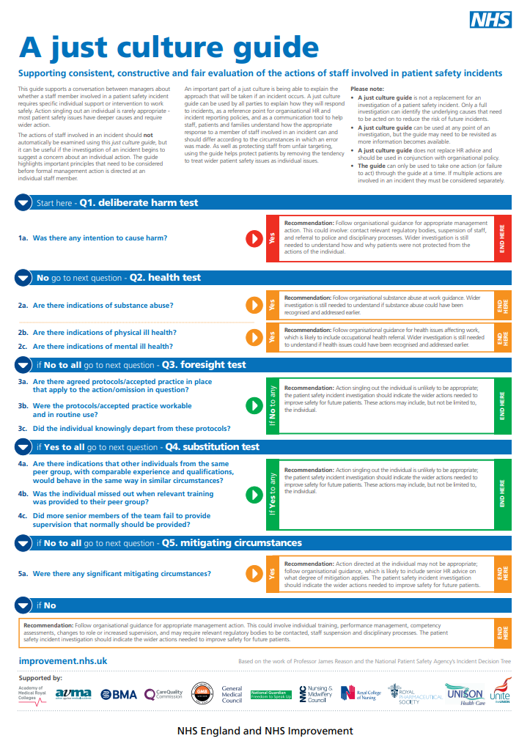
Appendix 1 – NHSE Just Culture Guide

Appendix 2 – After Action Review (AAR) Template
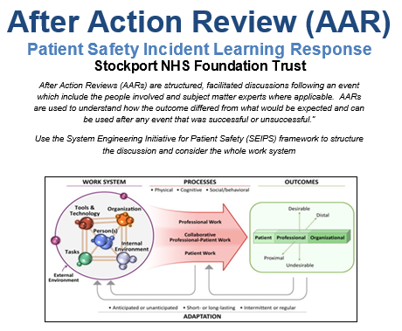

DATE OF AAR:
AAR FACILITATOR:
PARTICIPANTS AT AAR:

DATIX NO:
DIVISION / LOCATION OF INCIDENT:
OVERVIEW OF INCIDENT:

After Action Reviews (AARs) should include as many people who were involved in the incident/event as possible to enable a wide range of viewpoints to be discussed and explored. A prerequisite of an AAR is that everyone present feels able to contribute without fear of blame or retribution. AARs are about learning, not holding people to account.

WHAT DID WE SET OUT TO DO?  What should have happened? What was the expected outcome? | WHAT ACTUALLY HAPPENED?
SYSTEM LEARNING: Why was there a difference?  Consider the whole work system - People, Tasks, Tools/Technology, Organisation, Physical & External Environment | REFLECTING ON SUCCESSES & FAILURES:  What went well? Why?  What could have gone better? Why?
RECOMMENDATIONS FOR IMPROVEMENT:
What would we do differently next time?
COMPASSIONATE ENGAGEMENT OF PEOPLE AFFECTED:
What has been/will be put in place to support, engage, and meet the needs of patients, families and staff affected
ACTION PLAN
Ref | Safety Actions | Action required | Responsible person  (Name & role) | Deadline for action | Date completed | Progress update | Current status  1 2 3 4
1
2
3

Appendix 3 – Hot Debrief Tool Template

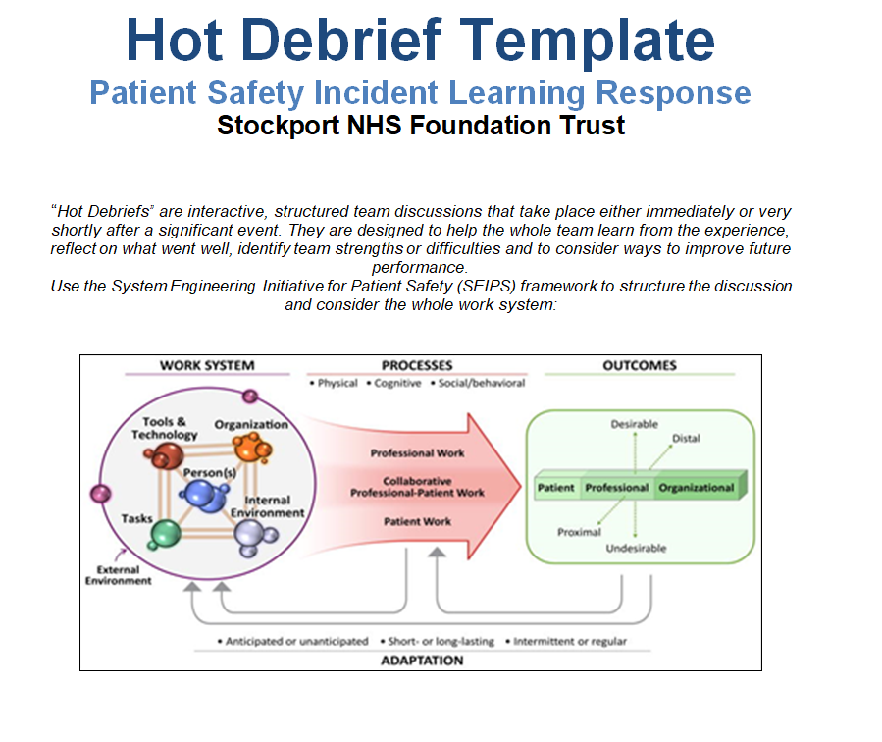

DATE OF HOT DEBRIEF: | DEBRIEF FACILITATOR: |  | DATIX NO: | DATE OF INCIDENT: | DIVISION/LOCATION:
OUTLINE THE EVENT:
What happened?

POSITIVES:
Discuss what went well.

CONCERNS:
What did not go well?
What must be changed?

IMPROVEMENTS/ACTIONS:
Identify actions for improvement
Assign an Action Lead

ACTION PLAN
Ref | Safety Actions | Action required | Responsible person  (Name & role) | Deadline for action | Date completed | Progress update | Current status  1 2 3 4
1
2
3

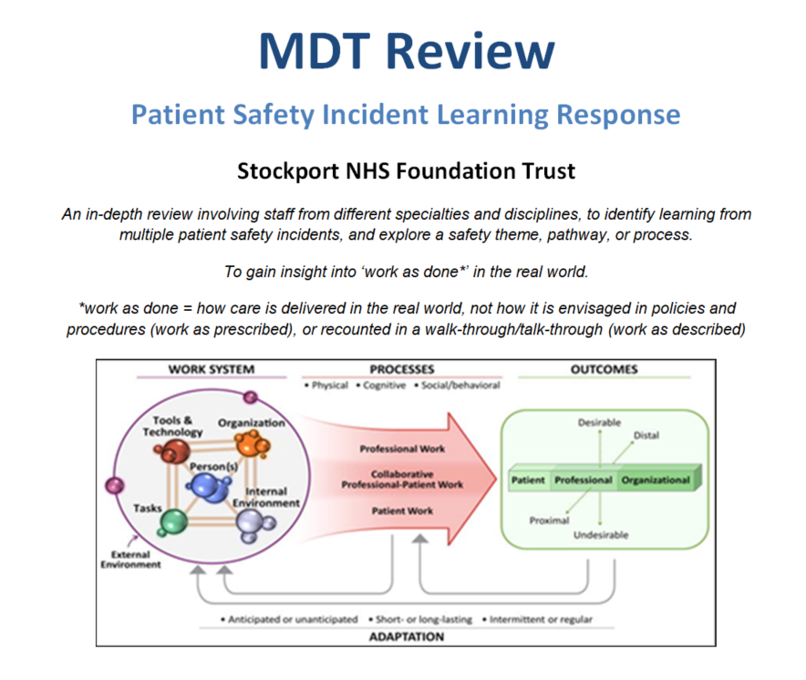
Appendix 4 – Multidisciplinary Team (MDT) Tool Template

DATE OF MDT REVIEW: |  | MDT FACILITATOR (NAME & ROLE): | STAFF PRESENT (NAME & ROLE):
DATIX NO:
DATE OF INCIDENT(S):
LOCATION OF INCIDENT(S):
INCIDENT: A brief summary of the incident/event.

DISCUSSION POINTS: Any issues regarding the incident (consider ‘work-as-done’ vs. ‘work-as-prescribed’). Use SEIPS framework to structure discussion.

ASSESSMENT: Key insights identified about ‘work-as-done.’ What was done well? What could be improved?

RECOMMENDATIONS: Record if any further investigation is required and why. Include any areas for improvement and relevant actions. How and where will findings and learning be shared?
ACTION PLAN
Ref | Safety Actions | Action required | Responsible person  (Name & role) | Deadline for action | Date completed | Progress update | Current status  1 2 3 4
1
2
3

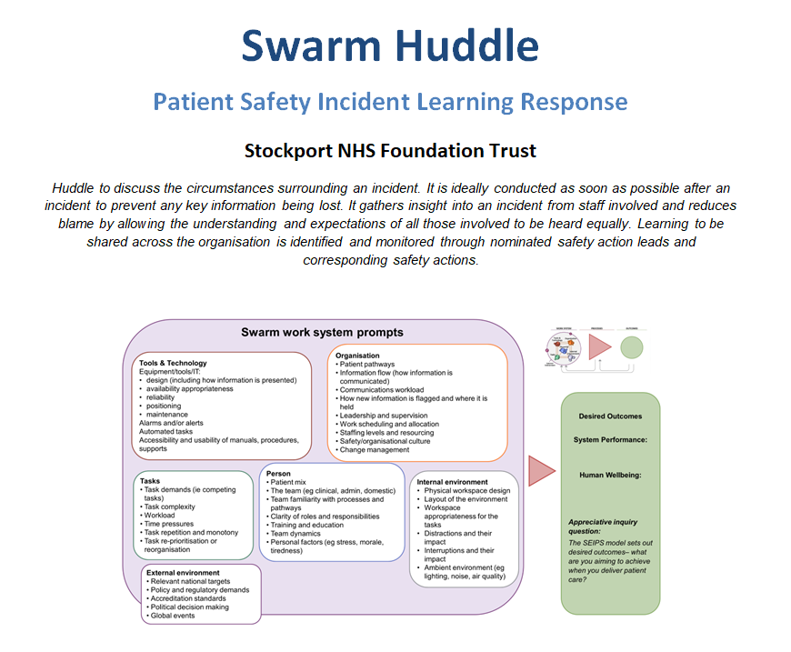
Appendix 5 – Swarm Huddle Template

DATE OF SWARM:  Figure 2: 10 tips for facilitating a Swarm  NHS England |  |  | DATIX NO:
SWARM HUDDLE FACILITATOR: |  |  | DATE OF INCIDENT:
INTRODUCTIONS
CREATE A SAFE SPACE:
NHSE - Swarm huddle guide
Facilitator introduces participants & roles in the Swarm.

REPLAY EVENTS THAT LED TO THE SWARM:
Consider a walk-through in area where the event occurred
Explore what happened and why

IDENTIFY WHERE ELSE IN THE TRUST THE LEARNING MAY BE RELEVANT:

Where to share and how to share?
Who will do this?

IDENTIFY SAFETY ACTIONS:

Assign leads and deadlines as appropriate.

Consider if there is any other learning/actions already in place and how this may contribute

ACTION PLAN
Ref | Safety Actions | Action required | Responsible person  (Name & role) | Deadline for action | Date completed | Progress update | Current status  1 2 3 4
1
2
3

Appendix 6 – Patient Safety Incident Investigation (PSII) Template

Patient safety incident investigation (PSII) report
On completion of your final report, please ensure you have deleted all the blue information boxes and green text.
Notes on the PSII template
This national template is designed to improve the recording and standardisation of PSII reports and facilitate national collection of findings for learning purposes. This format will continue to be evaluated and developed by the National Patient Safety Team.
General writing tips
A PSII report must be accessible to a wide audience and make sense when read on its own. The report should:
- use clear and simple everyday English whenever possible
- explain or avoid technical language
- use lists where appropriate
- keep sentences short.

Incident ID number:
Date incident occurred:
Report approved date:
Approved by:

Distribution list
List who will receive the final draft and the final report (eg patients/relatives/staff involved¸ board). Remove names prior to distribution.
Name | Position

About patient safety incident investigations
Patient safety incident investigations (PSIIs) are undertaken to identify new opportunities for learning and improvement. PSIIs focus on improving healthcare systems; they do not look to blame individuals. Other organisations and investigation types consider issues such as criminality, culpability, or cause of death. Including blame or trying to determine whether an incident was preventable within an investigation designed for learning can lead to a culture of fear, resulting in missed opportunities for improvement.
The key aim of a PSII is to provide a clear explanation of how an organisation’s systems and processes contributed to a patient safety incident. Recognising that mistakes are human, PSIIs examine ‘system factors’ such as the tools, technologies, environments, tasks, and work processes involved. Findings from a PSII are then used to identify actions that will lead to improvements in the safety of the care patients receive.
PSIIs begin as soon as possible after the incident and are normally completed within three months. This timeframe may be extended with the agreement of those affected, including patients, families, carers, and staff.
If a PSII finds significant risks that require immediate action to improve patient safety, this action will be taken as soon as possible. Some safety actions for system improvement may not follow until later, according to a safety improvement plan that is based on the findings from several investigations or other learning responses.
The investigation team follow the Duty of Candour and the Engaging and involving patients, families and staff after a patient safety guidance in their collaboration with those affected, to help them identify what happened and how this resulted in a patient safety incident. Investigators encourage human resources teams to follow the Just Culture guide in the minority of cases when staff may be referred to them.
PSIIs are led by a senior lead investigator who is trained to conduct investigations for learning. The investigators follow the guidance set out in the Patient Safety Incident Response Framework and in the national patient safety incident response standards.
A note of acknowledgement
Notes on writing a note of acknowledgement
In this brief section you should thank the patient whose experience is documented in the report along with contributions from their family and others (including carers, etc) who gave time and shared their thoughts.
You could consider referring to the patient by name or as ‘the patient’ according to their wishes.
Also thank the healthcare staff who engaged with the investigation for their openness and willingness to support improvements.

Executive summary
Notes on writing the executive summary
To be completed after the main report has been written.
Incident overview
Notes on writing the incident overview for the executive summary
Add a brief, plain English description of the incident here.
Summary of key findings
Notes on writing the summary of key findings for the executive summary
Add a brief overview of the main findings here (potentially in bullet point form).
Summary of areas for improvement and safety actions
Notes on writing about areas for improvement and safety actions for the executive summary
Add a bullet point list of the areas for improvement highlighted by the investigation and list any safety actions. Note whether the area for improvement will be addressed by development of a safety improvement plan.
Some actions to address identified areas for improvement may already have been designed in existing an organisational safety improvement plan. Note that here.
Areas for improvement and safety actions must be written to stand alone, in plain English and without abbreviations.
Refer to the Safety action development guide for further details on how to write safety actions.
NB: The term ‘lesson learned’ is no longer recommended for use in PSIIs.

Contents
To update this contents table¸ click on the body of the table; select ‘update field’; and then ‘update page numbers only’; and then click ‘ok’.
About patient safety incident investigations 48
A note of acknowledgement 49
Executive summary 50
Background and context 52
Description of the patient safety incident 13
Investigation approach 54
Findings 56
Summary of findings, areas for improvement and safety actions 57

Background and context
Notes on writing about background and context
The purpose of this section, where appropriate, is to provide a short, plain English explanation of the subject under investigation – in essence, essential pre-reading to assist understanding of the incident. It might be a description of a pulmonary embolism, aortic dissection, cognitive behavioural therapy, NEWS, etc.
It may also be worth using this section to summarise any key national standards or local policies/guidelines that are central to the investigation.

Description of the patient safety incident
Notes on writing a description of the event
The purpose of this section is to describe the patient safety incident. It should not include any analysis of the incident or findings – these come later.
Think about how best to structure the information – eg by day or by contact with different services on the care pathway.
It should be written in neutral language, eg ‘XX asked YY’ not ‘YY did not listen to XX.’ Avoid language such as ‘failure,’ ‘delay’ and ‘lapse’ that can prompt blame.
If the patient or family/carer has agreed, you could personalise the title of this section to ‘[NAME]’s story/experience.’

Investigation approach
Investigation team

Role | Initials | Job title | Dept/directorate and organisation
Investigation commissioner/convenor:
Investigation lead:
Summary of investigation process
Notes on writing about the investigation process
If useful, you should include a short paragraph outlining the investigation process:
- how the incident was reported (eg via trust reporting system)
- how agreement was reached to investigate (eg review of patient safety incident response plan, panel review, including titles of panel members)
- what happened when the investigation was complete (eg final report approved by whom)?
- how actions will be monitored.
Terms of reference
Notes on writing about scope
In this section you should describe any agreed boundaries (that is, what is in and out of scope) for the investigation. For example, you might want to note:
- the aspects of care to be covered by the investigation
- questions raised by the those affected that will be addressed by the investigation
If those affected by the patient safety incident (patients, families, carers and staff) agree, they should be involved in setting the terms of reference as described in the Engaging and involving patients, families and staff after a patient safety incident guidance.
A template is available in the learning response toolkit to help develop terms of reference.

Information gathering
Notes on writing about information gathering
The purpose of this section is to provide a short overview of your investigation approach. You should include a brief overview of your methods including:
- investigation framework and any analysis methods used. Remember to keep jargon to a minimum (eg the investigation considered how factors such as the environment, equipment, tasks, and policies influenced the decisions and actions of staff)
- interviews with key participants (including the patient/family/carer)
- observations of work as done
- documentation reviews, eg medical records, staff rosters, guidelines, SOPs
- any other methods.
Recorded reflections, eg those used for learning portfolios, revalidation or continuing professional development purposes, are not suitable sources of evidence for a systems focused PSII.
Statements are not recommended. Interviews and other information gathering approaches are preferred.

Findings
Notes on writing your findings
The purpose of this section is to summarise your analysis of the information you have gathered and to state the findings you have drawn from that analysis.
You may choose to include diagrams and/or tables to communicate your analytical reasoning and findings.
Do not re-tell the story in the description of the patient safety incident. This section is about the ‘how’ the incident happened, not the ‘what’ and ‘when.’
Start with an introductory paragraph that describes the purpose of the section and structure you are going to use.
For your findings to have impact you will need to communicate them in a clear and logical way. Before you start, think about how best to structure the section, then make a plan.
You may find sub-headings useful. The structure you choose will depend on your investigation, but you could organise the information as follows:
- by the themes you have identified during the investigation – in which case put your strongest theme first
- following the framework or the analytical method you used
- in chronological order corresponding to the care pathway described in the reference event, eg community care, ambulance service, acute care (taking care not to repeat the story of the reference event)
- in order of the main decision points during the incident.
Use clear, direct language, eg ‘The investigation found…’
If the section is long and contains multiple sub-sections, consider adding a summary of key points at the end of each sub-section.
Technical terms should be kept to an absolute minimum. If they are required, you should explain them in the text (glossaries should be avoided).
Include your defined areas for improvement and safety actions (where appropriate) in the relevant places in this section.
Areas for improvement that describe broader systems issues related to the wider organisation context are best addressed in a safety improvement plan. You should describe what the next stages are with regards to developing a safety improvement plan that will include meaningful actions for system improvement.
Summary of findings, areas for improvement and safety actions
Notes on writing the final summary
The purpose of this section is to bring together the main findings of the investigation.
Areas for improvement and associated safety actions (if applicable) should be listed using the table provided (also available in Appendix B of the safety action development guide).
If no actions are identified the safety action summary table is not required. Instead, you should describe how the areas for improvement will be addressed (eg refer to other ongoing improvement work, development of a safety improvement plan)

Safety action summary table
Area for improvement: [eg review of test results]
 | Safety action description  (SMART) | Safety action owner  (role, team directorate) | Target date for implementation | Date Implemented | Tool/measure | Measurement frequency  (eg daily, monthly) | Responsibility for monitoring/ oversight  (eg specific group/ individual, etc) | Planned review date  (eg annually)
1.
2.
…

Area for Improvement: [eg nurse-to-nurse handover]
 | Safety action description  (SMART) | Safety action owner  (role, team directorate) | Target date for implementation | Date Implemented | Tool/measure | Measurement frequency  (eg daily, monthly) | Responsibility for monitoring/ oversight  (eg specific group/ individual, etc) | Planned review date  (eg annually)
1.
…

Appendices
Notes on appendices
Include any necessary additional details such as explanatory text, tables, diagrams, etc (Delete this section if there are none).

References
Notes on references
Include references to national and local policy/procedure/guidance, and other data sources as required.

Appendix 7 – Learning Response Guide
Type of Learning Response (LR) | Description of LR | When to Use | Recommended Time | Response Lead | Persons to Attend
After Incident Review (AIR) | Structured, facilitated discussion following an event which includes the people involved and subject matter experts where applicable. To understand how the outcome differed from what would be expected. Can be used after any event that was successful or unsuccessful. | When patient care or service was not as safe/effective as expected, or if events/outcome is better than expected. | Approx. 45-90 mins dependent on the event and number of participants. | Trained AIR facilitator – who ensures psychological safety of all present | Staff directly involved, and those connected to the service or process.
Hot Debrief | Interactive, structured team discussions that take place either immediately or very shortly after a significant event. They are designed to help the whole team learn from the experience, reflect on what went well, identify team strengths or difficulties and to consider ways to improve future performance. | Following an event where learning has been identified, requirement for emotional debriefing and/or opportunities to improve. | Approx. 30 mins – further debrief sessions may be required for some individuals. | Patient safety facilitator | Staff directly involved and witnessed the event or incident.
Multidisciplinary Team (MDT) Review | An in-depth review involving staff from different specialties and disciplines, to identify learning from multiple patient safety incidents, and explore a safety theme, pathway, or process. To gain insight into ‘work as done*’ in the real world.  *work as done = how care is delivered in the real world, not how it is envisaged in policies and procedures (work as prescribed), or recounted in a walk-through/talk-through (work as described) | After cluster of similar events have occurred to determine safety themes. | Meeting/workshop approx. 2-3 hours | Patient safety facilitator, MDT review will be used as part of the review into the incidents | Staff directly involved and subject matter experts, senior clinicians.
Type of Learning Response (LR) | Description of LR | When to Use | Recommended Time | Response Lead | Persons to Attend
Swarm Huddle | Meeting to discuss the circumstances surrounding an incident. It is ideally conducted as soon as possible after an incident to prevent any key information being lost. It gathers insight into an incident from staff involved and reduces blame by allowing the understanding and expectations of all those involved to be heard equally. Learning to be shared across the organisation is identified and monitored through nominated safety action leads and corresponding safety actions. | Any event where patient safety was at risk | Approx. 30 minutes | Senior Lead who will generate a report | Staff directly involved in the patient safety event.
Thematic Review | Used to review and understand common links, themes, or issues within a cluster of investigations or incidents. Seeks to uncover key barriers to safety and identify safety recommendations. | When a series or cluster of similar patient safety incidents have occurred. | Varies dependent on the number of events being analysed – max. 3 months | Trained Patient Safety Investigator | Staff involved in the service, subject matter experts.
Patient Safety Incident Investigation (PSII) | In-depth review of a Patient Safety incident or cluster of events to understand what happened and how. | When serious harm has been caused.  Incidents as defined in National Priorities.  Incidents as defined in the Trust’s Local Priorities. | Over several weeks/months (max. 6 months).  Timescale to be agreed with patients/families involved where applicable. | Trained Patient Safety Investigator, who collects data, conducts interviews, and generates an investigation report. | Staff and patients/families directly involved, and senior clinicians.

Appendix 8 – Safety Action Reporting Template

Area for Improvement:
 | Safety action description  (SMART) | Safety action owner  (role/team/division) | Target date for implementation | Date implemented | Tool/measure  (eg audit) | Measurement frequency  (eg daily/monthly) | Responsibility for monitoring/oversight  (eg group/person) | Planned review date  (eg annually)
1.
2.
3.
…

