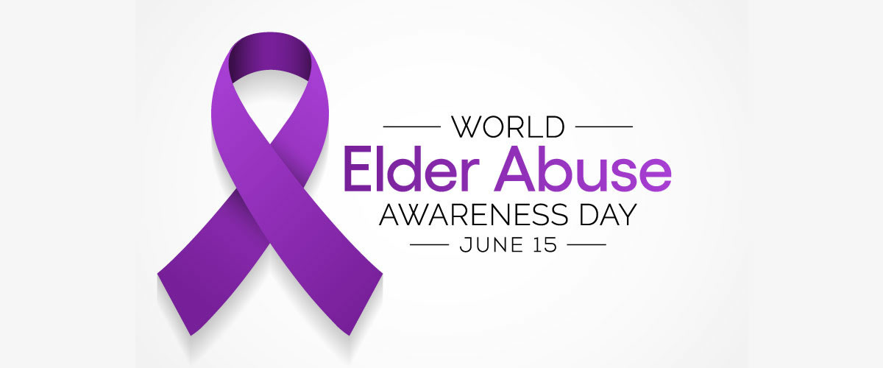

Types of Elder Abuse
Here are the eight most common forms of elder abuse:
- Self-Neglect – Refusal or failure to provide himself/herself with adequate food, water, clothing, shelter, personal hygiene, medication (when indicated), and safety precaution.
- Physical Abuse – The use of physical force that may result in bodily injury, physical pain, or impairment; or any physical injury to an adult caused by other than accidental means.
- Neglect by Others – Failure to provide the basic care, or services necessary to maintain the health and safety of an adult: this failure can be active or passive.
- Sexual Abuse – Sexual contact with a non-consenting adult or with an adult considered incapable of consenting to a sexual act.
- Financial Abuse – The illegal or unethical exploitation and/or use of an elder’s funds, property, or other assets.
- Mental Abuse – Verbal or emotional abuse includes threatening significant physical harm or threatening or causing significant emotional harm to an adult through the use of: Derogatory or inappropriate names, insults, verbal assaults, profanity, or ridicule; or harassment, coercion, threats, intimidation, humiliation, mental cruelty, or inappropriate sexual comments.
- Abandonment – the desertion or wilful forsaking by anyone has responsibility for care.
- Isolation – Preventing the individual from receiving mail, telephone calls, or visitors.

How to Recognise Abuse

1. Lack of basic amenities
2. Cluttered, unclean living environment
3. Unexplained or uncharacteristic changes in behaviour
4. Unexplained sexually transmitted diseases
5. Unpaid bills, new credit cards and/or increased cash withdrawals
6. Harassment, coercion, intimidation, humiliation
7. Caregiver isolates elder

What is Abuse?

Physical Abuse:
Pushing, striking, slapping, kicking, pinching, restraining, shaking, beating, burning, hitting, shoving or other
acts that can cause harm to an elder.

Emotional or Psychological Abuse:
Verbal berating, harassment, intimidation, threats of punishment or deprivation, criticism, demeaning comments, coercive behaviour or isolation from loved ones/caregivers.

Self-neglect:
When individuals fail to provide themselves with whatever is necessary to prevent physical or emotional harm or pain.
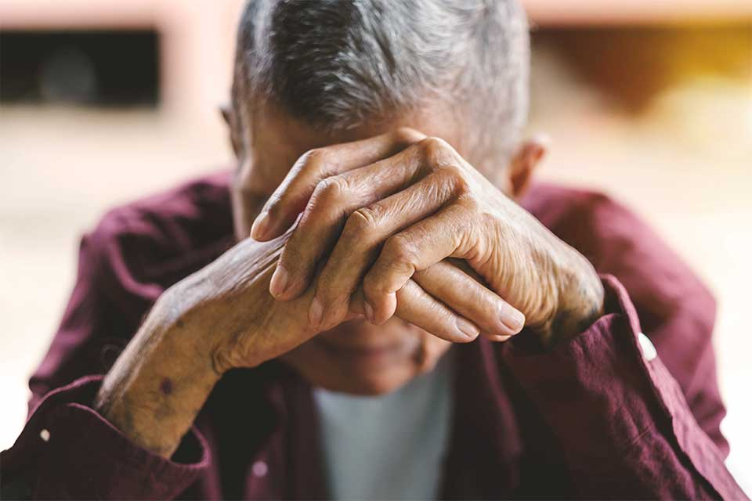

Financial or Material Exploitation:
Improper use of an elder’s funds, property, or assets; cashing checks without permission; forging signatures; forcing or deceiving an older person into signing a document; using an ATM/debit card without permission.
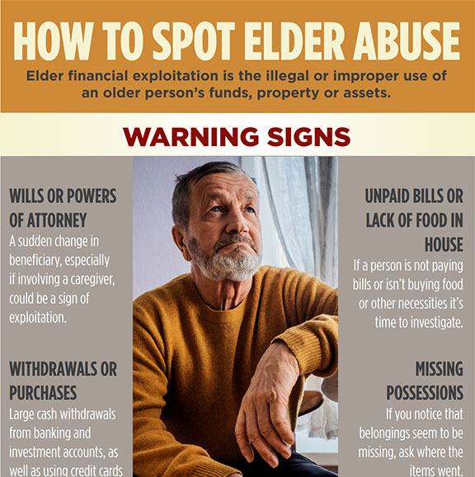

Sexual Abuse:
Non-consensual sexual contact of any kind including assault or battery, rape, sodomy, coerced nudity or sexually explicit photography.

Signs of Abuse

Physical signs may include:
- cuts, scratches, or puncture wounds
- burns
- bruises
- welts
- dehydration or malnutrition
- poor coloration
- sunken eyes or cheeks
- soiled clothing or bedding
- lack of necessities such as food, water, or utilities

Behavioural signs may include:
- fear or anxiety
- agitation
- anger
- isolation
- withdrawal
- depression
- resignation
- ambivalence
- contradictory statements
- implausible stories
- hesitation to talk openly
- confusion or disorientation

What to do if you suspect Elder Abuse
- Ensure the individual is safe and there are no immediate dangers. If you believe there are immediate risks of harm, escalate to a senior member of staff as soon as possible.
- Escalate to a senior member of staff for support.
- Escalate to the Adult Safeguarding team using a ‘do it online’ Cause for Concern form.
- If you need immediate advice and it is within office hours telephone the Adult Safeguarding team on 0161 419 5124 and follow instructions. Out of hours bleep the Senior Professional Cover holding the 1090 bleep.
- If the concern involves a member of staff always escalate to a senior member of staff.
- Document in the patients notes exactly what has happened and why you have raised a concern.
- Complete a DATIX outlining your concern.

