**Why is a new campus being built?**

We have seen a continued increase in emergency patients at Stepping Hill Hospital in recent years, and the existing facilities are outdated and not enough to provide for these increasing numbers. These new facilities will help us to provide the safe, good quality care which these patients need

**Where will the development be?**

The new development is extended from the existing Emergency Department (A&E) at Stepping Hill Hospital. The best place to visualise it is to consider the artists’ impression from the direction of Poplar Grove, directly in front of the main blue hospital building where the trust and hospital name can currently be seen. The following figures 1 and 2 further illustrate the location of the development.

***Figure 1. Hospital Site Map*** 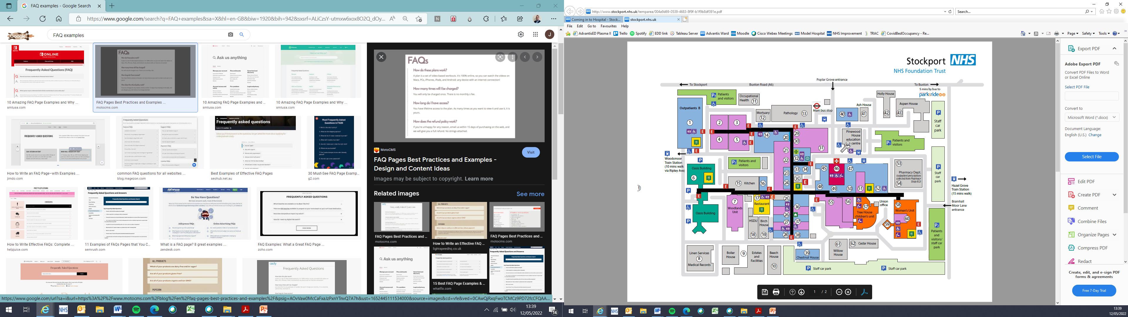

***Figure 2. Google Maps View*** 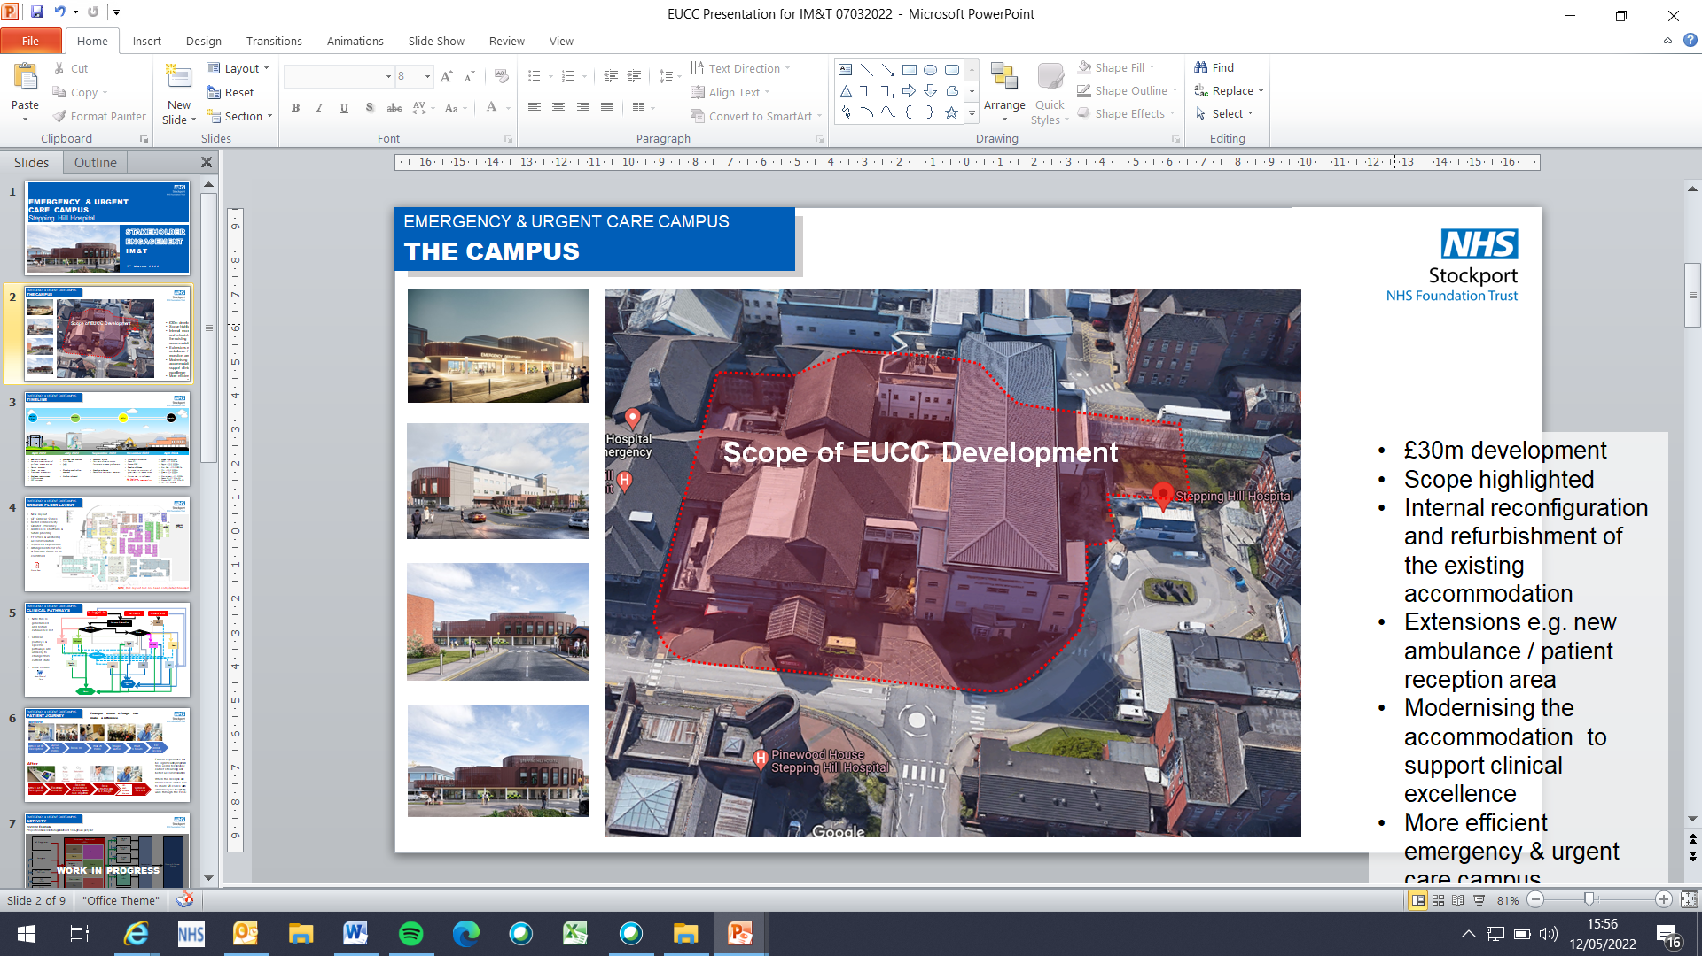

**What patient facilities will it provide? Will capacity increase?**

The campus will include new assessment, treatment and consultation areas for several key emergency and urgent care services including the children’s emergency department, mental health, and medical same day emergency care. The development will see the size of the clinical area increase by over 300m², enabling more patients to receive safe care and treatment sooner.

**What new staff facilities will it provide?**

The first floor of the development will supply a large staff break area, staff changing rooms, staff toilets, staff showers, staff meeting spaces and office accommodation for staff

**Why is money being spent on the new facility when lack of staff is a bigger problem? Will staffing increase?**

The money for the development is not from Stockport NHS Foundation Trust’s funds, but additional funding from the government which is specifically and only for capital projects.

Of course sufficient numbers of staff are needed, but they also need the best quality, suitable facilities in which to provide their care which the new campus will provide. We have seen a continued increase in emergency patients at Stepping Hill Hospital in recent years, and these new facilities will help us to provide the safe, good quality care which these patients need.

We do have staffing pressures, as have all NHS Trusts across the country, but this is a separate issue from our facilities. We are taking regular measures to help tackle this, including recruitment drives, involvement in recruitment fairs, and international recruitment.

**When will building work take place?**

Some work is required to take place before the main construction commences in September 2022. For example, the Cardiology pacing facilities will need to be relocated to newly refurbished premises opposite Endoscopy.

Construction is expected to be complete by March 2024

**Why is the new emergency and urgent care campus being built if we are planning to have a brand new hospital in Stockport town centre?**

There is currently a bid for another site in Stockport town centre, which is a long term strategic aim between Stockport NHS Foundation Trust, local Councils and Clinical Commissioning Groups.

Stepping Hill Hospital is an ageing hospital that was not designed to deliver modern acute services, and requires £95m worth of backlog maintenance. Even if funds were available to carry out all the work needed, it still would not provide the modern hospital environment patients and staff deserve.

Any new hospital would be years further down the line. The new emergency and urgent care campus on the site is responding to the more immediate needs of the population.

**Why is this new campus being created without new parking spaces?**

Our planned new emergency and urgent care campus is responding to the important care and treatment needs of our patients.

The additional funding we receive is for patient care, not for car parking.

The new development will not result in additional patients, but is responding to the numbers we are already seeing, and there will be no reduction in parking spaces with this scheme.

Although car parking at the hospital has reduced during the pandemic, limited car parking spaces are an ongoing challenge for hospital trusts across the country. We are continuing to look at a range of options to keep car parking on and around the site to a minimum, both as part of our commitment to the environment, and to ease parking pressures on local residents and ourselves.

We encourage all staff and visitors to travel to the hospital via public transport, cycling or walking, the local Park & Ride scheme, car share and other means where possible. Increased flexible working for our staff, greater use of online outpatient appointments, and the greatly improved cycling access to the hospital from the planned new Bee Network are other steps we also hope will help reduce parking pressures on and around the site.

**How will we continue to provide services during building work?**

It is essential that we are able to maintain services and minimise disruption to operational services during construction. Therefore a complex construction phasing plan has been co-developed between the Trust, Architects and our construction partner.

The phasing plan details the key dates of enabling works, decant, temporary arrangements, commencement and completion of areas/departments over the course of the construction period.

The phasing plan has been reviewed and approved by the EUCC Project Board; which comprises senior clinicians, operational managers and members of the executive team.

In the coming weeks the EUCC Project Team will be working with clinical operational teams to develop local actions and staff engagement sessions in the run up to construction starting.