Stockport NHS Foundation Trust

Workforce Race Equality Standard

(WRES) Report 2021



**Introduction**

The NHS Workforce Race Equality Standard (WRES) was made available to the NHS from April 2015, following sustained engagement and consultation with key stakeholders including a widespread of NHS organisations across England. The WRES is included in the NHS standard contract, and since July 2015, NHS trusts have been producing and publishing their WRES data on an annual basis.

The main purpose of the WRES is:

* to help local, and national, NHS organisations (and other organisations providing NHS services) to review their data against the nine WRES indicators,
* to produce action plans to close the gaps in workplace experience between white and Black and Ethnic Minority (BME) staff, and,
* to improve BAME representation at the Board level of the organisation.

This document reports on Trust’s activity between 1 April 2020 and 31 March 2021. In accordance with the three workforce themes: workforce diversity (indicators 1 – 4), staff experience (indicators 5 – 8) and leadership diversity (indicator 9).

In addition to reporting the metrics required of the WRES, this report also sets out actions that will be undertaken to address the inequalities identified.

It is recognised that whilst the Trust has seen a slight improvement in the Staff Survey metrics in relation to Harassment & Bullying there is still significant work to do particularly in relation to leadership development and progression of BAME staff within the organisation, recruitment and the likely hood of BAME staff members being shortlisted and the disparity figures in relation to disciplinary procedures.

**The WRES Indicators**



**Workforce indicators**

|  |  |
| --- | --- |
| Indicator | Descriptor |
| 1 | Percentage of staff in each of the AfC Bands 1-9 and Very Senior Managers (VSM) (including executive Board members) compared with the percentage of staff in the overall workforce Note: organisations should undertake this calculation separately for non-clinical and for clinical staff |
| 2 | Relative likelihood of staff being appointed from shortlisting across all posts |
| 3 | Relative likelihood of BAME staff entering the formal disciplinary process compared to that of White staff |
| 4 | Relative likelihood of staff accessing non-mandatory training and continuous professional development (CPD). |



**National NHS Staff Survey indicators**

|  |  |
| --- | --- |
| Indicator | Descriptor |
| 5 | KF 25. Percentage of staff experiencing harassment, bullying or abuse from patients, relatives or the public in last 12 months |
| 6 | KF 26. Percentage of staff experiencing harassment, bullying or abuse from staff in last 12 months |
| 7 | KF 21. Percentage believing that the trust (or organisation) provides equal opportunities for career progression or promotion |
| 8 | Q17. In the last 12 months have you personally experienced discrimination at work from any of the following? Manager/team leader or other colleagues |



**Board representation indicator**

|  |  |
| --- | --- |
| Indicator | Descriptor |
| 9 | Percentage difference between the organisation's Board voting membership and its overall workforce disaggregated:   * By voting membership of the Board * By executive membership of the Board |

**Reporting against the WRES Indicators**

**Indicator 1**

Percentage of staff in each of the AfC Bands 1-9 and Very Senior Managers (VSM) (including executive Board members) compared with the percentage of staff in the overall workforce Note: organisations should undertake this calculation separately for non-clinical and for clinical staff

**Non-Clinical workforce**

As of March 2020, within the non-clinical workforce, 88.4% of staff were White, and 9.7% of staff were from Black and Minority Ethnic backgrounds. In March 2021, the proportion of White staff rose slightly to 88.7% and the proportion of BAME staff had fallen to 9.5%.

|  |  |  |  |
| --- | --- | --- | --- |
| **31st March 2020** | | **31st March 2021** | |
| White | 1364 | White | 1388 |
| BAME | 150 | BAME | 149 |
| Unknown | 29 | Unknown | 28 |
| Total | 1543 | Total | 1565 |

**Clinical workforce**

As of March 2020, within the clinical workforce, 78.0% of staff were White, and 19.3% of staff were from Black & Minority Ethnic backgrounds. In March 2021, the proportion of White staff had fallen slightly to 76.2%, and the proportion of BAME staff had risen to 20.5%.

|  |  |  |  |
| --- | --- | --- | --- |
| **31st March 2020** | | **31st March 2021** | |
| White | 3057 | White | 3100 |
| BAME | 756 | BAME | 834 |
| Unknown | 106 | Unknown | 134 |
| Total | 3919 | Total | 4068 |

**Figure 1** shows the proportion of White and BAME staff in each of the agenda for change pay bands within the non-clinical workforce.

**Table 1** shows where the movement has occurred within each band:



In summary, the data shows:

* There has only been a percentage increase for BAME representation at bands 4, 5 and 8B over the assessed period
* There is very little to no BAME representation at Band 8A or above, with the only exception being Band 8B (absolute number is static over the periods)

**Figure 2** below shows the proportion of White and BAME staff in each of the agenda for change pay bands within the clinical workforce.

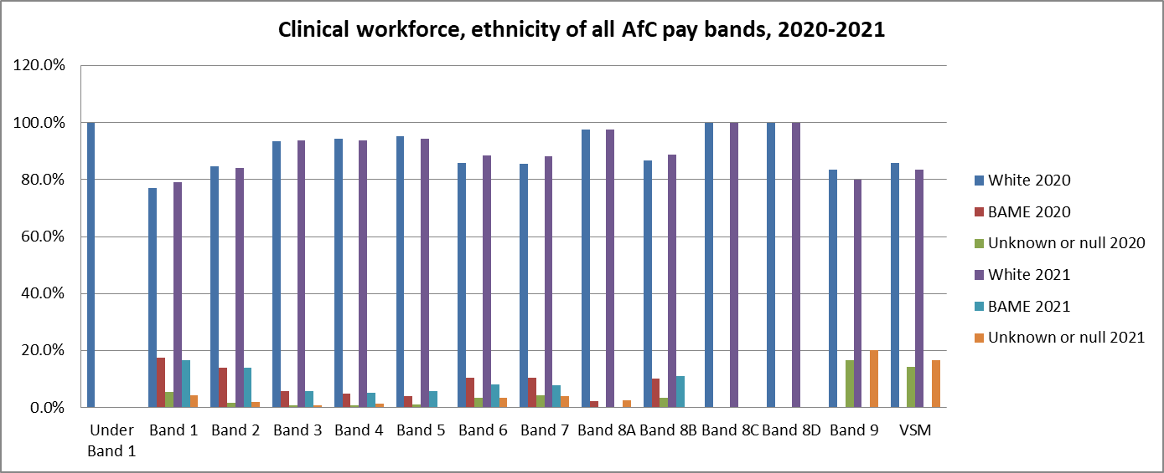

**Table 2** below shows where the movement has occurred within each band:



In summary, the data shows:

* There has been little change in BAME representation across all bands. The exception being a 5% increase in band 5 and a 9% decrease at VSM level.

**Figure 3** belowshows the proportion of White and BAME staff in each of the career band within the Medical and Dental workforce.

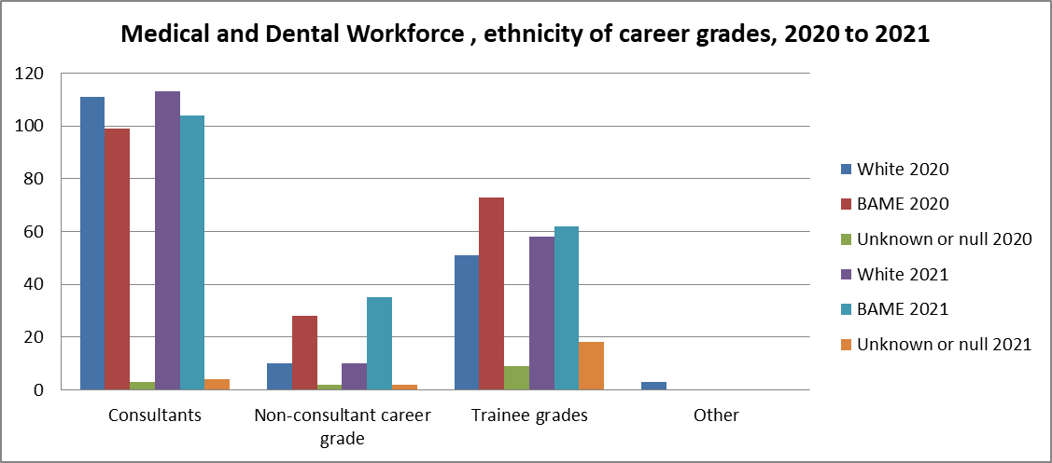

In summary, the data shows:

* There has been a 2.2% and 3.4% respective increase in slight increases in the % of BAME consultants and non-consultants career grades.
* There has been a 5.7% decrease in BAME representation at trainee grades.

**Indicator 2**

|  |  |  |  |
| --- | --- | --- | --- |
|  | Relative likelihood in 2020 | Relative likelihood in 2021 | Difference +/- |
| Relative likelihood of White staff being appointed from shortlisting compared to BAME staff. | 3.42 | 2.43 | -0.99 |

Analysis of recruitment data shows that there has been an improvement in the relative likelihood that White staff are appointed from shortlisting compared to BAME staff. However, these figures do not include our internationally recruited staff as their applications were not processed using the standard Trust recruitment systems and processes. This is demonstrated by the retrospective change in 2020 figure but still shows improvement.

**Indicator 3**

|  |  |  |  |
| --- | --- | --- | --- |
|  | Relative likelihood in 2020 | Relative likelihood in 2021 | Difference +/- |
| Relative likelihood of BAME staff entering the formal disciplinary process compared to that of White staff. | 1.47 | 1.14 | -0.33 |

There has been a small reduction in the relative likelihood that BAME staff will be entered into formal disciplinary process compared to that of White staff.

**Indicator 4**

|  |  |  |  |
| --- | --- | --- | --- |
|  | Relative likelihood in 2020 | Relative likelihood in 2021 | Difference +/- |
| Relative likelihood of staff accessing non-mandatory training and continuous professional development (CPD). | 0.83 | 0.91 | +0.08 |

There has been a small increase in the relative likelihood of BAME staff accessing non-mandatory training and continuous professional development (CPD), compared to White staff.

**Indicators 5-8**

The figure below summarise the staff survey data that is used to inform the WRES submission.

|  |  |  |
| --- | --- | --- |
| Metric | 2020 | 2021 |
| % of BAME staff reported experiencing harassment, bullying or abuse from patients, relatives or the public in the last 12 months | 28.2 | 25.8 |
| % of BAME staff reported experiencing harassment, bullying or abuse from staff in last 12 months | 29.1 | 27.6 |
| % of BAME staff said they had experienced discrimination at work from either their manager, team leader or other colleagues | 71.2 | 73.2 |
| % of BAME staff believed that the organisation provides equal opportunities for career progression or promotion | 14.3 | 18.1 |

Comparative analysis shows that there has been a small fall in the proportion of BAME staff experiencing harassment, bullying or abuse from patients, relatives or the public and other staff members in the last 12 months and a significant improvement in equality for career progression. However, we note a small deterioration in BAME colleagues experiencing discrimination in the workplace.

**Indicator 9**

Percentage difference between the organisation's Board voting membership and its overall workforce disaggregated:

|  |  |  |  |
| --- | --- | --- | --- |
|  | White | BAME | Unknown |
| Board Membership of which; | 15 | 2 | 0 |
| Exec Board Members | 6 | 0 | 0 |
| Non-Exec Board Members | 9 | 2 | 0 |
|  |  |  |  |
| Number of staff in overall workforce | 4488 | 983 | 162 |
| Overall Workforce % by ethnicity | 79.7% | 17.5% | 2.9% |
|  |  |  |  |
| Total Board members by ethnicity (%) | 88.2% | 11.8% | 0% |
|  |  |  |  |
| Difference Board membership to overall workforce | 8.6% | -5.7% | -2.9% |

There has been an additional BAME Non-Executive Director appointed to the Board.

**Workforce Disparity Ratios**

The ‘disparity ratio’ has been developed as a metric by the national WRES team to aid organisations in working towards the Model Employer target to reflect representation of ethnic minority staff for equal proportions in all AfC pay scales by 2025.

One of the national priorities was for organisations to provide a dedicated action plan on the steps identified to reduce the disparity ratio in BAME staff from **Band 6 and above** to **1.5.**

Figure 3, shows our WRES disparity ratios. Please note the disparity ratio is the comparison between the progression ratios for white and BME staff. Progression ratios are the probability of white staff versus BME staff being promoted through the lower (band 5 and below), middle (band 6 & &7) and higher bands (8a and above).

|  |  |  |  |
| --- | --- | --- | --- |
| **Trust Name** | **Lower to Middle** | **Middle to Upper** | **Lower to Upper** |
| STOCKPORT NHS FOUNDATION TRUST | 2.10 | 2.03 | 4.26 |

The data above shows that white staff at grades 6 & 7 (middle) are 2.03 times more likely to progress to 8a and above through the organisation compared to BME staff; white staff are 4.26 times more likely to progress through the organisation in relative comparison to BME staff.

Our approach to Equality, Diversity & Inclusion supports the development of our staff networks; of which a BAME staff network continues to meet & will continue to consider the WRES findings and appropriate actions.. We are working closely with the network leadership to build membership and engage with members to better understand the issues faced by our BAME workforce.

**Action Planning**

The following outlines proposed plans to address some of the issues identified through this analysis. These actions will be consolidated into the EDI work plan and reported through our EDI Steering Group and people, engagement & leadership group and our people performance committee.

|  |  |  |
| --- | --- | --- |
| **Task** | **Who** | **Timescale** |
| Develop recruitment processes to embed diverse interview panels with training on good practice. Clear guidance for hiring managers to ensure fair and inclusive practices. | Recruitment Manager | 30/09/2022 |
| Support BAME staff to undertake NHS NWLA courses including Stepping Up and Ready Now | EDI Manager | 31/12/2022 |
| Create a formal talent management framework for diversity and develop a pool of people talent that are eligible for developmental opportunities and promotion through a variety of training methods and acting up roles | Head of OD & Learning | 30/09/2022 |
| Review the reverse mentoring program and develop provision to assist senior leadership understand the lived experiences of staff groups | EDI/ L&OD | 30/03/2022 |
| Develop and implement a suite of Equality, Diversity and Inclusion masterclasses to build staff and manager competence around EDI and EDI trust wide processes at all levels | EDI/LD | 31/07/2022 |
| Develop a range of resources for leaders and staff to engage in meaningful conversations about race inequality using the Black History Month #proud to be platform | EDI | 30/06/2022 |
| Strengthen recruitment and retention of members for Staff Networks by widening participation and developing robust engagement and involvement opportunities | EDI | 30/03/2022 |
| Scope dedicated projects and identify protected funding for evidence based approaches to reduce health and workforce inequalities and specific leadership initiatives and programmes to support BAME development | EDI/L&OD | 30/01/2022 |
| Review existing practice and recruit EDI champions and ambassadors to support the wider SNHSFT EDI network | EDI | 30/07/2022 |
|  |  |  |

**Conclusions**

The data from this WRES submission clearly shows that whilst there has been small progress in some areas there remains significant further work to do to improve our BAME representation and the experience BAME members feel whilst working in the organisation

There is an ongoing commitment to the actions identified within our action plan which seeks to address the barriers identified in the recruitment processes, identification and development of talent, leadership development and support for a more diverse workforce. To this end, in recognition of the need for further work the Trust will be revisiting and refreshing its EDI Plan and Strategy; a Board development session is due to take place in relation to EDI where a discussion on how we need to move to a more inclusive culture and our appetite for ambitious targets to support the improvement process.