Workforce Equality Monitoring Report

2024

**1. Introduction**

The public sector equality duty was developed in order to harmonise the equality duties and to extend it across the protected characteristics. It consists of a general equality duty, supported by specific duties which are imposed by secondary legislation. In summary, the general duty, requires the Trust to, in the exercise of their functions, have due regard to the need to:

* Eliminate unlawful discrimination, harassment and victimisation and other conduct prohibited by the Act.
* Advance equality of opportunity between people who share a protected characteristic and those who do not.
* Foster good relations between people who share a protected characteristic and those who do not.

These are sometimes referred to as the three aims or arms of the general equality duty. The Act explains that having due regard for advancing equality involves:

* Removing or minimising disadvantages suffered by people due to their protected characteristics.
* Taking steps to meet the needs of people from protected groups where these are different from the needs of other people.
* Encouraging people from protected groups to participate in public life or in other activities where their participation is disproportionately low.

In addition to the General Duty, the Trust is also subject to the Specific Equality Duty.

There are three sets of requirements in the specific duties:

* The first set requires certain listed authorities to publish gender pay gap information on their employees
* The second set requires the Trust to publish information to demonstrate their compliance with the general equality duty (‘equality information’).
* The third requires the preparation and publication of one or more equality objectives which it thinks it should achieve to do any of the things mentioned in the general equality duty (‘equality objectives’).

In respect of the requirement to publish one or more equality objectives, this element of the duty is met by the publication of the actions contained within the Trust’s Equality, Diversity and Inclusion Strategy.

This report provides the information required to demonstrate compliance with the second set of requirements - to publish information to demonstrate compliance with the general equality duty (‘equality information’). The following data is provided in the report:

* Staff in Post by relevant protected characteristic.
* Recruitment data by relevant protected characteristic.
* Leavers and staff turnover by relevant protected characteristic.

In addition to fulfilling the statutory reporting requirements, this report also includes summary of the Equality, Diversity and Inclusion activity over the previous 12 months.

**2. Staff in Post**

**Age**

The chart below shows the age profile of the Trust’s workforce. The majority of the workforce are in the age ranges of 31-45 and 51-60. The proportions fall sharply after the age of 60 recognising the retirement age for many staff. The normal pension age (NPA) for staff in the 1995 section of the NHS pension is 60. The proportion of those aged under 20 represents less than 1% of the total workforce.

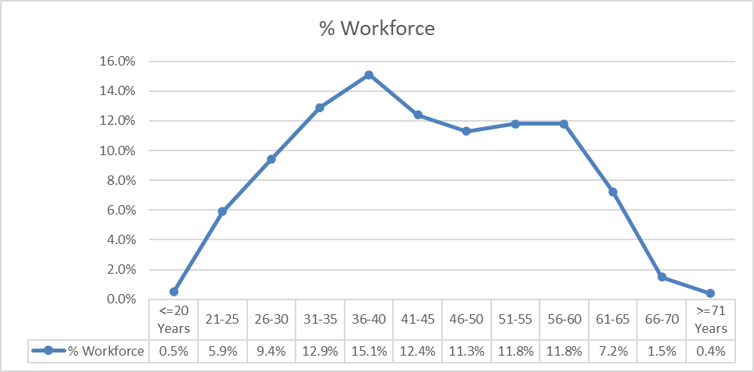

*Figure 1: Age profile of all staff at the Trust.*

**Sex**

Figure 2 below shows the distribution of the Trust’s workforce by Sex. The majority of staff across the Trust are women.

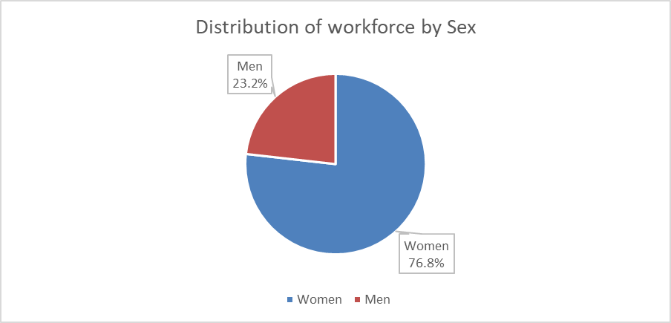

The chart below shows the distribution of men and women across the workforce, by AfC pay bands, and collectively the Medical workforce. Whilst women represent the overwhelming majority of the workforce, over 55% of the medical workforce are men. The proportion of men and women in the medical workforce is a significant contributory impact to the Trust’s Gender Pay Gap.

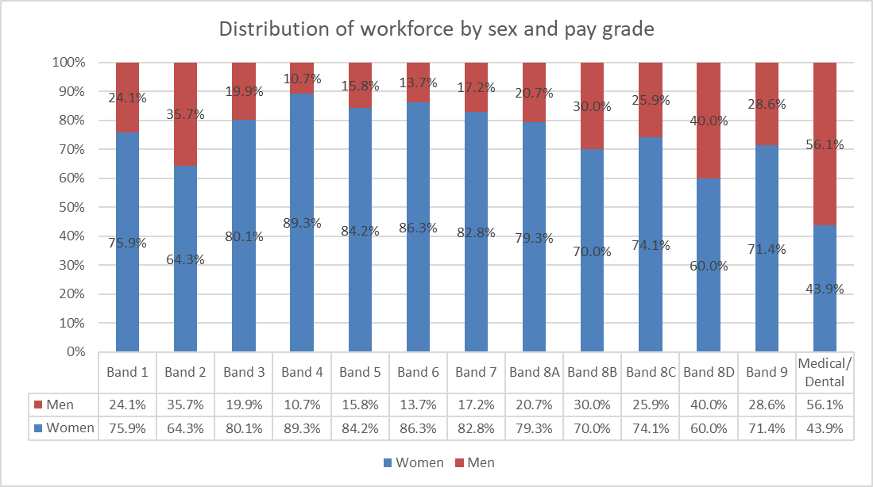

*Figure 3: Distribution of men and women across the workforce*

In addition to this report, the Trust is subject to the requirement to publish gender pay gap information, this data is provided under a separate report and will be published on the Trust web pages.

**Ethnicity**

The chart below shows the workforce composition by ethnicity. The majority of the workforce are White. There has been a small increase in the proportion of Black / Black British staff by 1.1% compared to the previous 12 months.

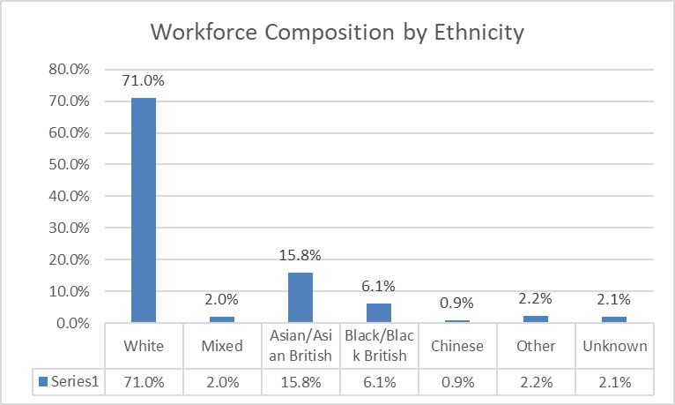

*Figure 4: Workforce composition by ethnicity*

Aggregating the data shows that 26.9% of the workforce are from Black, Asian and Minority Ethnic groups, compared to 25.6% in the previous year.

|  |  |  |
| --- | --- | --- |
|  | **% of workforce** | **% of Stockport population[1]** |
| BAME | 26.88% | 12.6% |
| White | 71.07% | 87.4% |
| Unknown | 2.05% |  |

Data from the 2021 Census shows that there has been an increase in the local BAME population (Stockport) from 7.9% to 12.6%.

The differences observed between the BAME proportions of the workforce, compared to the local population are likely to be as a result of occupational segregation (primarily the proportion of BAME staff within the medical profession), as well as a result of international recruitment.

The chart below shows the distribution of white and BAME staff cross the AfC pay bands and medical grades.

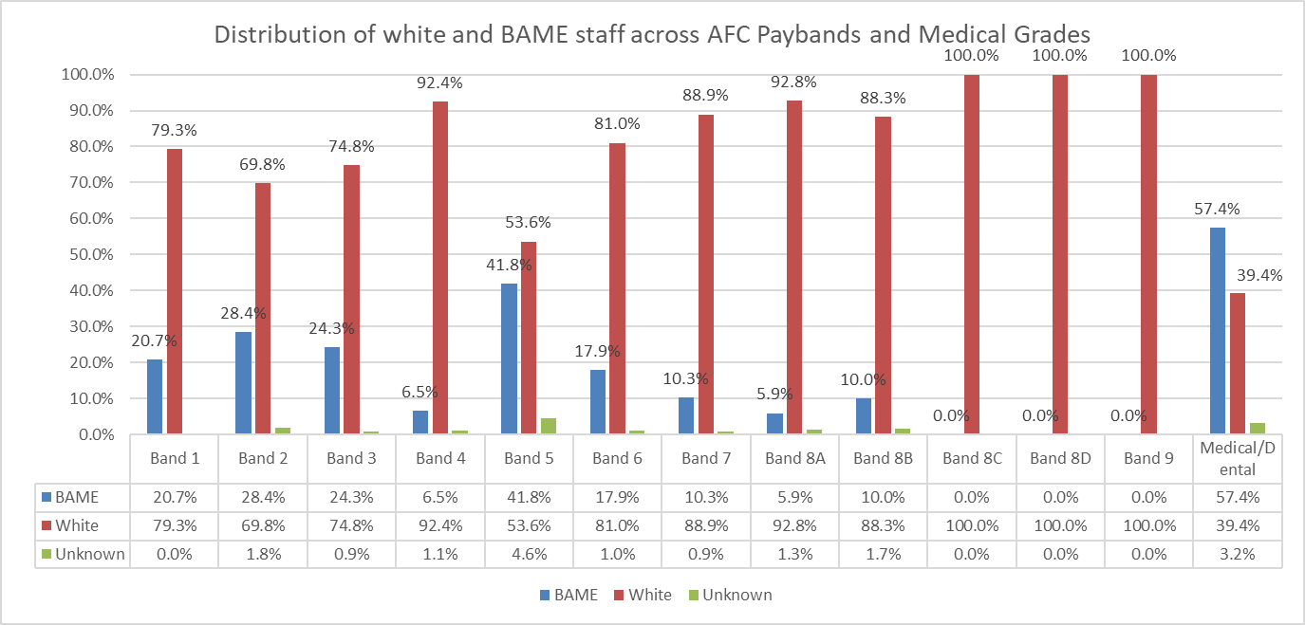

*Figure 5: Distribution of White and BAME staff across AfC pay bands and medical grades*

The table below shows the change in the proportion of BAME staff in the previous 12 months. At almost all AfC grades there has been a marginal increase in the proportion of BAME staff, however, there is still not representation at grades 8B and above. The increase at Band 5 is likely due to the impact of international recruitment. The slightly higher increases at Band 3, is likely due to significant drives in recruitment for HCA roles and as above the higher increase in the medical / dental workforce reflects the occupational segmentation.

|  |  |  |  |
| --- | --- | --- | --- |
| **Banding** | **% of BAME staff 2023** | **% of BAME staff 2024** | **Change** |
| Band 1 | 20.0% | 20.7% | +0.7% |
| Band 2 | 29.0% | 28.4% | -0.6% |
| Band 3 | 19.4% | 24.3% | +4.9% |
| Band 4 | 5.6% | 6.5% | -0.9% |
| Band 5 | 40.1% | 41.8% | +1.7% |
| Band 6 | 15.6% | 17.9% | +2.3% |
| Band 7 | 10.1% | 10.3% | +0.9% |
| Band 8A | 5.3% | 5.9% | +0.6% |
| Band 8B | 10.0% | 10.0% | No change |
| Band 8C | 0.0% | 0.0% | No change |
| Band 8D | 0% | 0.0% | No change |
| Band 9 | 0% | 0.0% | No change |
| Medical/Dental | 51.7% | 57.4% | +5.7% |

**Disability**

The chart below shows the proportion of disabled staff across the entire workforce.

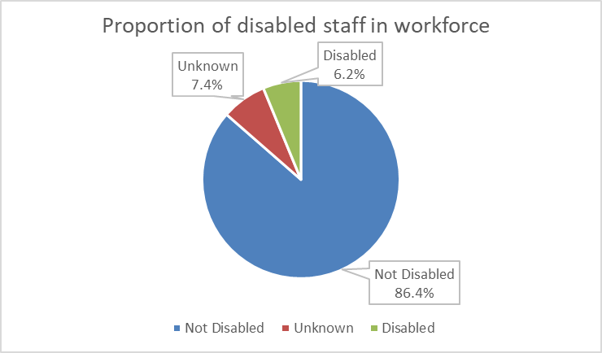

*Figure 6: Composition of workforce by disability*

There are 6.2% of staff at the Trust who have declared that they are disabled, an increase of 1.2% in the previous 12 months.

The Census 2021 data shows that 18.1% of residents of Stockport consider themselves to be disabled or have a long term health condition.

The chart below shows the distribution of disabled staff across the AfC and Medical pay bands.

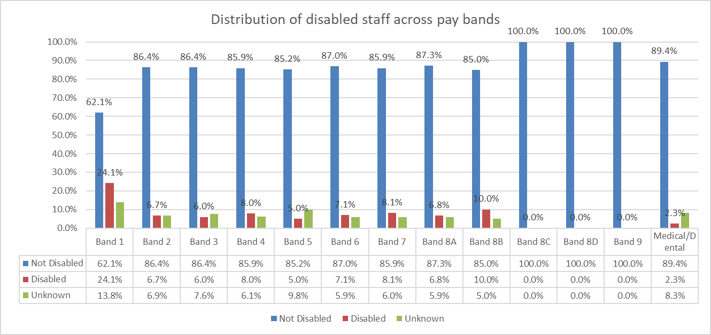

*Figure 7: Distribution of disabled staff across AfC and Medical pay bands*

In the 12 months since the publication of last year’s Workforce Equality Monitoring Report, there have been marginal increases in the proportions of disabled staff across all AfC pay bands, except for Band 8B and above where there is still no representation. The table below summarises the changes over the past 12 months. Whilst there has been a significant change in the proportion of Band 8B, the total disabled in this band is 6 members of staff.

|  |  |  |  |
| --- | --- | --- | --- |
| **Banding** | **% of disabled staff 2023** | **% of disabled staff**  **2024** | **Change** |
| Band 1 | 23.3% | 24.1% | +0.8% |
| Band 2 | 5.1% | 6.7% | +1.6% |
| Band 3 | 5.0% | 6.0% | +1.0% |
| Band 4 | 6.9% | 8.0% | +1.1% |
| Band 5 | 4.5% | 5.0% | +0.5% |
| Band 6 | 6.0% | 7.1% | +1.1% |
| Band 7 | 5.2% | 8.1% | +2.9% |
| Band 8A | 5.7% | 6.8% | +1.1% |
| Band 8B | 1.7% | 10.0% | +8.3% |
| Band 8C | 0.0% | 0.0% | No change |
| Band 8D | 0.0% | 0.0% | No change |
| Band 9 | 0.0% | 0.0% | No change |
| Medical | 1.6% | 2.3% | +0.7% |

**Sexual Orientation**

The chart below shows the distribution of sexual orientation across the workforce. 3.1% of the workforce identify as lesbian, gay or bisexual, an increase of 0.1% on the previous year.

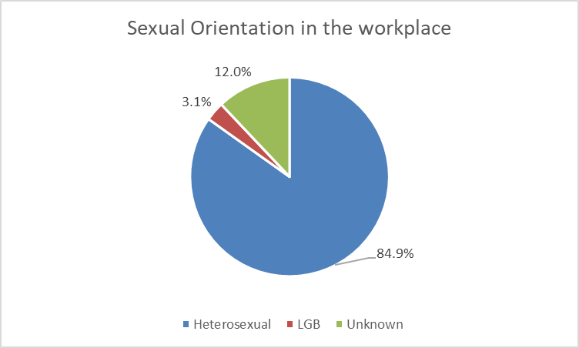

*Figure 8: Workforce composition by sexual orientation*

From the 2021 census data available for sexual orientation and gender identity, around 1.5 million people (3.2%) identified with an LGB+ orientation (“Gay or Lesbian”, “Bisexual” or “Other sexual orientation”). For Stockport this figure is 3.3%. Across England and Wales 7.5% of respondents did not answer the question and across Stockport this figure is 6.4%.

The chart below shows the distribution of staff by sexual orientation across the AfC pay bands and medical profession. Proportions remain similar to the previous 12 months.

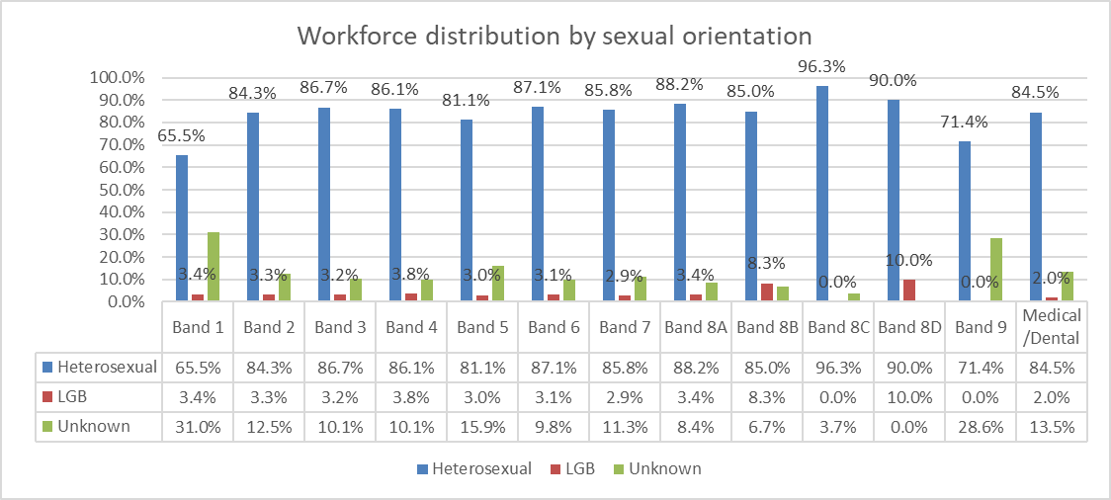

*Figure 9: Distribution of sexual orientation across AfC bands and medical workforce*

**Religion or Belief**

The chart below summarises the proportions of staff in each major religion. Just over half of the staff at the Trust identify as Christian. Of the other major world religions, 5.9% of staff are Muslim, 3.3% Hindu, 0.5% Buddhist, 0.3% Jewish and 0.2% Sikh, with very little change to the previous year.

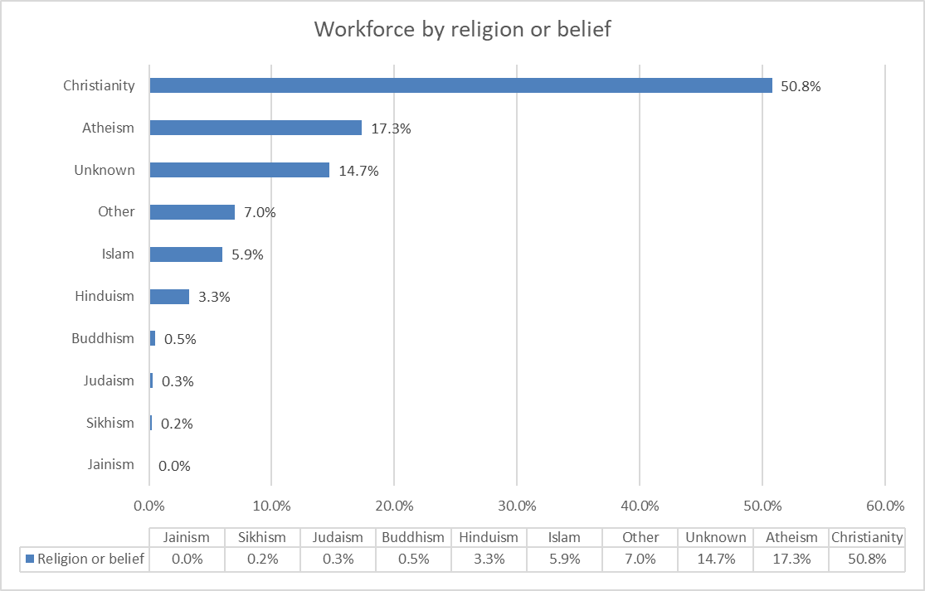

*Figure 10: Distribution of workforce by religion or belief*

**3. Recruitment Data**

Recruitment data is provided for vacancies held in the Trust’s recruitment system (Trac jobs) over a 12-month period. The following fields are provided:

* Number of applications
* Percentage of applications by relevant protected characteristic
* The number of candidates interviewed, and proportion of candidates interviewed as a percentage of applications
* The number of offers by relevant protected characteristic, and the proportion of offers made as a percentage of candidates interviewed.

In total there were 37,449 applicants of whom 3,555 were shortlisted for interview and 214 successful candidates were successfully appointed.

The following analysis shows the applications, shortlisting and successful appointments stratified by protected characteristics.

**Age**

|  |  |  |  |  |  |  |
| --- | --- | --- | --- | --- | --- | --- |
| **Age** | **Applications** | **% of all applications** | **Interviewed** | **Proportion of applicants interviewed** | **Appointed** | **% of interviewed appointed** |
| Under 20 | 386 | 1.0% | 40 | 10.4% | 2 | 5.0% |
| 20 - 24 | 4395 | 11.7% | 398 | 9.1% | 26 | 6.5% |
| 25 - 29 | 11818 | 31.6% | 664 | 5.6% | 43 | 6.5% |
| 30 - 34 | 8124 | 21.7% | 727 | 8.9% | 48 | 6.6% |
| 35 - 39 | 5558 | 14.8% | 581 | 10.5% | 35 | 6.0% |
| 40 - 44 | 3492 | 9.3% | 403 | 11.5% | 28 | 6.9% |
| 45 - 49 | 1841 | 4.9% | 297 | 16.1% | 11 | 3.7% |
| 50 - 54 | 883 | 2.4% | 184 | 20.8% | 4 | 2.2% |
| 55 - 59 | 581 | 1.6% | 156 | 26.9% | 11 | 7.1% |
| 60 - 64 | 293 | 0.8% | 93 | 31.7% | 6 | 6.5% |
| 65+ | 76 | 0.2% | 10 | 13.2% | 0 | 0.0% |
| Not stated | 2 | 0.0% | 2 | 100.0% | 0 | 0.0% |
| Total | 37449 | 100.0% | 3555 | 9.5% | 214 | 6.0% |

In total there were 37,449 applicants, of who 3,555were shortlisted for interview, and 214 successful candidates were successfully appointed. The overall rate of shortlisting from application was 6.0%. The groups less likely to be shortlisted came from the older age brackets, in spite of them making up larger proportions of applicants. Candidates aged 25-44 were generally more successful at shortlisting stage.

**Sex**

|  |  |  |  |  |  |  |
| --- | --- | --- | --- | --- | --- | --- |
| **Sex** | **Applications** | **% of all applications** | **Interviewed** | **Proportion of applicants interviewed** | **Appointed** | **% of interviewed appointed** |
| Male | 13823 | 36.9% | 1121 | 8.1% | 66 | 5.9% |
| Female | 23538 | 62.9% | 2414 | 10.3% | 147 | 6.1% |
| I do not wish to disclose | 88 | 0.2% | 20 | 22.7% | 1 | 5.0% |
| Not stated | 0 | 0.0% | 0 | 0.0% | 0 | 0.0% |
| Total | 37449 | 100.0% | 3555 | 9.5% | 214 | 6.0% |

Women make up the majority of applications, although not quite to the same proportionate composition of the Trust workforce. Women were more likely to be shortlisted than men.

**Ethnicity**

|  |  |  |  |  |  |  |
| --- | --- | --- | --- | --- | --- | --- |
| **Ethnicity** | **Applications** | **% of all applications** | **Interviewed** | **Proportion of applicants interviewed** | **Appointed** | **% of interviewed appointed** |
| White | 5395 | 14.4% | 1323 | 24.5% | 99 | 7.5% |
| Asian/Asian British | 14161 | 37.8% | 1031 | 7.3% | 54 | 5.2% |
| Black/Black British | 14755 | 39.4% | 927 | 6.3% | 38 | 4.1% |
| Mixed Heritage | 1231 | 3.3% | 105 | 8.5% | 8 | 7.6% |
| Chinese | 289 | 0.8% | 31 | 10.7% | 0 | 0.0% |
| Other | 1164 | 3.1% | 77 | 6.6% | 5 | 6.5% |
| Unknown | 454 | 1.2% | 61 | 13.4% | 10 | 16.4% |
| Total | 37449 | 100.0% | 3555 | 9.5% | 214 | 6.0% |

In the Stockport 2021 Census, Black, Asian and other Minority groups account for 12.6% of the population. However, 77% of applications made to the Trust identify as either Asian/Asian British, or Black/Black British compared with less than 15% identifying as White and other heritage classifications combined making up less than 9%.

There is a significantly disproportionate percentage of those identifying as White who are chosen to progress to interview at nearly 25% of the total – very nearly twice that of Asian/Asian British, or Black/Black British groups combined.

Disproportionality continues in the proportion of those interviewed being appointed, albeit not to the same level with 7.5% of those white people interviewed, being appointed, versus 5.2% for Asian/Asian British and 4.1% for Black/Black British.

The Code of Practice for International Recruitment was updated on 2nd August 2022. With this update, rules were strengthened regarding the recruitment of individuals from red and amber list countries via different recruitment models. NHS Trusts and collaboratives are no longer able to recruit direct applicants from these countries on behalf of other NHS Trusts. This is likely to have contributed to an increase in direct applications from overseas candidates, in part leading to the increase in the number of Black/Black British candidates. The 2023/4 pay uplift for Agenda for Change (AfC) Staff increased the entry-point Band 3 salary from £20,330 to £21,730. This now exceeds the minimum salary requirement for sponsorship via the skilled worker route. Whilst other criteria must also be satisfied, this has significantly increased the volume of roles across the NHS, for which overseas candidates requiring sponsorship can apply. To ensure a fair recruitment process, we have produced updated guidance for managers on the requirement to shortlist and interview candidates without bias related to a candidates Visa status or requirement for sponsorship. An analysis of Black/Black British applicants has confirmed that a significant number of this applicant group are from those countries referenced above, rather than domestic Black/Black British candidates.

**Disability**

|  |  |  |  |  |  |  |
| --- | --- | --- | --- | --- | --- | --- |
| **Disabled** | **Applications** | **% of all applications** | **Interviewed** | **Proportion of applicants interviewed** | **Appointed** | **% of interviewed appointed** |
| Non-Disabled | 35970 | 96.1% | 3245 | 9.0% | 189 | 6% |
| Disabled | 1167 | 3.1% | 250 | 21.4% | 13 | 5% |
| I do not wish to disclose | 262 | 0.7% | 53 | 20.2% | 3 | 6% |
| Not stated | 50 | 0.1% | 7 | 14.0% | 9 | 129% |
| Total | 37449 | 100.0% | 3555 | 9.5% | 214 | 6% |

Disabled people make up 3 % of the applications. Disabled applicants are significantly more likely to be shortlisted than non-disabled applicants. This is a result of the guaranteed interview scheme throughout the Government’s Disability Confident scheme. There is no significant difference in the appointment from interview between disabled and non-disabled candidates.

**Sexual Orientation**

|  |  |  |  |  |  |  |
| --- | --- | --- | --- | --- | --- | --- |
| **Sexual orientation** | **Applications** | **% of all applications** | **Interviewed** | **Proportion of applicants interviewed** | **Appointed** | **% of interviewed appointed** |
| Heterosexual | 35157 | 93.9% | 3251 | 9.2% | 189 | 5.8% |
| Lesbian and Gay | 390 | 1.0% | 63 | 16.2% | 5 | 7.9% |
| Bisexual | 596 | 1.6% | 85 | 14.3% | 4 | 4.7% |
| Unknown | 1306 | 3.5% | 156 | 11.9% | 16 | 10.3% |
| Total | 37449 | 100.0% | 3555 | 9.5% | 214 | 6.0% |

Over the last year the proportion of LGB applicants has reduced to 2.6%, below the 3.3% 2021 Census date for Stockport. However, Lesbian, Gay and Bisexual applicants were significantly more likely to be shortlisted for interview than heterosexual applicants.

**Religion or Belief**

|  |  |  |  |  |  |  |
| --- | --- | --- | --- | --- | --- | --- |
| **Religion or belief** | **Applications** | **% of all applications** | **Interviewed** | **Proportion of applicants interviewed** | **Appointed** | **% of interviewed appointed** |
| Atheism | 1923 | 5.1% | 448 | 23.3% | 27 | 6.0% |
| Buddhism | 700 | 1.9% | 24 | 3.4% | 5 | 20.8% |
| Christianity | 20183 | 53.9% | 1895 | 9.4% | 106 | 5.6% |
| Hinduism | 5357 | 14.3% | 236 | 4.4% | 13 | 5.5% |
| Islam | 6476 | 17.3% | 452 | 7.0% | 27 | 6.0% |
| Jainism | 8 | 0.0% | 0 | 0.0% | 0 | 0.0% |
| Judaism | 32 | 0.1% | 7 | 21.9% | 0 | 0.0% |
| Sikhism | 90 | 0.2% | 11 | 12.2% | 0 | 0.0% |
| Other | 1056 | 2.8% | 223 | 21.1% | 17 | 7.6% |
| Unknown | 1624 | 4.3% | 259 | 15.9% | 19 | 7.3% |
| Total | 37449 | 100.0% | 3555 | 9.5% | 214 | 6.0% |

The overall rate of shortlisting is 9.5%. Those groups with a higher chance of being shortlisted include Jewish, Atheists and Sikhs (although the numbers of Jewish and Sikh applicants are small). At appointment, Atheists, Christians and Muslim applicants had a higher rate of appointment. Buddhists had a higher proportion of appointments (although the interview numbers are very small).

**4. Staff Leavers and Turnover**

**Age**

The table below shows the number of employees within each age bracket, the number of leavers in the same age brackets, and the staff turnover for each group. The overall annual staff turnover for the Trust was calculated at 13.6%, compared to 14.6% in the previous year.

The rate of staff turnover is highest amongst the youngest age groups and the 66-70 age group, the former recognises the level of career mobility within these age groups, and the latter retirement.

|  |  |  |  |
| --- | --- | --- | --- |
| **Age** | **No of Staff** | **Leavers** | **Turnover** |
| <=20 Years | 31 | 7 | 22.6% |
| 21-25 | 371 | 71 | 19.1% |
| 26-30 | 595 | 142 | 23.9% |
| 31-35 | 815 | 116 | 14.2% |
| 36-40 | 959 | 131 | 13.7% |
| 41-45 | 783 | 71 | 9.1% |
| 46-50 | 718 | 53 | 7.4% |
| 51-55 | 745 | 61 | 8.2% |
| 56-60 | 745 | 93 | 12.5% |
| 61-65 | 457 | 76 | 16.6% |
| 66-70 | 93 | 37 | 39.8% |
| >=71 Years | 27 | 2 | 7.4% |
| **TOTAL** | **6339** | **860** | **13.6%** |

**Sex**

The table below shows the number of men and women employed by the Trust and the number of leavers and staff turnover. There is no material significant difference in the rate of turnover between men and women.

|  |  |  |  |
| --- | --- | --- | --- |
| **Sex** | **No. of Staff** | **Leavers** | **Turnover** |
| Women | 4868 | 640 | 13.1% |
| Men | 1471 | 220 | 15.0% |
| **TOTAL** | **6339** | **860** | **13.6%** |

**Ethnicity**

The table below shows the workforce by ethnicity, number of leavers and rate of staff turnover by group.

|  |  |  |  |
| --- | --- | --- | --- |
| **Ethnicity** | **No of Staff** | **Leavers** | **Turnover** |
| **Asian/Asian British** | 1004 | 154 | 15.3% |
| **Black/Black British** | 385 | 56 | 14.5% |
| **Chinese** | 54 | 8 | 14.8% |
| **Mixed Heritage** | 124 | 17 | 13.7% |
| **Other ethnic group** | 139 | 25 | 18.0% |
| **Unknown** | 134 | 28 | 20.9% |
| **White** | 4499 | 572 | 12.7% |
| **TOTAL** | **6339** | **860** | **13.6%** |

The rate of turnover of staff from Other Ethnic Group and Asian/Asian British heritage were the highest, whereas the turnover rate for mixed heritage staff was the lowest.

**Disability**

The table below shows the number of disabled staff, disabled leavers and turnover rate.

|  |  |  |  |
| --- | --- | --- | --- |
| **Disability** | **No of Staff** | **Leavers** | **Turnover** |
| **Disabled** | 394 | 47 | 11.9% |
| **Not Disabled** | 5479 | 753 | 13.7% |
| **Unknown** | 466 | 60 | 12.9% |
| **TOTAL** | **6339** | **860** | **13.6%** |

The turnover rate for non-disabled staff was higher than that for disabled staff, at 11.9% compared to 13.7% for non-disabled.

**Sexual Orientation**

The table below shows all staff by sexual orientation, leavers and turnover rate. The data shows that the turnover rate for LGB staff is significantly higher that for heterosexual staff (21.8% compared to 12.9%).

|  |  |  |  |
| --- | --- | --- | --- |
| **Sexual Orientation** | **No of staff** | **Leavers** | **Turnover** |
| **Heterosexual** | 5379 | 694 | 12.9% |
| **LGB** | 197 | 43 | 21.8% |
| **Unknown** | 763 | 123 | 16.1% |
| **TOTAL** | 6339 | 860 | 13.6% |

**Religion or Belief**

The table below shows the workforce by religion or belief, number of leavers and rate of staff turnover by group.

|  |  |  |  |
| --- | --- | --- | --- |
| **Religion** | **No of staff** | **No of leavers** | **Turnover** |
| **Atheism** | 1098 | 154 | 14.0% |
| **Buddhism** | 30 | 5 | 16.7% |
| **Christianity** | 3218 | 425 | 13.2% |
| **Hinduism** | 207 | 34 | 16.4% |
| **Islam** | 377 | 67 | 17.8% |
| **Jainism** | 0 | 1 | 0.0% |
| **Judaism** | 18 | 0 | 0.0% |
| **Sikhism** | 15 | 0 | 0.0% |
| **Other** | 445 | 54 | 12.1% |
| **Unknown** | 931 | 120 | 12.9% |
| **TOTAL** | **6339** | **860** | **13.6%** |

The highest rate for turnover is Muslim colleagues. Other significant rates for turnover are Buddhists, Hindus and Atheist staff.

**5. EDI Activity During the Monitoring Period**

In the last 12months, we have had a specific focus on the following areas to help accelerate the progress of our EDI journey:

**Inclusive recruitment**

Progressing the collaborative work we are doing with Tameside FT we have:

* Created stronger links with local community groups and are continuing to enhance our reach around recruitment.
* Enabled candidates to apply for a job vacancy using an alternative method to Trac.
* Started to provide all candidates with additional information about the interview they are invited to attend and supplied the questions that will be asked, prior to the day of the interview. The aim is to help individuals with a neurodivergent condition to prepare meaningful responses to the questions and alleviate any feelings of anxiety about the interview. So far we have received positive feedback from candidates about this approach.
* Continued to maximise our social media presence to promote careers and job vacancies.
* Introduced processes to enable our job adverts to reach marginalised groups.
* Enhanced the support for volunteers who are seeking paid employment.

**Becoming an anti-racist organisation**

Through the actions incorporated in the consolidated plan, relating to becoming an anti-racist organisation, we have:

* In conjunction with the Race Equality Staff Network (RESN) network, we have developed an organisational anti-racism statement, which was approved by the Executive Management Team and has been published on the Trust’s website.
* Appointed a Non-Executive level anti-racism champion, combining the role with our RESN sponsor.
* Established a cross divisional WRES working group, in order to examine divisional level data, and to provide appropriate challenge, and develop local actions. This work will be further enhanced by the publication of our EDI dashboard.

**Understanding the lived experience of our colleagues**

Recognising that the staff survey data provides us with largely quantitative data in relation to the lived experience of our colleagues, we have:

* Held listening events with all our staff networks. Their feedback has shaped the focus/theme of their network meetings for the 12 months ahead.
* Held a series of curiosity cafes during July and August 2024. The theme was focused on staff's lived experience of career progression within the Trust. Despite only a few employees attending the sessions we gained helpful insights which is now informing the action plan of the Career Progression Task Group.

**Career progression**

               Recognising the career progression remains an area of inequality that requires addressing, we have:

* Established a Career Progression Task Group to add additional pace to this element of our work.
* Developed a mechanism to identify specific inequality within promotion and progression. This data will routinely be reported in the annual EDI monitoring report and is being proactively used by the career progression for all working group, to ensure that interventions are appropriately targeted.

**Bullying and harassment**

Recognising that sadly some individuals are on the receiving end of unacceptable behaviour and the negative impact that has on them and others, we have:

* Started to review our internal conduct process, which incorporates learning from internal review, peer review and insights from legal services. This is a collaborative development with Tameside NHS FT to update action plan in relation to learning.
* Appointed FTSU champions to support the work of the FTSU Guardian.
* The next round of curiosity cafes will focus on the lived experience of colleagues, through the theme of bullying and harassment.
* Launched a sexual safety pilot training programme in October 2024 that will run until December 2024. The pilot includes ‘Responding to a First Disclosure’ half-day training sessions and sexual harassment in the workplace sessions. The pilot will be evaluated to inform roll-out plans.

In addition the above we have also:

* Started to develop a new EDI dashboard which will provide more frequent updates on our key EDI metrics.
* Appointed Board level sponsors to our staff networks, including the appointment of a Non- Executive to sponsor our Race Equality Staff Network.

1. [Ethnic group, England and Wales - Office for National Statistics (ons.gov.uk)](https://www.ons.gov.uk/peoplepopulationandcommunity/culturalidentity/ethnicity/bulletins/ethnicgroupenglandandwales/census2021)