Dementia Friendly Art Book Competition

People living with dementia can be disorientated, anxious and scared, and being in an unfamiliar environment this can heighten these feelings. They can also feel helpless, bored and frustrated.
Having an activity to do can really help someone living with dementia feel useful, engaged, safe and have a purpose. When someone feels calmer and safe they are more likely to eat and drink better, which can also help reduce the risk of falls, and help them engage in other activities such as Physio and Occupational Therapy assessments and treatment. They are less likely to be agitated and aggressive.

Art can play an important role in this. This is why I am starting a competition for budding artists , both those working for Stockport NHS Foundation Trust and also the wider public too; basically anyone who would like to be involved.

I want to make a Stockport NHS Foundation Trust Dementia Friendly Art Book. My challenge to you is to draw an A4 size picture with clear black outlines that a person living with dementia could use to colour in. These drawings need to be clear and not too detailed. The artwork can be either a picture of a scene or a pattern.

The best drawings will be added into this art book which will be available to patients in both the hospital and the community. The art book will be a free resource for people living with dementia who are in our care in the hospital or the community.

A gift voucher for the three best drawings is up for grabs, as well as all the winning drawings being part of this wonderful art book which we will offer patients living with dementia. If permission is granted, each artist will be named in the book.

Please either email your drawings AND contact form to ruth.terry@stockport.nhs.uk or post to Ruth Terry, Birch House, Stepping Hill Hospital, Poplar Grove, Stockport, SK2 7JE by the closing date of 17th January 2022. Winners will be announced on 28th January 2022.

Each drawing requires a contact form to be completed and attached – without a contact form the drawing will not be able to enter into the competition.

For further information please do not hesitate to contact the Matron for Dementia Care Ruth Terry ruth.terry@stockport.nhs.uk or 0161 419 5637

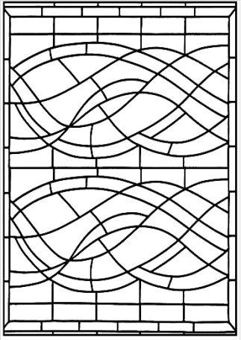

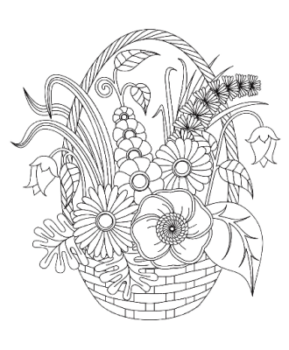

Dementia Friendly Art Book Competition- Contact Form

Name: _________________________________________________________________

Tel:____________________________________________________________________

Age:____________________________________________________________________

Email address:___________________________________________________________

Address:________________________________________________________________

_______________________________________________________________________

Postcode:_______________________________________________________________

Where did you hear about the competition?

 | Tick |  | Tick
Twitter |  | Facebook
Staff email |  | Stockport NHS Foundation comms
School/college |  | Pennine Care
Friend or family member |  | Other (please specify)

If you are a winner do you give Stockport NHS Foundation Trust permission to print your name in the art book Yes/No

Please complete the form AND send it with your drawing(s) to Ruth Terry, Matron for Dementia, Birch House, Stockport NHS Foundation Trust, Poplar Grove, Stockport, SK2 7JE or ruth.terry@stockport.nhs.uk

Each drawing requires a contact form to be completed and attached – without a contact form the drawing will not be able to enter into the competition.

