

Freedom To Speak Up Champions

Freedom to Speak Up is vital to us as an NHS trust. When people speak up, everyone benefits. Building a more open culture, in which leadership encourages learning and improvement, leads to safer care and treatment and improved patient experience.
Our Champions are guides for anyone considering raising concerns or speaking up about workplace issues. They provide confidential advice, signposting, and support but do not hold a case load.
To connect with our Champions, simply send them an email. They are here to assist and ensure that your concerns are heard and that you feel supported.
The following are our Freedom To Speak Up Champions at work in Stockport NHS Foundation Trust. They are available for you to contact. Their contact details, and information from each about their involvement is below.
Let's make Stockport NHS Foundation Trust a place where every voice counts. Our Speak Up Champions are here to empower you.

Donna Davenport - Professional Nurse Advocate & Specialist Practice Facilitator, District Nursing

E-mail: donna.davenport@stockport.nhs.uk
I have chosen to be a FTSU Champion because I am passionate about supporting staff at all levels to feel they have a voice, and can advocate for and on behalf of patients and their families to receive the best care.
In my roles as a DN Facilitator, Professional Nurse Advocate (PNA) and Mental Health First Aider (MHFA), I support staff daily to build their resilience and courage to feel enabled to speak up so becoming a FTSU Champion is an effective way of enhancing these skills further.
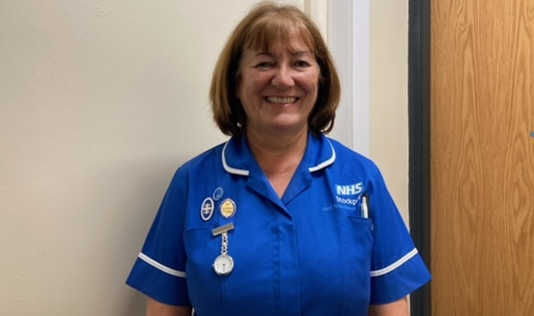

Dawn Welsford - Clinical Auditor
E-mail: dawn.welsford@stockport.nhs.uk

I believe that staff should feel they are safe to speak out at work about any issue or matter that may concern them. Staff should feel safe and comfortable in the knowledge they have support available should they need it. Only by speaking openly can we hope to learn and improve. As a Speaking Up Champion, I hope to support the structure and process needed to deliver the values and behaviours required of the service.
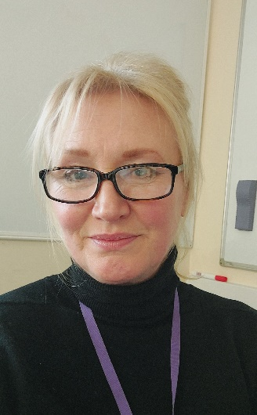
Jayn Seedhouse - Practice Development and Education Lead –
E-Mail: Nicola.Seedhouse@stockport.nhs.uk
I believe it is important that colleagues speak out so that we can improve our service, retain, and support staff members as well as learners, ensure patient safety and promote a culture that supports colleagues to feel valued heard and safe at work.
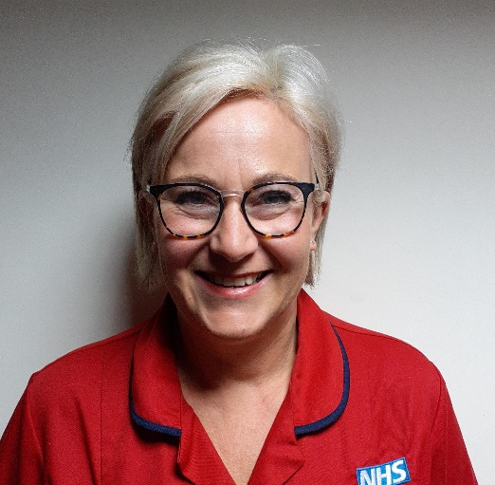

Rachel Hall - Digital Nurse
E-mail: rachel.hall2@stockport.nhs.uk
I am looking forward to being part of the FTSU Champions in promoting an effective freedom to speak up culture across the Trust, supporting individuals who may not feel confident in speaking up. I feel it is invaluable to foster a culture of openness, honesty and supporting the goal of a happy workplace for all staff, including external staff who visit our Trust.



João Ferreira - Specialist Cardiac Physiologist
E-mail: joao.ferreira@stockport.nhs.uk
I believe all staff should feel at ease raising concerns when issues arise and be encouraged to have their voices heard. My goal is to offer a safe and comfortable space to empower all colleagues through this journey as this can have such a great impact in trust and overall morale in the NHS.

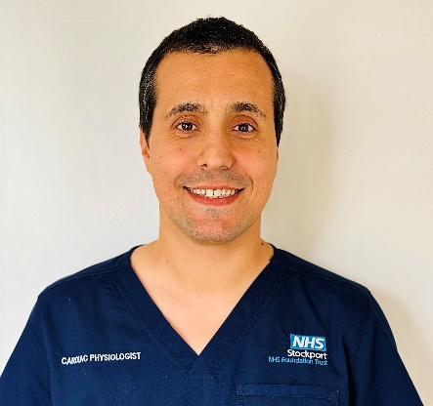

Gail Platt - Medical Examiner Officer
E-mail: Gail.Platt@stockport.nhs.uk
My name is Gail and I am based in the Medical Examiner’s Office. I have a real belief in equality and fairness within the workplace and feel that all staff should have the ability to be listened to, and have the confidence that concerns raised will be directed safely by the FTSU Champions for the best support available.
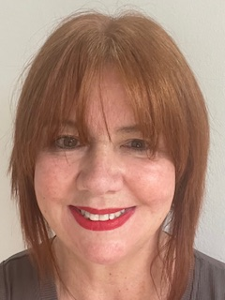

Kirstie Doyle - Lead CPF for integrated/acute care
Email: Kirstie.Doyle@stockport.nhs.uk
My name is Kirstie Doyle, I am the Lead Clinical Practice Facilitator for Acute care. I have chosen to be a speak up champion as I passionately believe that all staff members should feel valued and heard in their place of employment. By working together, we can ensure that Stepping Hill Hospital is an inclusive and rewarding workplace.
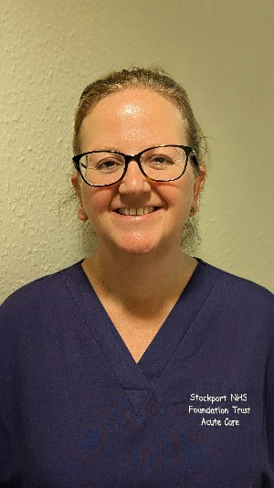

Victoria Rankin -Deputy IT Procurement and Business Lead
Email: Victoria.Rankin@stockport.nhs.uk
I’ve worked for the Trust for 8 years in the Digital Technology Services (IT) Dept. I took up the role of Freedom to Speak up Champion as I believe it’s extremely important for everyone to have a voice and to feel confident in speaking up about issues that concern them. I’m hoping to get to know lots more colleagues through this role and I welcome anyone who would like to discuss any issues and hopefully make a great impact. We are looking to build a positive movement and give everyone to the opportunity to feel safe, secure and comfortable in their job role.


Sarah Heaney – Health Visitor Team Lead
E-Mail: sarah.heaney@stockport.nhs.uk
Hi my name’s Sarah and I’m passionate about making a difference. I’m open and friendly and through my current role working as a health lead within the MASSH can see how important honesty and transparency supports secure relationships. I chose to be a freedom to speak up champion as believe everyone should have a voice. It is essential in maintaining excellent quality of care through an engaged, supported workforce. My motto will always be happy staff, happy people!


