**Prompt card for Falls Holistic Assessment and Care Plan**

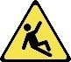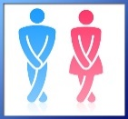http://www.clker.com/cliparts/3/0/3/8/1194986541442028018ear_-_body_part_nicu_buc_01.svg.hi.png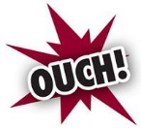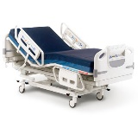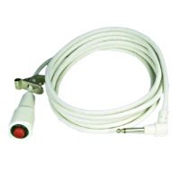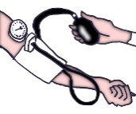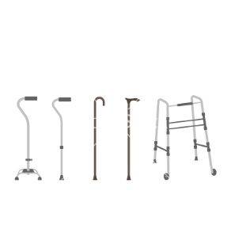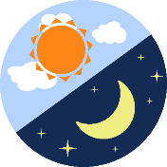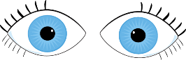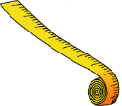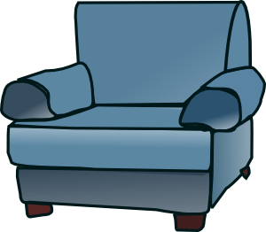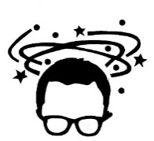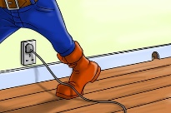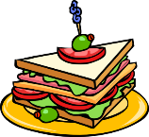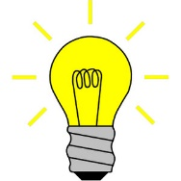

**Fall hazard sign & Wristbands**

**Hearing**

**Pain**

**Observational Beds**

**MCA Cognition  
Defined Diagnosis  
of Dementia**

**Call Bells**

**Alarms/ Bedrails**

**Learning Difficulties**

**Home Environment**

**Dizziness**

**Furniture Height**

**MOOD**

**Vision**

**Wires**

**Bladder Urgency**

**Lighting**

**Blood Pressure**

**Food and Drink**

**Walking equipment**

**Balance**

**Time of day**

Could this have been prevented?

Documentation 🡪 What’s my plan? 🡪 Falls Template and Care Plan

How can my input be evidenced?

What am I going to do about it?

What has happened?

Need to discuss with,,,

http://i.ebayimg.com/00/s/NDI1WDQyNQ==/z/emwAAMXQLs5RoMbx/$T2eC16FHJFoE9nh6m++HBRoMb)VT+Q~~60_35.JPG

**Toiletry Needs**

**Medication**

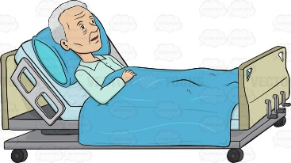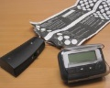

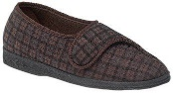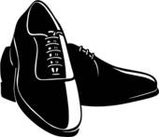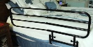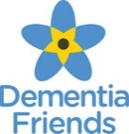

**Shoes/  
Slipper Project**