

|  |  |  |  |  |
| --- | --- | --- | --- | --- |
| **Standard Operating Procedure for the Management and Prevention of In-Patient Falls, including use of bed rails** | | | | |
| State whether the document is: **🗹 Trust wide**  **□** Business Group  **□** Local | | | **State Document Type:**  **□** Policy  **🗹 Standard Operating Procedure**  **□** Guideline  **□** Protocol | |
| APPROVAL / VALIDATION | | | Chair Approval by Assistant Director of Nursing on behalf of Falls Group | |
| DATE OF APPROVAL / VALIDATION | | | November 2016 | |
| INTRODUCTION DATE | | | November/December 2016 | |
| DISTRIBUTION | | | Hospital Falls Group  Risk & Safety Microsite  Governance Leads, Business Groups | |
| REVIEW | | | **Original Issue Date**  2004  **Review Date**  November 2018 | |
| CONSULTATION | | | Manufacturer/Supplier  EBME  Falls Group  Finance & Supplies | |
| **EQUALITY IMPACT ASSESSMENT**  (Tick) | | | **□** Screening  **🗹** Initial  **□** Full  **□** Not Applicable as Guidance | |
| **RELATED APPROVED TRUST DOCUMENTS** | | | Staff Falls SOP  Bed/Chair Sensor Alarms SOP  Low Profiling Beds Standard Operating Procedure  Incident Reporting & Management Policy  Risk Assessment Procedure  Risk Register Procedure  Mandatory Training SOP  MHRA Device Bulletin – DB2006(06) v 2.0  NPSA Alert regarding Bed Rails  NICE Guideline 161 – Falls : Assessment and Prevention of Falls in Older People  NICE Quality Standards QS86 – March 2015 | |
| **AUTHOR/FURTHER**  **INFORMATION** | | | Christine Gidley, ADNS – extension 4970 | |
| **THIS DOCUMENT REPLACES** | | | Version 9 – August 2014 | |
| **Document Change History:** | | | | |
| **Issue No** | **Page** | **Changes made**  (include rationale and impact on practice) | | **Date** |
| Version 5 |  | Changes in line with NHSLA and new Policy on Policies | |  |
| Version 5 Rev 1 | All | Changes regarding training, awareness, and risk assessment | | October 2010 |
| Version 6 | ALL | Changes in line with NHSLA and to Falls Risk Assessment Document | | October 2011 |
| Version 7 | ALL | Changes in line with Community Services/NHSLA, Post Fall Actions | | October 2012 |
| Version 8 | ALL | Changes re. new combined Falls Risk/Bed Rails Form and assessment process  Changes re. incorporation of bed rails | | December 2012 |
| Version 9 | ALL | Changes re. process, new NICE guideline, Lying and Standing BP, Neurological Observations, 1:1 Staffing due to Falls, update of assessment form/care plan | | August 2014 |
| Version 10 | All | Full review of SOP | | November 2016 |

**1. INTRODUCTION/PURPOSE OF THE DOCUMENT**

Patient safety is a key focus, especially when providing care and services to older persons. Falls are a particular clinical concern because of the frequency at which they can occur and also because of the physical, psychological and social consequences. Falls and fall-related injuries are a common and serious problem for older people, particularly those who have underlying pathologies or conditions. Falls are a major cause of disability and the leading cause of mortality resulting from injury in people aged 75 and older in the UK. (NICE Quality Standards – March 2015)

People aged 65 and older have the highest risk of falling. Around 30% of adults who are over 65 and living at home will experience at least one fall per year. This rises to 50% of adults over 80 who are either at home or in residential care. (NICE Quality Standards – March 2015)

Bed rails should only be used to reduce the risk of a patient accidentally slipping, sliding, falling or rolling out of bed. Bedrails used for this purpose are not a form of restraint. Restraint is defined as ‘the intentional restriction of a person’s voluntary movement or behaviour’.

Bed rails will not prevent a patient leaving their bed and falling elsewhere, and should not be used for this purpose. Bed rails are not intended as a moving and handling aid.

Patients in hospital may be at risk of falling from bed for many reasons including poor mobility, dementia or delirium, visual impairment, and the effects of their treatment/medication.

Bed rails are not appropriate for all patients, and using bed rails also involves risk. For patients who can mobilise without help from staff, bedrails may create a barrier to independence. They may also create a greater risk of falls and injury for patients who are both confused enough and mobile enough to climb over them

**2. STATEMENT OF INTENT / SCOPE OF THE DOCUMENT**

This Standard Operating Procedure applies to all those working in the Trust, in clinical areas, and in community settings. A failure to follow the requirements of the policy may result in investigation and management action being taken as considered appropriate. This may include formal action in line with the Trust's disciplinary or capability procedures for Trust employees; and other action in relation to other workers, which may result in the termination of an assignment, placement, secondment or honorary arrangement.

**3. SUMMARY OF THE DOCUMENT**

This document will detail the standard operating procedure for assisting in the prevention and management of in-patient falls including use of bed rails.

**4. DEFINITIONS**

There are many definitions of falls within Healthcare. However, it is important to identify a practical definition that is workable in the clinical setting, as the current lack of concerns has lead to fast differences in auditing and researching the numbers of falls.

**FALL** – A fall is an unplanned/unintentional descent to the floor, with/without injury, regardless of cause (National Patient Safety Agency).

Falls can originate at one of two levels, ground level and from a height. There is not regulatory height specified in the “The Work at Height Regulations 2005” but the following definition:- “A place is ‘at height’ if a person could be injured falling from it, even if it is at or below ground level”.

**SLIP** – A slip is to slide accidentally causing the patient to lose their balance, this is either corrected or causes a patient to fall. (adapted from COED 2000)

**TRIP**  - A trip is to stumble accidentally often over an obstacle causing the patient to lose their balance, this is either corrected or causes a patient to fall (adapted from COED 2000)

**Near Miss** – If a patient is placed on a low profiling bed (due to high falls risk), and rolls onto the crash mat, this is a near miss and should be reported using the Trust Incident Form.

**Change in Condition** – For example if the patient improves and starts to mobilise, following an operation, or if the patient deteriorates.

**Bed Rail -** A piece of equipment attached to the side(s) of a bed to reduce the risk of patients rolling, slipping, sliding or falling out of bed. These are also sometimes referred to as cot sides, bed side rails, side rails and bed guards. They should not be confused with bed grab handles which are designed to aid getting in and out of bed and movement whilst in bed. Bed grab handles are not designed to prevent patients falling from bed, and should not be used as bed rails (MDA 2001).

**Pressure Relief Equipment -** Any equipment placed on top of the bed base or on top of the current mattress in situ. This equipment is used for pressure relief to reduce the risk of ulcers.

**Entrapment -** This is a situation which may occur when any part of the patient’s body becomes caught or trapped between the mattress and the bed rail or between the gap of the head/foot board and the mattress.

**Bed Accessories -** Any equipment that can be added or attached to a bed (eg. Pressure relief mattress/overlay, grab rail, bed rail protectors, mattress variator, electric profiling bed controls).

**5. ROLES & RESPONSIBILITIES**

**Chief Executive**:

Has overall accountability and is responsible for ensuring that there are appropriate processes in place for the prevention and management of patient falls, including bed rails. This is also delegated to the Director of Nursing and Midwifery.

**Director of Nursing and Midwifery:**

Is responsible for ensuring that the Trust has comprehensive policies/standard operating procedures for the prevention and management of falls, including bed rails. Development of an effective implementation strategy and ensuring monitoring arrangements are in place.

**Assistant Director of Nursing:**

* Will oversee on behalf of the Director of Nursing and Midwifery, the day to day responsibility for the management of falls, including bed rails.
* Chair the meetings of the Falls Group on a bi-monthly basis.
* To ensure that the falls prevention and management SOP is implemented.

**Business Groups/Heads of Nursing/Governance Leads:**

* Ensure all staff in their area are made aware of this procedure and know their responsibilities.
* All relevant staff have received training in the implementation of the procedure.
* Are sufficient resources allocated for this procedure’s implementation.
* Monitor the implementation in the area, developing action plans for any short falls identified.
* Ensure all incidents are reviewed and action plans in place.
* Conduct Falls Spot Audits as and when required.

**Ward Sister/Department Manager/Matrons:**

* Will share the responsibility with Business Group for their area of concern.
* Day to day implementation of this procedure.
* Undertake risk assessments where there is any significant falls risk, including bed rails.
* Ensure appropriate equipment is utilised to reduce risk.
* Provide, maintain and monitor the work environment to ensure safety.
* All staff have received training in falls management and prevention.
* Incidents relating to falls/bed rails are reported on the Trust incident reporting system, actions reviewed, ensure lessons learnt. Assist in undertaking investigations of serious incidents.

**Risk & Safety Team:**

* Work with the Assistant Director of Nursing on the day to day management and prevention of falls, including bed rails.
* Assist in the implementation and review of Trust initiatives to assist in the management and prevention of falls.
* Undertake a falls prevention and management training programme.
* Obtain information from the Datix System in relation to incidents and risks, and provide to the Assistant Director of Nursing in order to produce reports as and when required.
* Maintain the database for recording of serious incidents requiring investigation.

**Medical Staff:**

Will conduct and document a full review of each patient following a fall in a timely manner and complying with the post fall action chart detailed later in this document – Appendix 1

**All Staff:**

* Adhere to the falls policies and procedures and follow the guidance on falls risk assessments.
* Ensure that they have received training in falls management and prevention, including bed rails.
* Report any falls/issues relating to bed rails through the incident reporting system.
* Ensure falls risk assessments are undertaken and reviewed and the agreed review times.

**In-Patient Falls Group**:

The In-Patient Falls Group will meet on a bi-monthly basis and receive reports on all matters relating to the Trust’s Fall Prevention Strategy. The Group will be responsible for taking any appropriate action. The in-patients falls group receives a full review of incidents and risk register report.

**6. THE STANDARD OPERATING PROCEDURE**

**Prevention**

Ward Sisters should review the environment and organisation of their area to reduce the risk of falls to the lowest possible level. To assist in this all wards and departments complete a hazard inventory every 2 years.

* All seating/beds should be assessed to ensure that the bed/chair is at the correct height and in good working condition (i.e., brakes working and on where appropriate).
* Prior to mobilising a patient, foot wear should be checked/assessed to ensure appropriateness. (i.e. well fitting slippers/shoe with a back). If uncertain as to what is appropriate, contact the Physiotherapist/Occupational Therapist/Age UK for Slipper Project. – See Appendix 2
* Staff should be vigilant and identify any potential hazards and where appropriate, move them, or if this is not possible ensure that the patient is aware and supervised.
* Safe staffing levels should be maintained at all times at all times. Concerns regarding this should be raised with Business Group Management.
* Where possible all patients must be orientated to the ward/department.
* Ensure bed areas are kept clear of clutter or items that may be hazardous or increase the risk of falling
* Ensure spills are cleaned up immediately.
* Use of appropriate signage to warn people of hazards and/or arrange alternative passage.
* Position equipment to avoid cables crossing pedestrian routes.
* Ensure that lighting is appropriate for the environment and the patient activity.
* If a patient walks with walking aids, ensure that these are positioned within the vicinity of the patient, and stored appropriately following use.

**Assessment**

* All adult in-patients should be assessed upon admission using the Trust Falls Risk Assessment including Bed Rails (See Appendix 3) taking into account the following two points below:
* All Adult patients who are classed as “majors” in ED should be assessed using the Trust Falls Risk Assessment – Screen questions. If patient identified at risk of falls, actions to be identified and documented in the patient notes. Also to be communicated when transferring a patient to the ward.
* Maternity Patients are excluded from this Policy, however a screening question is asked at every antenatal booking and on admission in labour, if women have not booked for antenatal care at Stockport to identify those women who have mobility/disability issues so that an individualised care plan can be written.
* For District Nursing – a falls risk assessment is completed and this can be found in Appendix 4. Actions taken to reduce risk of falling to be documented in the patient notes.
* If a patient is transferred to another ward, and identified at risk of falls, the handover should include actions taken on the previous ward to reduce falls, and continued on the receiving ward. Following this, the falls risk assessment should be carried out immediately (no later than within 6 hours) as part of the nursing assessments, as the layout, observation etc. may be very different from the previous ward, and may require different interventions to be implemented for the patient.
* The Falls Risk Care Plan includes consideration of whether the patient is at risk of falls from height, and preventative measures to be implemented as applicable (eg. Bed to be in lowest position, use of electric bed, or use of a low profiling bed).
* This assessment and any subsequent re-assessments must be documented in the patient’s records and reviewed at the appropriate times:

The Falls Risk Assessment asks four Screening Questions (refer to Falls Risk Assessment in Appendix 3) these should be completed on admission/transfer.

If any of the answers to the screening questions are Yes, the falls risk care plan must be completed, including the bed rails assessment.

If any of the answers to the screening questions are No, no further action is required, unless clinical condition changes, after a fall, on transfer, or to be reviewed weekly.

* The assessment must be dated and timed.

**Strategy**

* Once a patient has been assessed at risk, the falls risk care plan must be completed and the relevant nursing interventions implemented, by stating Yes (implemented), or No (not required), or a comment.
* All staff working on the ward or department should be informed of those patients who are at risk. This will be undertaken at hand over and during safety huddles.
* If any patient is transferred to another ward or department, whether temporarily or permanently, then this information must be passed on to the receiving area. The risk assessment would also be undertaken on transfer by the new ward.
* It is paramount to ensure that all documentation is accurate.
* The patients should be assessed/re-assessed using the falls risk assessment form.
* All staff working within the Trust should be made aware of the guidelines, especially in a high-risk area, (i.e. those with older patients )
* Consent may need to be obtained from the patient or a discussion held with the next of kin for any fall prevention strategies that are identifying a patient at risk.
* Re-assessment of the falls risk must be filed and kept within the health records.

**Bed Rails – Procedure/Strategy**

**Consent and Mental Capacity**

The clinical condition of the patient may mean that they are at greater risk of entrapment in bed rails.

Decisions about bed rails need to be made in the same way as decisions about other aspects of treatment and care, as outlined in the Trust’s Consent to Examination and Treatment Policy.

This means:

* The patient should decide whether or not to have bed rails if they have mental capacity to consent.
* Assessment of capacity may need to be undertaken to see if the person understands the need for bed rails and understands the risks and benefits of using them, once those have been explained to the patient.
* Staff can learn about the patient’s likes, dislikes and normal behaviour from relatives and carers, and should discuss the benefits and risks with relatives or carers. However, relatives or carers cannot make decisions for adult patients (except in certain circumstances where they hold a Lasting Power of Attorney for Personal Welfare (including health).
* If the patient lacks capacity to understand the need for bed rails and how they may be of benefit, staff have a duty of care and must decide if bed rails are in the patient’s best interests.

**Individual Patient Assessment**

Decisions about the use of bed rails are a balance between competing risks. The risk for each individual patient can be complex and relate to their physical and mental health needs, the environment, their treatment, their personality and lifestyle.

Staff should use their professional judgement to consider the risk and benefits for each patient, in conjunction with completing the Bed Rails Risk Assessment.

When undertaking the risk assessment, a review date must be identified and documented clearly.

Staff should also be aware that patient’s who may have mental health issues, need to consider that profiling beds may be used for self harm.

**Indications for use of Bed Rails**

* History of falls from bed.
* Fluctuating levels of consciousness.
* Sensory loss.
* Limb weakness or hemiplegic conditions.
* Cognitive or perceptual deficit.

**Contra-indications for use of Bed Rails**

* Climbing over or around bed rails.
* Independent in movement and likelihood of entrapment.
* Patient is able to maintain their own safety.
* Patient uses them to pull themselves up or turn over.
* Patient’s risk of injury is greater with bed rails.
* Patient is agitated or confused.
* As a method of restraint.
* Should never be used routinely.
* Effects of medication which may cause confusion/agitation.

**Decision for use of Bed Rails**

* A bed rail risk assessment should be completed where adult patients have been identified at risk in conjunction with the Trust Falls Risk Assessment, any risks documented and changes made to the patient’s plan of care.
* Consideration to moving and handling and falls policies.
* The patient and their relatives/carers should be involved wherever possible in any discussion regarding the use of bed rails. This must be documented in the patient notes.
* Decisions about bed rails need to be regularly reviewed and may need to be changed (eg. A patient is admitted for surgery and may move from being independent to semi-conscious/immobile whilst recovering from anaesthetic).

If bed rails are not to be used, how likely is it that the patient will come to harm? The following questions should be asked:

* How likely is it that the patient will fall out of bed?
* How likely is it that the patient would be injured in a fall from bed?
* Will the patient feel anxious if the bed rails are not in place?

If bed rails are to be used, how likely is it that the patient will come to harm? The following questions should be asked:

* Will bed rails stop the patient from being independent?
* Could the patient climb over the bed rails?
* Could the patient injure themselves on the bed rails?
* Could using bed rails cause the patient distress?

**Children and Small Adults**

There are no published standards on bed rails for children. Most bed rails are to be used with people over the age of 12. If there is a patient under the age of 12, a full risk assessment must be completed. This is due to the spaces between the bars, which may put the child more at risk of entrapment. Bed rail bumpers must always be issued with any child if bed rails are deemed necessary.

**Reducing Risks**

If a patient is found in positions which could lead to bed rail entrapment (eg. Feet or arms through rails, halfway off the side of their mattress, or with legs through gaps between split rails), this should be taken as a clear indication that they are at risk of injury from entrapment. Urgent changes must be made to the plan of care.

If a patient is found attempting to climb over their bed rail, or does climb over their bed rail, this should be taken as a clear indication that they are at risk of serious injury from falling from a greater height. The risks of using bed rails are likely to outweigh the benefits, unless their condition changes.

The safety of patients with bed rails may be enhanced by regular checking that the patient is still in a safe and comfortable position in bed, that they have everything they need, including toileting needs.

Beds should be kept at the lowest possible height to reduce the likelihood of injury in the event of a fall, whether or not bed rails are used. The exception to this is independently mobile patients who are likely to be safest if the bed is adjusted to the correct height for their feet to be flat on the floor, whilst they are sitting on the side of the bed.

To reduce the risk of manual handling to staff, beds will need to be raised when direct care is being provided.

**Education and Training**

All staff who make decisions about bed rail use, or advise patients on bed rail use, must have appropriate knowledge to do so. Training will be included as part of any bed training for Clinical Practice Facilitators (CPF’s) who will ensure all staff within their ward/department has received the necessary instruction.

It will also be included in Specialised Falls Prevention and Management.

All staff who have contact with patients (including students, temporary staff, untrained staff), must understand how to safely lower and raise bed rails and know that they should alert the nurse in charge if the patient is distressed by the bed rails, appears in an unsafe position, or is trying to climb over bed rails.

Records of training will be kept on the Trust Training Database (OLM).

A patient information sheet is included in Appendix 5 – to assist in providing information.

**Rails on Trolleys**

Trolleys may involve a higher risk of falls and injury than beds because they are usually narrower, higher and used for patients who are newly admitted and those whose condition may not yet have been assessed (eg. Emergency Department).

**Safe Use of Integral Bed Rails**

Beds that have integral bed rails should be used in accordance with instructions of the manufacturers.

**Safe Use of Air Mattress/Pressure Ulcer Prevention Mattress and Bed Rail**

Staff should consider the overall height of the mattress as the reduction in the effective height of the bed rail relative to the top of the mattress, may allow the patient to roll over the top of the bed rail.

The hazard of entrapment between the mattress and the bed rails may be exacerbated due to the soft, easily compressed nature of the mattress, therefore a risk assessment of the mattress/bed rail should be carried out to ensure entrapment cannot occur.

**Bed Rail Bumpers**

Should the patient require bumpers to cover the bed rails to prevent impact injury or entrapment, only bed rail bumpers or equivalent should be used. Under no circumstances should duvets or blankets be placed over bed rails to prevent injury.

**Supply, Cleaning, Purchasing and Maintenance**

The Trust aims to ensure that bed rails, covers and any special bedrails, are available for all patients assessed as requiring them.

The bed/bed rails should be cleaned following a patient’s discharge from the ward, and following any contamination, in accordance with the Trust’s cleaning and disinfection guidelines.

If a bed rail is found to be faulty, this must be taken out of use and reported to Estates for repair.

If the bed rail is involved in any incident, this must be taken out of use and the Risk & Safety Team notified in order to report to the MHRA. An incident form must be completed.

Maintenance of bed rails which are included as part of the electric bed or low profiling bed must be undertaken as agreed.

**Post Fall Action/Injuries**

If a patient does fall, the member of staff who finds the patient should ensure, before contacting medical staff, that the patient is safe. Medical staff must be informed of a patient fall, and this must be documented in the notes. However, a physical assessment of the patient must take place, by a nurse, and the results documented in the patient’s records.

A Post Fall Injury flow chart has been developed following the issue of the National Patient Safety Alert – Essential Care after an In-Patient Fall (Stepping Hill Site Only – Appendix 6). This has been distributed to all areas and should be followed following a fall. This can be found at the back of this Standard Operating Procedure.

A Post Fall Injury Flow Chart has also been developed for Bluebell, Devonshire Centre and patient’s homes (Appendix 7), and this can also be found at the back of this Standard Operating Procedure.

A Post Fall Chart to assist Medical Staff has been developed for use after a fall. This should be completed and placed in the patients notes. See Appendix 1, and this can also be found at the back of this Standard Operating Procedure.

A Falls Prompt Card has also been developed to assist nursing staff after a fall to consider actions to take ( Appendix 8 ), this can be found at the back of this Standard Operating Procedure.

When a serious fall (fracture or head injury) occurs in a patient’s home, whilst a member of Trust staff is visiting, if any injury occurs, the member of staff will report the incident through the incident reporting system, and call 999 ambulance for transfer to hospital.

**Post Fall Observations**

If any patient falls and you cannot definitely rule out head injury (eg. unwitnessed falls), the following procedure must be undertaken:-

|  |  |
| --- | --- |
| **EARLY WARNING SIGNS (EWS) OR VITAL/PHYSIOLOGICAL SIGNS**  **(E.G. RESPIRATORY RATE, TEMPERATURE, BLOOD PRESSURE, PULSE, OXYGEN SATURATIONS, BLOOD GLUCOSE)** | |
| **GLASGOW COMA SCALE (GCS) OR NEUROLOGICAL SIGNS**  **(E.G. LIMB MOVEMENTS/MOTOR RESPONSE, VERBAL RESPONSE, PUPIL SIZE AND REACTIVITY)** | |
| **If GCS < 15** | **HALF hourly obs.** |
| **If GCS = 15** | **Repeat GCS** |
| **If GCS still = 15** | **HALF hourly obs for 2 hours, ONE hourly obs for 4 hours, TWO hourly obs thereafter** |
| **If GCS decreases** | **Inform doctor urgently, change to HALF hourly obs.** |

Neurological observations can only be undertaken by a registered nurse, with the exception of HCA’s on wards identified through their Head of Nursing. No NHSP/Agency HCA should undertake neurological observations.

Neurological observations are recorded on patient track.

Any staff undertaking neuro observations must have been trained and assessed as competent in this area of practice.

* Once a patient has fallen they must be re assessed and further preventative measures MUST, where possible, be put into place. If this can not be done at Ward level, or more falls occur, then advice should be sought from Heads of Nursing/Matrons. Discussions with a patient’s family should also be considered.
* When the patient is safe, an incident form should be completed ensuring that accurate details are entered onto the form. State in the notes the reference number of the incident. The form does not need to be printed.

**Patient/Relative Information/Communication/Duty of Candour**

* If patient has fallen, this information is passed onto the next of kin with the patient’s consent. Staff must ensure that they document in the case notes, which member of the family has been informed and what has been said.
* If the patient does not have the capacity to give consent, the information regarding the fall must be passed to the next of kin/significant other.
* Contact with the next of kin/significant other must be within a maximum time of 12 hours and documented in the patient records. This should include what is said, name of next of kin informed.
* For any major to catastrophic fall, the family also need to be informed that an investigation will be undertaken, and this must be written in the notes. The Business Group/Ward will ensure that the duty of candour leaflet and letter have been given, and a decision made on who will complete the Duty of Candour process with the outcome once the investigation has been completed.

**Initiatives available for Management and Prevention of Falls**

On completion of the Falls Risk Assessment, if a patient is at risk, consideration should be given to the use of bed/chair sensor alarms or a low profiling bed.

An bed/chair alarm is for patients who are at risk of falls, wandering or who may be confused due to condition.

An electric bed can be used for patients who are at risk of falls, and who may fall out of bed (falls from height).

Bed rails are available to assisting in reducing patient falls, however their use must be assessed in accordance with the falls risk assessment.

A standard operating procedure for both of these initiatives has been developed including flow chart to assist staff in making this assessment. These can be found on the Risk & Safety Microsite, and have been circulated to all areas.

**Delirium**

If a patient is acutely confused, doctor to complete Delirium Assessment. Delirium Assessment forms can be found on the dementia microsite in the documents section.

**DOLS**

If a patient is placed under 1:1 nursing care, staff should ensure that a DOLS application is made as the patient will be under continuous supervision, therefore being deprived of their liberty.

**Lying and Standing Blood Pressure (at risk patients)**

As part of the care plan for at risk patients, lying and standing blood pressure to be undertaken for all patients who are over 75 years old, history of falls, or a history of dizziness on standing. A pathway has been developed and copies of the yellow forms can be obtained through R&D Stores ( Appendix 9)

If the lying and standing blood pressure cannot be taken due to the patient’s condition, this must be stated on the yellow form and also on the falls care plan.

The Doctor must be informed if a lying and standing blood pressure cannot be taken and this must be written on the falls risk assessment form and on the lying and standing blood pressure pathway. Not applicable cannot be used. If the patient condition improves, the lying and standing blood pressure needs to be taken as soon as possible.

**Referral to Hospital Falls Clinic (≥65 years old)**

Patients should be referred to the falls clinic if they are experiencing:

Recurrent unexplained falls

Recurrent syncope

Recurrent falls with significant gait and balance problems

**One to One Nursing for Patients at Risk of Falls**

If a nurse thinks that one to one nursing is required, the therapeutic observation pack contained in the Therapeutic Observation, Restrictive Intervention and Restraint Policy needs to be completed prior to requesting one to one nursing care.

The policy and pack are available on the MCA/DOLS microsite.

**Footwear – Slipper Project**

If through the falls risk assessment/care plan, the patient has been identified at risk of falls and has no suitable footwear, the nurse/therapist must firstly speak to the patient/family to see if the correct footwear can be brought in, this can also be shoes that are well fitting.

If the correct footwear can still not be brought in, the nurse/therapist can follow the slipper pathway and refer the patient.

A discussion must be held with the patient/family regarding the cost implications, and if agreed to go forward, Age UK Stockport to be contacted as per the pathway. In extreme circumstances, the Trust will provide the footwear.

Monitoring of the project is undertaken through the In-Patient Falls Group.

**Training/Awareness**

Please refer to the Trust training needs analysis in the Trust Training SOP, available on the Risk & Safety Microsite and Training Microsite. The table below identifies how training in Falls prevention and management is undertaken for each course, staff group, and frequency.

|  |  |  |  |  |  |  |  |  |
| --- | --- | --- | --- | --- | --- | --- | --- | --- |
|  | | Designation | | | | | | |
|  | | **Unqualified** | **Qualified/Technical (e.g. nursing, medical, allied health prof)** | **Ward/Departmental Managers/Officers and Deputies** | **Business Group Managers or equiv.** | **Governance Leads/Risk**  **Co-ordinators** | **Senior Managers, Clinical Directors, Executive/non-executive directors** | |
| Course | |
| Corporate Welcome *(on appointment) – Falls Awareness* | | ✓ | ✓ | ✓ | ✓ | ✓ | ✓ | |
| Local Induction *(on appointment) – Falls Awareness* | | ✓ | ✓ | ✓ | ✓ | ✓ | ✓ | |
| Essentials Training – Falls Awareness | | 3 | 3 | 3 | 3 | 3 | 3 | |
| specialised courses:  Falls Prevention and Management Training conducted by Risk Management – see brochure for dates. Course undertaken either classroom or ward/dept based. Every 3 years – refer to Training Matrix in Mandatory Training SOP | | ✓ | ✓ | ✓ |  |  |  | |

**Follow Up of Non-Attendees**

The Pinewood House Education Centre Administrator distributes attendance records following induction and mandatory training courses to Business Groups in order that they can follow up non-attendees and ensure they re-book on the next available course. As per the Training SOP.

Classroom sessions regarding Falls Prevention and Management Sessions are followed up by the Training Department. It is the responsibility of the Ward/Department managers to ensure that staff re-book.

Ward/Department sessions regarding Falls Prevention and Management Sessions are followed up by the Ward/Department manager to ensure that all their staff have attended this course.

**Awareness Raising about Preventing Falls to Patients, Staff and Others**

Awareness is also undertaken through Corporate Welcome/Essentials training, specialised training courses, and through various reports produced eg. quarterly risk management incident report, annual falls report, annual risk management report, monthly quality board reports.

**Specialist Ward/Department Incident Reports**

Where a particular trend has been identified regarding a ward or department (eg. increase in number of falls, harm rates etc), a full analysis report will be completed by the Assistant Risk Manager, which will also include recommendations, action plan and risk assessment. The Ward/Department manager will be responsible for actioning this report, and the risk assessment will be included on the Risk Register which is monitored by the In-Patient Falls Group. From this, further specialist training may be required and this will be undertaken by the Assistant Risk Manager/Risk & Safety Team in conjunction with the ward/department manager and records kept.

**Reporting of Falls Incidents & Near Misses**

All falls incidents/near misses are to be reported on the Datix Incident Reporting System in accordance with the Trust Incident Reporting Policies. For community, if a falls happens during a visit to the patient’s home, this must be reported.

Following a fall, the patient must be seen by a Doctor.

Statements must be completed by staff who have witnessed the fall, or in the event of serious injury from any staff involved after the fall (post fall action). These must be completed timely and sent to the Governance Lead/Ward Manager for the Business Group to attach onto the system.

In the event of a serious injury (Fracture or Serious Head Injury) the Risk & Safety Team must be notified and also the relevant Governance Team in order to commence the serious incident investigation process.

**Reporting Incidents involving bed rails**

When a bed rail, bed or mattress is involved in an incident, staff should immediately take the remedial action to ensure that the patient, carers/visitors, staff and the environment are safe.

An incident report needs to be completed in accordance with the Trust’s Incident Reporting and Management Policy.

The Risk & Safety Team in conjunction with the ward/business group will decide if the equipment is to be reported to the Medicines and Healthcare Regulatory Agency (MHRA). If so, this is reported by the Risk & Safety Team, in accordance with Medical Devices Policies and Procedures. The equipment must be taken out of use and quarantined and must not be given back to the manufacturer. This can only be undertaken by the Risk & Safety Team, following approval by the MHRA, in order to maintain a full audit trail.

**7. IMPLEMENTATION**

This Standard Operating Procedure will be launched during November/December 2016 to wards and departments. The procedure has been discussed and agreed the In-patient Falls Group and will be available on the Risk & Safety Microsite. The procedure will also be circulated to all Governance Leads and Heads of Nursing.

**8. MONITORING**

This procedure will be monitored through:-

|  |  |  |  |  |  |
| --- | --- | --- | --- | --- | --- |
| **Process for monitoring e.g. audit** | **Responsible individual/ group/ committee** | **Frequency of monitoring** | **Responsible individual/ group/ committee for review of results** | **Responsible individual/ group/ committee for development of action plan** | **Responsible individual/ group/ committee for monitoring of action plan** |
| Annual Falls Section in Risk & Safety Annual Report  **Internal Monitoring:**  Falls Incident Bi-Monthly Report  Falls Risk Register  Risk Management Annual Report – Falls Section.  Quarterly Incident Report – Falls Section.  Random in-depth audit of wards across Trust | Assistant Director of Nursing with Assistance from Risk & Safety  Assistant Director of Nursing with Assistance from Risk & Safety  Assistant Director of Nursing with Assistance from Risk & Safety  Assistant Director of Nursing with Assistance from Risk & Safety  Assistant Director of Nursing with Assistance from Risk & Safety  Business Groups | Annual  Bi-Monthly  Bi-Monthly  Annual  Quarterly  Annual | Assistant Director of Nursing with Assistance from Risk & Safety  Assistant Director of Nursing with Assistance from Risk & Safety  Assistant Director of Nursing with Assistance from Risk & Safety  Assistant Director of Nursing with Assistance from Risk & Safety  Assistant Director of Nursing with Assistance from Risk & Safety  Business Groups | Falls Group  Falls Group  Falls Group  Falls Group  Falls Group  Falls Group | Falls Group  Falls Group  Falls Group  Falls Group  Falls Group  Falls Group |

|  |
| --- |
| **If you would like this policy in a different format, for example, in large print, or on audiotape, or for people with learning disabilities, please contact:**  Sue Clark, Equality & Diversity Manager, Aspen House, Stepping Hill Hospital.  Tel: 0161 419 4784. Email: [susan.clark@stockport.nhs.uk](mailto:susan.clark@stockport.nhs.uk) |

|  |
| --- |
| **translation** |

**Appendix 1**

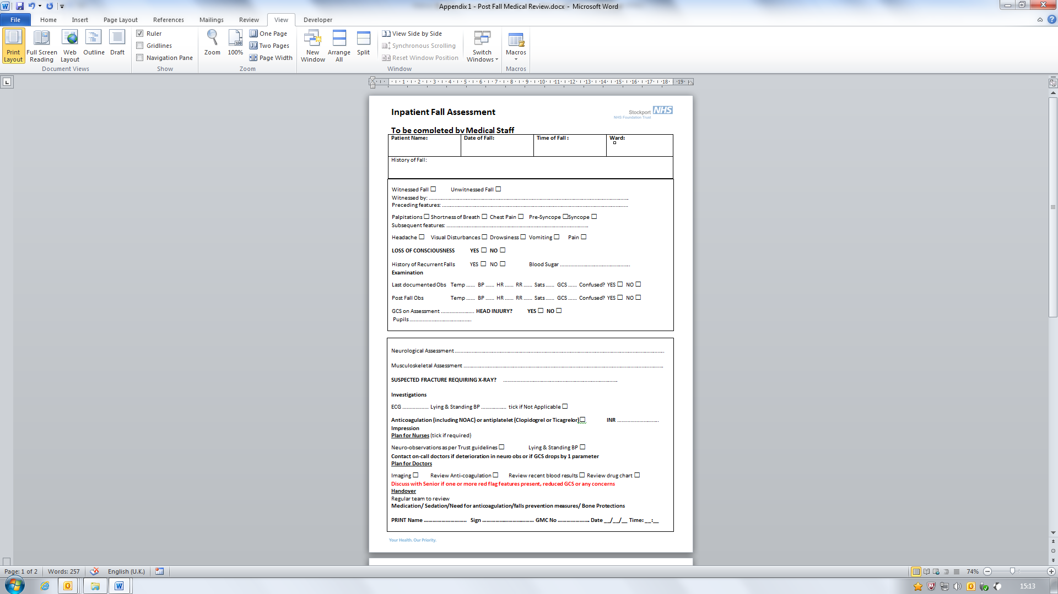

**Appendix 2**



**SLIPPER PROJECT – REFERRAL PATHWAY**

**Service Open Monday to Friday (9.00 am – 3.00 pm)**

This project is being undertaken by Stockport NHS Foundation Trust and Age UK Stockport, with the aim of preventing and reducing the risk of falls both within the hospital and home setting. This service is for patients who cannot obtain suitable footwear/slippers in the first instance from family etc.

This project will provide patients with a pair of non-slip, washable Velcro fastening slippers, available in a range of sizes and styles. The charge for a pair of slippers is £10.00. If desired, this will be followed by a home visit upon discharge, where an accident prevention assessment will be carried out to reduce the risk of future accidents/falls within the home. Monitoring of usage/service will be undertaken by the Assistant Risk Manager (Lead for Falls) and Age UK Stockport.

Complete Falls Risk Assessment and Care Plan

Has patient got good supporting shoes/slippers?

Yes

No

Refer via Tel. 0161 419 5238, Fax. 0161 482 4033

Information Needed: Name, DOB, Ward, Home Address, Phone Number, Doctors Surgery, Next of Kin Details, Slipper Size, Payment Details (Cash or Cheque)

Visit will be arranged for next available working day

Visit made with slippers supplied

Follow up visit arranged for discharge – if date not known contact details left with patient/ward staff to inform project once arranged

Two week follow up (if desired)

If contact has not been made with the project, a follow up call will be made to arrange home visit.

Home Visit

Accident Prevention Assessment conducted, where appropriate referrals to additional support services will be made

**CASE CLOSED**

Discuss with patient/relative cost implications. In extreme circumstances, can be provided free - however, limited resource.

Revised and Approved: August 2014 v3

**Appendix 3**

**FALLS RISK ASSESSMENT INCLUDING BED RAILS**

***To be completed for all Adult In-Patients as per the Trust In-Patients Falls Standard Operating Procedure***

|  |  |
| --- | --- |
| **Patient Name:** | **Date of Admission:** |
| **Hospital No.** | **NHS No.** |

**Falls Risk Assessment:**

**If answer to any of the Screen Questions below are YES, complete the bed rails risk assessment form below, and Falls Risk Care Plan on the back of this form. To be re-assessed on transfer to another ward (within 6 hours), if clinical condition changes, after a fall, or weekly if no changes.**

**If answers are NO, to be re-assessed on transfer to another ward (within 6 hours), if clinical condition changes, after a fall, or weekly if no changes.**

|  |  |  |  |  |
| --- | --- | --- | --- | --- |
| **Falls Risk Assessment must be completed for all Adult In-Patients within 6 hours of admission and on transfer from another area.**  **Bed Rails Risk Assessment to be completed if any answers to the screen questions below are Yes.** | **Ward:** | **Ward:** | **Ward:** | **Ward:** |
| ……………………… | ……………………… | ……………………… | ……………………… |
| **Initial Assessment Date/Time:** | **Review Assessment Date/Time:** | **Review Assessment Date/Time:** | **Review Assessment Date/Time:** |
| ……………………… | ……………………… | ……………………… | ……………………… |
| **Screen Questions:** |  |  |  |  |
| History of Falls before Admission?  (within the last 12 months prior to admission) | Yes / No | Yes / No | Yes / No | Yes / No |
| Falls since Admission? | Yes / No | Yes / No | Yes / No | Yes / No |
| Tries to Walk Alone but Unsteady / Unsafe? | Yes / No | Yes / No | Yes / No | Yes / No |
| Patient or Relatives anxious about Falls? | Yes / No | Yes / No | Yes / No | Yes / No |
| **Print Name, Signature and Grade of Nurse Completing Assessment:** |  |  |  |  |

**Bed Rails Assessment:**

|  |  |  |  |  |
| --- | --- | --- | --- | --- |
|  |  | **Mobility** | | |
|  |  | **Patient is very Immobile (bedfast or hoist-dependent)** | **Patient is neither independent nor immobile** | **Patient can mobilise without help from staff** |
| **Mental State** | **Patient is confused and disorientated?** | Use Bed Rails | Bed Rails **NOT** Recommended | Bed Rails **NOT** Recommended |
| **Patient is drowsy?** | Bed Rails Recommended | Use Bed Rails | Bed Rails **NOT** Recommended |
| **Patient is orientated and alert?** | Bed Rails Recommended | Bed Rails Recommended | Bed Rails **NOT** Recommended |
| **Patient is unconscious?** | Bed Rails Recommended | N/A | N/A |

*Taken from the National Patient Safety Agency’s Safer Practice Notice ‘Using Bed Rails Safely and Effectively’*

* Use the risk matrix in combination with nursing judgement.
* Patients with capacity can make their own decisions about bed rails use.
* Patients with visual impairment may be more vulnerable to falling from bed.
* Patients with involuntary movements (e.g. spasms) may be more vulnerable to falling from bed. If bed rails are used, may need padded covers.
* Ensure you know how to fit bed rails correctly, including assessing any potential entrapment gaps.

|  |  |  |  |  |  |  |  |
| --- | --- | --- | --- | --- | --- | --- | --- |
| **Are Bed Rails required?** | | | | | | | |
| **Yes** | **No** | **Date** | **Time** | **Rationale** | **Signature** | **Review Date** | **Bumpers Used** |
|  |  |  |  |  |  |  |  |
|  |  |  |  |  |  |  |  |
|  |  |  |  |  |  |  |  |
|  |  |  |  |  |  |  |  |

**FALLS RISK CARE PLAN**

|  |  |  |  |
| --- | --- | --- | --- |
| **Patient Name:** | | **Hospital No.** | |
| **NHS No.** | | **Ward:** | |
| **Patient’s Problem:** Is at risk of falls | | **Problem Number:** | |
| **Short Term Goal** | To reduce risk of patient falling | **Long Term Goal** | To keep patient harm free |

|  |  |  |  |  |
| --- | --- | --- | --- | --- |
| **Nursing Interventions**  *Assess against criteria below*  **State Yes – criteria in situ**  **State No – not needed or required** | **Ward:** | **Ward:** | **Ward:** | **Ward:** |
| …………………… | …………………… | …………………… | …………………… |
| **Initial Assessment Date/Time:** | **Review Assessment Date/Time:** | **Review Assessment Date/Time:** | **Review Assessment Date/Time:** |
| …………………… | …………………… | …………………… | …………………… |
| Ensure the patient’s call bell is within reach and patient understands how to use it. |  |  |  |  |
| Ensure their footwear is well-fitting and non-slip *(if not, refer to slipper project, where applicable).* |  |  |  |  |
| For Patients Over 65 – Has the Doctor been informed that the patient is at risk of falls and that a medication review needs to be undertaken? |  |  |  |  |
| Does the patient need to be moved to an observable bed/bay? |  |  |  |  |
| Falls Leaflet to be given to patient or family *(on first assessment)* |  |  |  |  |
| Apply a yellow wrist band. |  |  |  |  |
| Display a falls hazard sign above the bed and indicate on electronic handover. |  |  |  |  |
| Is a bed/chair sensor alarm required and is this in place? *(refer to SOP/Flow Chart)* |  |  |  |  |
| Is an electric bed required to reduce falls from height and is this in place? *(refer to SOP/Flow Chart)* |  |  |  |  |
| If the patient’s falls are associated with the need to use toilet, offer toileting every 2 hours *(refer to intentional rounding document)* |  |  |  |  |
| Following bed rail assessment, if bed rails/bumpers have been identified as required, are they in place? |  |  |  |  |
| Lying and Standing Blood Pressure to be undertaken as per pathway if the patient triggers one or more of the following criteria:  a. Over seventy five years old  b. Has a history of falls  c. Has a history of dizziness on standing  Reason for not undertaking Lying and Standing Blood Pressure, if applicable (to be completed as soon as condition improves) |  |  |  |  |
| Date Care Plan Discontinued: |  |  |  |  |
| **Print Name, Signature and Grade of Nurse completing Assessment / Care Plan** |  |  |  |  |

**Appendix 4**

**FALLS RISK ASSESSMENT TOOL (FRAT) – DISTRICT NURSING**

|  |  |  |  |
| --- | --- | --- | --- |
| 1 | Has the person had a fall in the previous year? | yes | no |
| 2 | Does the person take 4 or more medications per day? | yes | no |
| 3 | Does the person have a diagnosis of stroke or Parkinson’s disease? | Yes | no |
| 4 | Does the person have problems with their balance? | Yes | no |
| 5 | Is the person unable to stand up without using their hands to help? | Yes | no |
|  | Yes to more than 3/5 on the FRAT indicates significant risk of falling.  **Total score:** |  |  |

|  |
| --- |
| Any other additional information e.g. fear of falling,dizziness, vertigo or postural hypotension. |

|  |
| --- |
| FRAT not completed because |

|  |  |  |
| --- | --- | --- |
| Name: | Signature: | - 1 - |
| Designation: | Date and Time: |

**Appendix 5**

Patient Information Sheet for Bed Safety Rails

## How Bed Rails Are Used?

Bed rails are attached to the sides of hospital beds to reduce the risk of patients rolling, slipping, sliding or falling out of bed. They cannot be used to stop patients getting out of bed, even if they might be at risk of falling when they walk.

## Who Decides When to Use Bed Rails?

A bed rail risk assessment is undertaken for all adult patients to consider if bed rails will be required or are suitable, and will be undertaken in conjunction with the patient if they can decide. If they are too ill to decide for themselves, hospital staff will decide after first completing an assessment, and again in conjunction with the patient’s relative. Bed rails are used if the benefits are greater than the risks.

## The Benefits

Some patients fall out of bed because their illness affects their balance, or their treatment makes them very drowsy. Some patients need special air-filled mattresses to reduce the risk of pressure sores, which can be easier to roll off accidentally. Some patients have electric beds with controls they use to move from lying down to sitting up. These beds can be very comfortable, but some patients are at risk of falling when they use the controls to change their position. Most patients who fall out of bed receive only small bumps or bruises, but some patients are seriously injured. Bed rails may help in the prevention of such accidents.

## The Risks

Some illnesses can make patients so confused that they might try to climb over the rails. If there is a possibility that a patient will try to climb over a bed rail, increasing the risk of falls and subsequent injury, it is safer not to use them.

If patients are independent, bed rails would get in their way.

If patients are very restless in bed, they can knock their legs on a bed rail or get their legs stuck between the bars. Padded covers can reduce this risk.

In hospital, all bed rails should be checked prior to use to reduce the small risk of patients getting trapped between the bed and the bed rail.

***Further Information***

If further information is required please ask the staff on the ward.

**Appendix 6**

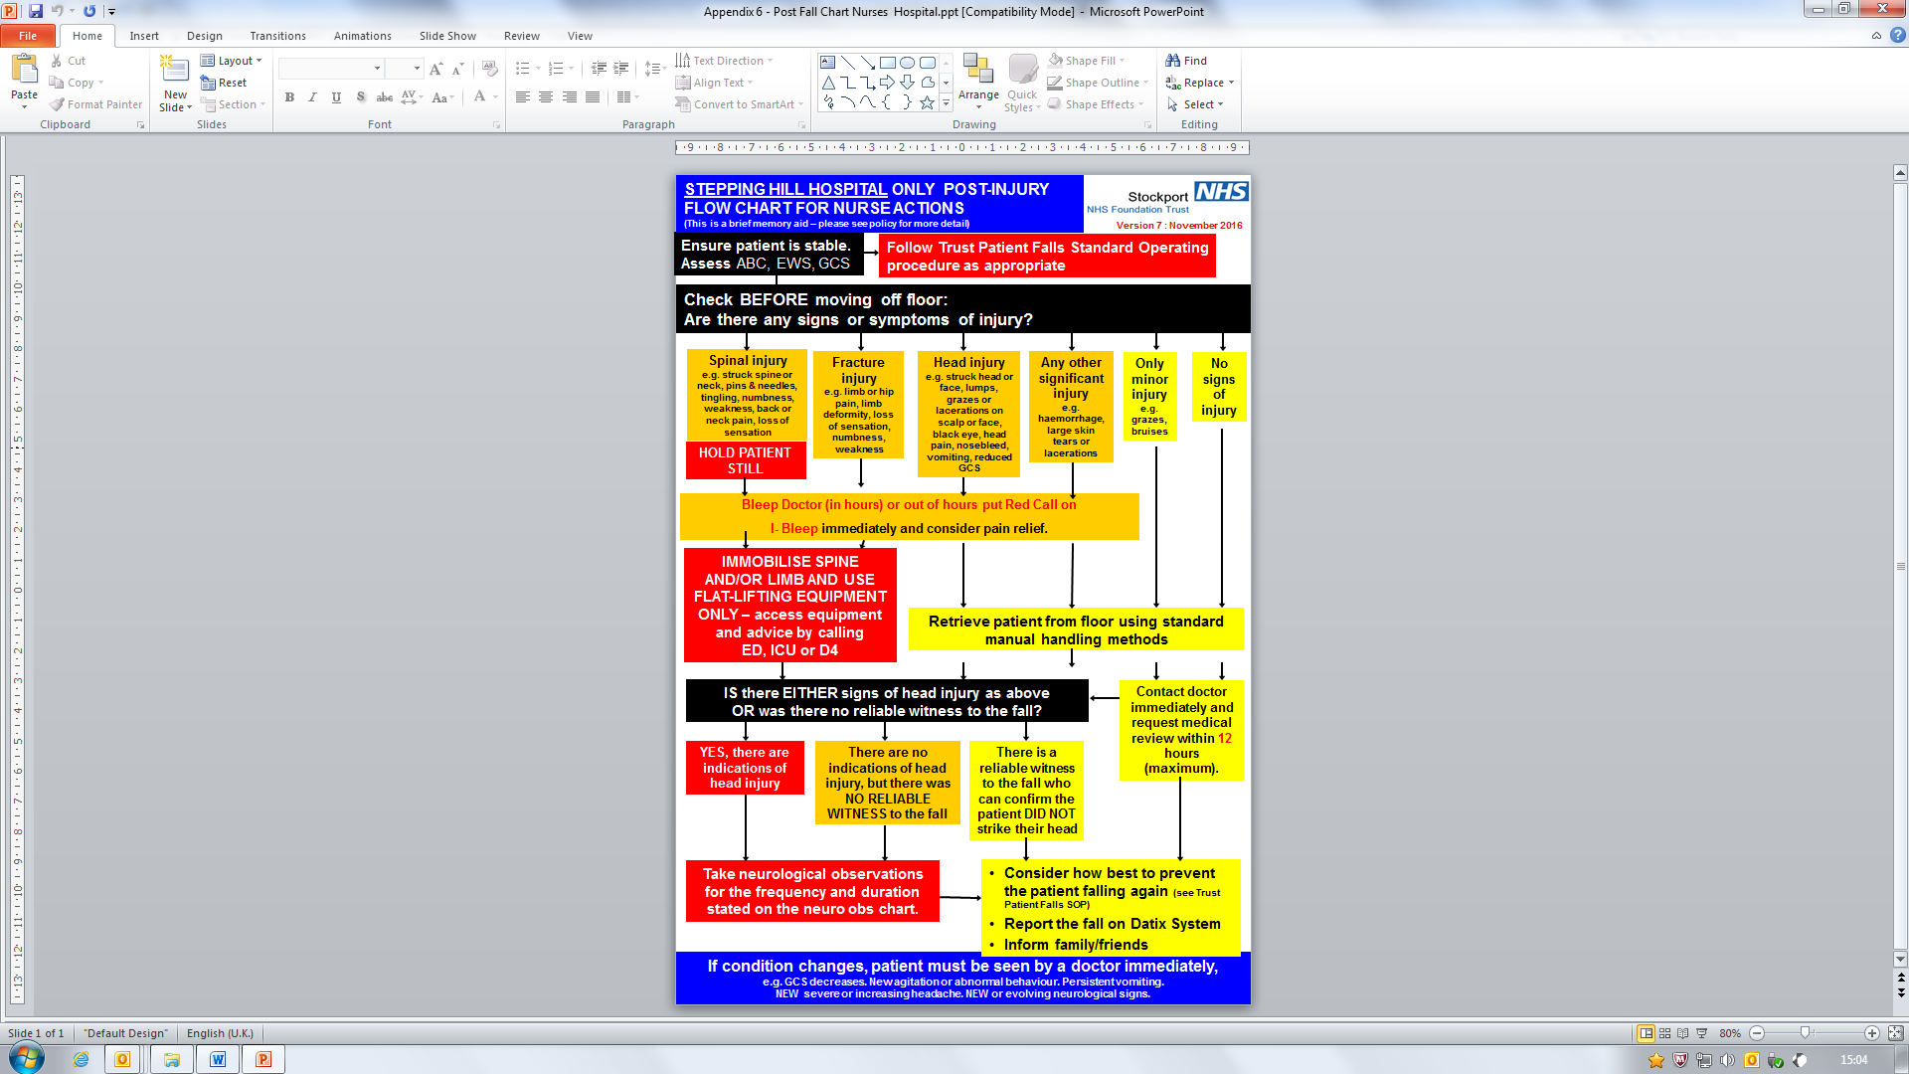

**Appendix 7**

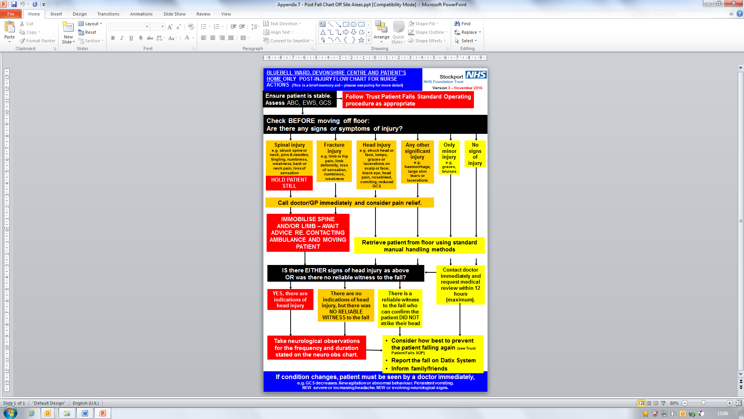

**Appendix 8**

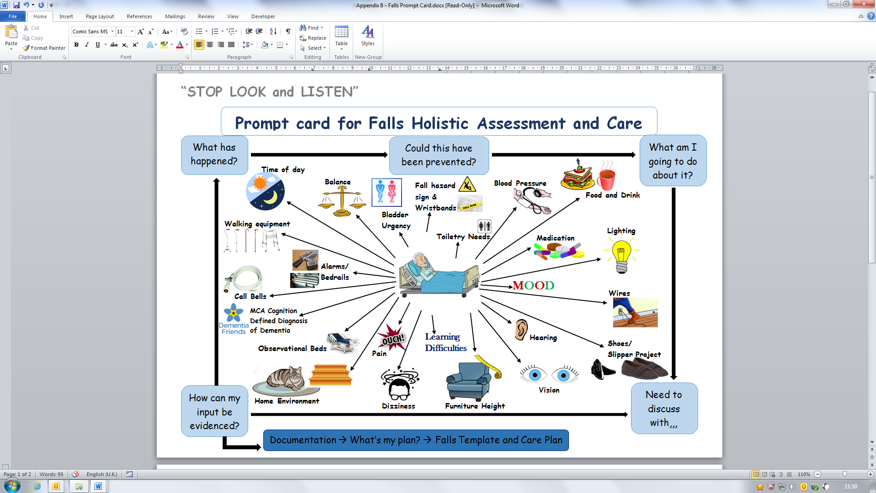

**Lying and Standing Blood Pressure Pathway**

|  |  |
| --- | --- |
| **Name:** | **Date of Birth:** |
| **Hospital Number:** | **Consultant:** |
| **Community Patient Identifier:** | |

This pathway should be used in conjunction with the falls risk assessment if the patient triggers one or more of the following criteria;

* 1. Over seventy five years old
  2. Has a history of falls
  3. Has a history of dizziness on standing
* The first lying and standing blood pressure assessment should be carried out either within the first 24 hours after admission (non-surgical patients) or for surgical patients within 24 hours of mobilising post-op.
* The assessment is to be carried out by a health care professional trained in the taking of lying and standing blood pressure.
* The comments box should be used to record any variance.
* Assistance may be needed to enable the person to stand, this must be recorded.
* All results should be made known to the clinician in charge of the patient’s care.
* The second assessment, if required, should be undertaken forty eight hours after a medication change.
* There are further assessment records to be used at clinicians’ discretion.
* If patient unable to stand, or poorly due to condition, and lying and standing blood pressure unable to be taken, this must be documented on both this form and the falls risk assessment care plan.
* If the patient condition improves, the lying and standing blood pressure needs to be taken as soon as possible.



**ORTHOSTATIC HYPOTENSION ASSESSMENT**

|  |  |  |  |  |  |  |  |  |  |
| --- | --- | --- | --- | --- | --- | --- | --- | --- | --- |
|  | **Date** |  | **Lying** BP  (after **5 mins**) | Standing BP  **On Standing** | Standing BP  **3min** | Standing BP  **5 min** | **Dizzy / Light-headed**  (circle) | **Postural Drop** | **Sign, Print Name & Designation** |
| **1st assessment** |  | L | BP |  |  |  | Yes /  No |  |  |
| R | Pulse |
| **2nd assessment** |  | L | BP |  |  |  | Yes /  No |  |  |
| R | Pulse |
| **Variance** | | | | | | | | | |

|  |  |  |  |  |  |  |  |  |  |
| --- | --- | --- | --- | --- | --- | --- | --- | --- | --- |
|  | **Date** |  | **Lying** BP  (after **5 mins**) | Standing BP  **On Standing** | Standing BP  **3min** | Standing BP  **5 min** | **Dizzy / Light-headed**  (circle) | **Postural Drop** | **Sign, Print Name & Designation** |
|  |  | L | BP |  |  |  | Yes /  No |  |  |
| R | Pulse |
|  |  | L | BP |  |  |  | Yes /  No |  |  |
| R | Pulse |
| **Variance** | | | | | | | | | |