**Stockport NHS Foundation Trust**

**Workforce Disability Equality Standard**

**(WDES) Report 2021**



**Introduction**

The Workforce Disability Equality Standard (WDES) is a set of ten specific measures (metrics) which enables NHS organisations to compare the workplace and career experiences of Disabled and non-disabled staff. NHS trusts use the metrics data to develop and publish an action plan. Year on year comparison enables trusts to demonstrate progress against the indicators of disability equality.

The WDES is important, because research shows that a motivated, included and valued workforce helps to deliver high quality patient care, increased patient satisfaction and improved patient safety.

The WDES enables NHS organisations to better understand the experiences of their Disabled staff and supports positive change for all existing employees by creating a more inclusive environment for Disabled people working and seeking employment in the NHS.

This report summarises the Trust position, and progress against the 10 indicators of the NHS Workforce Disability Equality Standard. It is recognised that this report captures a point in time and whilst there have been some positive improvements we recognise that there is still significant work to do in improving the experience of our staff who have a disability.

**The WDES Indicators**



**Workforce indicators**

|  |  |
| --- | --- |
| Indicator | Descriptor |
| 1 | Percentage of staff in each of the AfC Bands 1-9, Medical and Dental and VSM staff groups compared by:  Non-Clinical staff & Clinical staff |
| 2 | Relative likelihood of staff being appointed from shortlisting across all posts |
| 3 | Relative likelihood of Disabled staff compared to non-disabled staff entering the formal capability process, as measured by entry into the formal capability procedure. |



**National NHS Staff Survey indicators**

|  |  |
| --- | --- |
| Indicator | Descriptor |
| 4 | a) Percentage of Disabled staff compared to non-disabled staff  experiencing harassment, bullying or abuse from:  i. Patients/Service users, their relatives or other members of the public  ii. Managers  iii. Other colleagues  b) Percentage of Disabled staff compared to non-disabled staff saying that the last time they experienced harassment, bullying or abuse at work, they or a colleague reported it. |
| 5 | Percentage of Disabled staff compared to non-disabled staff believing that the Trust provides equal opportunities for career progression or promotion. |
| 6 | Percentage of Disabled staff compared to non-disabled staff saying that they have felt pressure from their manager to come to work, despite not feeling well enough to perform their duties. |
| 7 | Percentage of Disabled staff compared to non-disabled staff saying that they are satisfied with the extent to which their organisation values their work. |
| 8 | Percentage of Disabled staff saying that their employer has made adequate adjustment(s) to enable them to carry out their work. |
| 9 | a) The staff engagement score for Disabled staff, compared to non-disabled staff.  b) Has your Trust taken action to facilitate the voices of Disabled staff in your organisation to be heard? (Yes) or (No) |



**Board representation indicator**

|  |  |
| --- | --- |
| Indicator | Descriptor |
| 10 | Percentage difference between the organisation’s Board voting membership and its organisation’s overall workforce, disaggregated:  • By voting membership of the Board.  • By Executive membership of the Board |

**Reporting against the WDES Indicators**

**Indicator 1:** Percentage of staff in each of the AfC Bands 1-9, Medical and Dental and VSM staff groups compared by: Non-Clinical staff & Clinical staff

Figure 1 shows the distribution of disabled/non-disabled staff across the AfC pay bands in the non-clinical workforce for 2021.

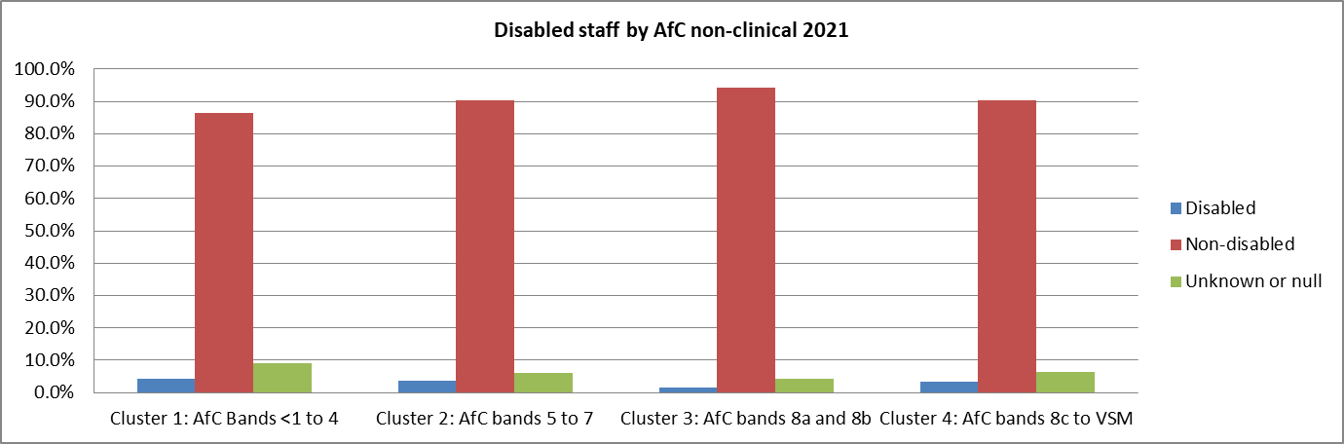



Summary analysis shows that:

* There has been an improvement in the representation of disabled staff in clusters 1 and 2 against the Trust total average of 3.2%, as compared to 2020.
* There has been a decrease in representation of disabled staff against the Trust total average in cluster 3 as compared to 2020
* There has been an increase in representation in within cluster 4, but in absolute terms this is a very small number.
* 8.5% have no data in the disability field of the Trust staff data system, the Electronic Staff Record (ESR.)

Figure 2 shows the distribution of disabled/non-disabled staff across the AfC pay bands and the medical grades, in the clinical workforce for 2021.

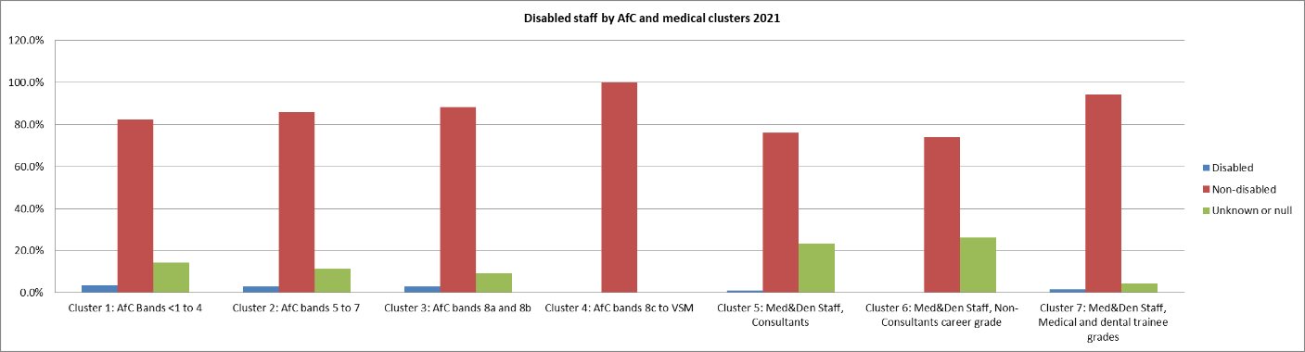



Summary analysis shows that:

* Percentage of clinical disabled staff in every band is lower than the Trust Disabled staff average of 3.2% apart from cluster 1.
* A difference in reporting methodology between 2020 and 2021 makes direct comparison difficult, but a slight decrease representation in clusters 2 and 3 is indicated.
* 11.5% have no data in the disability field of the Trust staff data system, the Electronic Staff Record (ESR.)

**Indicator 2**

|  |  |  |  |
| --- | --- | --- | --- |
|  | Relative likelihood in 2020 | Relative likelihood in 2021 | Difference +/- |
| Relative likelihood of disabled staff being appointed from shortlisting across all posts | 1.00 | 1.33 | +0.33 |

Non-disabled staff is 1.3 times more likely to be appointed from shortlisting, compared to disabled staff. This represents a deterioration compared to the 12 months before.

**Indicator 3**

|  |  |  |  |
| --- | --- | --- | --- |
|  | Relative likelihood in 2020 | Relative likelihood in 2021 | Difference +/- |
| Relative likelihood of Disabled staff compared to non-disabled staff entering the formal capability process, as measured by entry into the formal capability procedure | 5.19 | 1.22 | -3.97 |

There was significant improvement in the relative likelihood of staff entering the formal capability procedure throughout the 2021 reporting period. Whilst it is 0.22 more likely that staff with disability will enter the process it is significantly improved from 2020 when disabled staff were 5 times more likely to enter into formal capability.

**Note:** A figure above 1:00 indicates that Disabled staff is more likely than Non-Disabled staff to enter the formal capability process.

**Indicator 4**

a) Percentage of Disabled staff compared to non-disabled staff experiencing harassment, bullying or abuse from:

i. Patients/Service users, their relatives or other members of the public

ii. Managers

iii. Other colleagues

b) Percentage of Disabled staff compared to non-disabled staff saying that the last time they experienced harassment, bullying or abuse at work, they or a colleague reported it.

|  |  |  |
| --- | --- | --- |
|  | Disabled staff | Non-disabled staff |
| Percentage of staff experiencing harassment, bullying or abuse from patients, relatives or the public in last 12 months | 28.5% | 23.2% |
| Percentage of staff experiencing harassment, bullying or abuse from manager in last 12 months | 24.0% | 11.2% |
| Percentage of staff experiencing harassment, bullying or abuse from other colleagues in last 12 months | 25.4% | 16.5% |
|  |  |  |
| Percentage of staff saying that the last time they experienced harassment, bullying or abuse at work, they or a colleague reported it | 44.6% | 48.7% |

There has been an overall decline in staff experiencing harassment, bullying or abuse although staff with disabilities remains higher.

**Indicator 5**

|  |  |  |
| --- | --- | --- |
|  | Disabled staff | Non-disabled staff |
| Percentage of Disabled staff compared to non-disabled staff believing that the Trust provides equal opportunities for career progression or promotion. | 81.2% | 87.4% |

There has been an increase with both disabled (81.2%) and non-disabled (87.4%) staff believing that our Trust acts fairly in terms of career progression.

**Indicator 6**

|  |  |  |
| --- | --- | --- |
|  | Disabled staff | Non-disabled staff |
| Percentage of Disabled staff compared to non-disabled staff saying that they have felt pressure from their manager to come to work, despite not feeling well enough to perform their duties. | 33.6% | 25.0% |

There has been a reduction of 3.3% for disabled staff experiencing pressure from line managers; this bucks the trend for staff without disabilities in which we have seen a marginal increase of 0.1%

**Indicator 7**

|  |  |  |
| --- | --- | --- |
|  | Disabled staff | Non-disabled staff |
| Percentage of Disabled staff compared to non-disabled staff saying that they are satisfied with the extent to which their organisation values their work. | 32.2% | 43.9% |

There has been an overall decrease from 36.1% to 32.2% for our disabled staff and 45.7% to 43.9% for our non-disabled staff.

**Indicator 8**

|  |  |
| --- | --- |
|  | Disabled staff |
| Percentage of Disabled staff saying that their employer has made adequate adjustment(s) to enable them to carry out their work. | 71.8% |

We continue to see an increase across the board and both disabled (71.8%) and non-disabled (75.5%).

**Indicator 9**

a) The staff engagement score for Disabled staff, compared to non-disabled staff.

b) Has your Trust taken action to facilitate the voices of Disabled staff in your organisation to be heard? (Yes) or (No)

|  |  |  |
| --- | --- | --- |
|  | Disabled staff | Non-disabled staff |
| Staff Engagement Scores (1-10) of Disabled Staff v Non-Disabled Staff | 6.4 | 6.9 |

The staff survey engagement scores show that overall, disabled staff are less engaged than non-disabled colleagues.

b) Has your Trust taken action to facilitate the voices of Disabled staff in your organisation to be heard? **Yes**

Our Trust has an established staff network of people living with disability,

to ensure the voices of staff to be heard and meet bi-monthly. In collaboration, over the last 12 months we have delivered the following across the Trust:

* Staff stories at Performance in People Performance Committees (PPC)
* Opportunities for staff with disabilities to share their lived experience with our

NEDs on what life is like for them as employee

* Values into Action – these sessions are delivered for all staff groups with

targeted delivery of sessions aimed at staff with protected characteristics.

* People Pulse, our quarterly survey that collects data around protected characteristics to use in organisational development
* Staff with disabilities were invited to share their lived experiences in inform the work streams of Values into Action group

**Indicator 10**: Percentage difference between the organisation’s Board voting membership and its organisation’s overall workforce, disaggregated:

* By voting membership of the Board.
* By Executive membership of the Board.

|  |  |  |  |
| --- | --- | --- | --- |
|  | Disabled | Not Disabled | Not Disclosed /Unknown |
| Board Membership | 0 | 17 | 0 |
| Of which;  Voting Board Members | 0 | 6 | 0 |
| Non-voting Board Members | 0 | 11 | 0 |
|  |  |  |  |
| Board Membership | 0 | 17 | 0 |
| Of which;  Exec Board Members | 0 | 6 | 0 |
| Non-Exec Board Members | 0 | 11 | 0 |
|  |  |  |  |
| Number of staff in overall workforce | 180 | 4822 | 651 |
| Overall Workforce % by disability | 3.2% | 85.3% | 11.5% |
|  |  |  |  |
| Total Board members by disability (%) | 0% | 100% | 0% |
|  |  |  |  |
| Difference Board membership to overall workforce | -3.2% | 14.7% | -11.5% |

There are currently no members of the Board who identify as disabled, and no members of the board who have not disclosed within the ESR record.

**Action Planning**

The following outlines proposed plans to address some of the issues identified through this analysis. These actions will be consolidated into the EDI work plan and reported through the Trust EDI steering group and workforce committee.

|  |  |  |
| --- | --- | --- |
| **Task** | **Who** | **Timescale** |
| Review and refresh our EDI approach and strategy including the introduction of ambitious targets to aid our improvement plan | HR Director | 31/12/21 |
| Board Development Session on the 9th December on Equality, Diversity & Inclusion to agree the way forward and the culture change required. | Board Members | 9/12/2021 |
| Strengthen recruitment and retention of members for Staff Networks by undertaking a review of the network and Communications plan to encourage participation and engagement | EDI | 30/03/2022 |
| Develop Cultural Competence Training and  Participation for staff with disability to join in the NHS North West Leadership Academy Shadow Board programme | EDI/L&D | 30/04/2021 |
| Further develop Leadership Development Programme provision to provide equitably for staff with protected characteristics | L&D | 30/06/2022 |
| Create cultural awareness calendar and awareness training for all staff to foster good relations and civility awareness training | EDI, L&OD | 31/03/2022 |
| Roll out a Trust-wide campaign to encourage all staff to update their personal details, including their protected characteristics in ESR. | EDI Communications | 31/08/2022 |
| Review the reverse mentoring program and develop provision | EDI/ L&OD | 30/03/2022 |
| Develop and implement a suite of Equality, Diversity and Inclusion masterclasses to build staff and manager competence around EDI and EDI trust wide processes | EDI/LD | 31/12/2021 |
| Development of Supporting Disabilities in Work guide for managers to offer guidance in supporting disabled colleagues, including the provision of reasonable adjustments | OH/HR | 31/12/2021 |
| Develop and launch Equality in Employment policy to cover practical guidance in relation to employing individuals with a range of protected characteristics | HR/EDI/ LD/WOD | 30/08/2022 |
| Continue to develop recruitment processes to embed diverse interview panels with training on good practice. Clear guidance for hiring managers to ensure fair and inclusive practices. | HR/EDI/ LD/WOD | 30/09/2022 |

**Conclusions**

The data from this WDES submission clearly shows that there are some significant barriers to disabled people whilst in our employment. It should be noted whilst there have been some improvements the Trust recognises that there is still a significant amount of work to be undertaken to improve its position.

As a consequence of this report, whilst some actions will continue the Trust will undertake a complete review of its EDI Plans and Strategy which will include a discussion with Board members regarding the implementation of ambitious targets to aid improvements within these metrics and to improve the experience of our staff who have a disability.

The report will be shared with the Disability Staff Network and we will engage with the network on the development of the actions required and the revision of the EDI Strategy. This report will be published on the Trust website and intranet page.