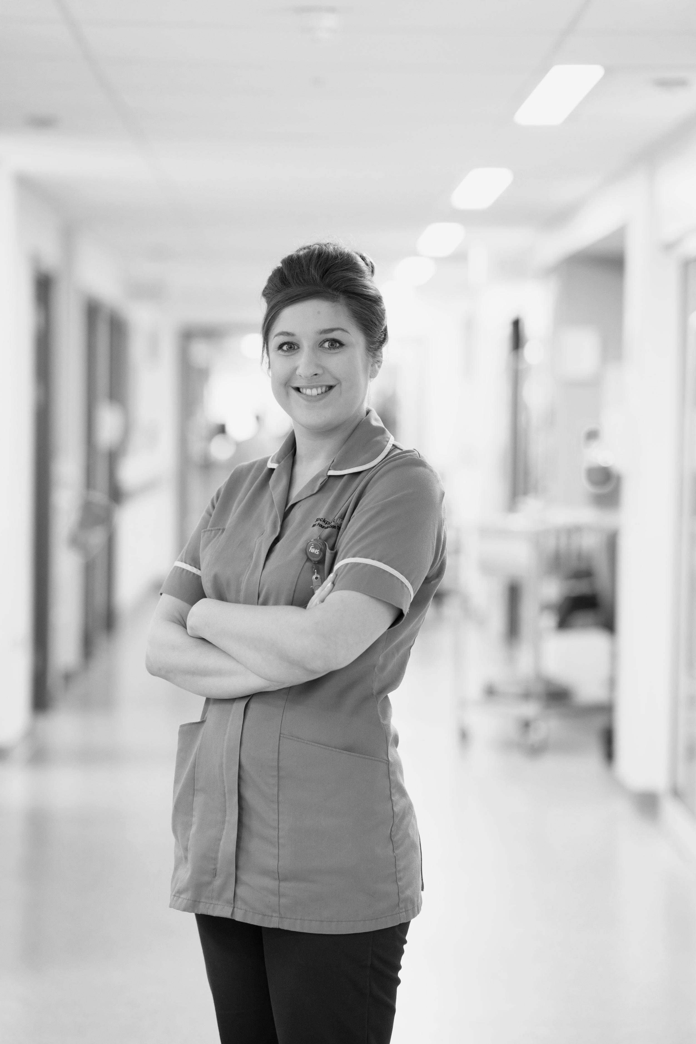
Annual Members Meeting
Thursday 12th October 2017
6.00pm – 8.00pm
Doors open from 5.00pm for
free mini health checks

Pinewood House Education Centre,
Stepping Hill Hospital,
Poplar Grove,
Stockport SK2 7JE
Programme

5.00pm: Sign in desk opens, with opportunity for a free mini health check, including blood pressure, Body mass index (BMI) check and flu jab

6.00pm: Welcome and opening remarks – Adrian Belton, Chair

6.05pm: Review of the year 2016/17 (video) - Ann Barnes, Chief Executive

6.15pm: Annual accounts 2016/17 – Feroz Patel, Director of Finance

6.25pm: Looking ahead - Ann Barnes, Chief Executive

6.40pm: Stockport Together – Dr Gill Burrows, Deputy Medical Director, Viren Mehta, Medical Director and Jaweeda Idoo, Clinical Transformation Director for Stockport Neighbourhood Care

6.55pm: Eileen’s story (video)

7.00pm: Council of Governors election results – Paul Buckingham, Director of Corporate Affairs

7.05pm: Membership update – Les Jenkins, Lead Governor

7.15pm: Question Time – Adrian Belton, Chair

7.55pm: Closing remarks – Adrian Belton, Chair

8.00pm: Event ends

