Workforce Equality Monitoring Report

2023

Executive Summary
The Public Sector Equality Duty came into effect in 2011, replacing all existing equality duties. The Duty – split into the General Duty and the Specific Duty, both apply to all public sector organisations with more than 150 employees.
There are three requirements in the specific duty:
- The first requires certain listed authorities (including all NHS Trusts) to publish gender pay gap information on their employees.
- The second requires the Trust to publish information to demonstrate their compliance with the general equality duty (‘equality information’).
- The third requires the preparation and publication of one or more equality objectives which the Trust believes it should achieve to do any of the things mentioned in the general equality duty (‘equality objectives’).
In respect of the requirement to publish gender pay gap information, this data is provided under separate cover to the People Performance Committee for consideration.
This report provides the information required to demonstrate compliance with the second set of requirements - to publish information to demonstrate compliance with the general equality duty (‘equality information’).
In respect of the requirement to publish one or more equality objectives, this element of the duty is met by the publication of the actions contained within the Trust’s Equality, Diversity and Inclusion Strategy 2022-25.
This report provides the workforce data (information relating to employees who share protected characteristics). The following data is provided in the report:

- Staff in post by relevant protected characteristic.
- Recruitment data by relevant protected characteristic.
- Leavers and staff turnover by relevant protected characteristic.
The report also summarises some of the key EDI activity over the past 12 months. The data period runs from January 2023 to December 2023.
Key highlights:
- The majority of staff, 76% across the Trust are women.
- Distribution of men and women across the workforce, by AfC pay bands, and aggregated Medical workforce represent overwhelmingly women, however, nearly 60% of the medical workforce are men.
- The majority of the workforce are White. There has been a small increase in the proportion of Asian staff by 1.5% in the previous 12 months.
- There has been a change in the proportion of BAME staff workforce in the previous 12 months. The increase at Band 5 is likely due to the impact of international recruitment.
- 5% of staff at the Trust who have declared that they are disabled, an increase of 1% in the previous 12 months.
- Whilst 5% of our workforce (316 staff), consider themselves to be disabled, 33.6% of respondents in the 2022 NHS staff survey self-defined as disabled (577 staff), compared to 28.7% in the previous year (464 staff).
- There have been some changes in the proportions of disabled staff across the AfC pay bands. The table below summarises the changes over the past 12 months.
- For sexual orientation and gender identity, around 3.3% identified with an LGB+ orientation (“Gay or Lesbian”, “Bisexual” or “Other sexual orientation” for Stockport with 6.4%.of respondents did not answer the question. Across the AfC pay bands and medical profession. Proportions remain similar to the previous 12 months.
- Across the workforce half of the staff at the Trust identify as Christian. Of the other major world religions, 5.7% of staff are Muslim, 3.4 % Hindu, 0.5% Buddhist, 0.3% Jewish and 0.2% Sikh.
- In the last 12 months there were 37,562 applicants of who 4,604 were shortlisted for interview and 553 successful candidates were successfully appointed.
- The overall rate of shortlisting from application was 12.3%. The groups less likely to be shortlisted came from the younger age brackets, in spite of them making up larger proportions of applicants. Candidates aged 35+ were generally more successful at shortlisting stage.
- Women make up the majority of applications, although not quite the proportionate composition of the Trust workforce. Women were more likely to be shortlisted than men, however there was a minor difference in the rates of appointment between men and women.
- Over 70% of applicants identify as either Asian/Asian British, or Black/Black British, compared with less than 20% identifying as White.
- Disabled people make up 3 % of the applicant pool. Disabled applicants are significantly more likely to be shortlisted than non-disabled applicants. There is no significant difference in the appointment from interview between disabled and non-disabled candidates.
- The proportion of LGB applicants was exactly in line with the 2021 census date for Stockport at 3.3%. Lesbian and gay applicants were significantly more likely to be shortlisted for interview than heterosexual applicants
- The overall rate of shortlisting is 12.3%. Those groups with a higher chance of being shortlisted include Atheists and Jewish applicants (although the numbers of Jewish applicants are small).
- The overall annual staff turnover for the Trust was calculated at 14.6%, compared to 15.2% in the previous annual report.
- The rate of staff turnover is highest amongst the youngest age groups and the 66-70 age group, the former recognises the level of career mobility within these age groups, and the latter retirement.
- There is no significant difference in the rate of staff turnover between men and women.
- The rate of turnover of staff from a Black/Black British heritage were the highest, whereas the turnover rate for Asian/Asian British staff was the lowest.
- The turnover rate for disabled staff was higher than that for non-disabled staff, at 17.7% compared to 14.5% for non-disabled.
- The data shows that the turnover rate for LGB staff is significantly higher that for heterosexual staff (21.2% compared to 14.3%).
- The highest rate for turnover is Buddhist colleagues, although the numbers are very small. Other significant rates for turnover are Atheists and Muslim staff. Jains, Sikhs and Jewish have lower turnover rates than the Trust overall average, although the number of staff are very small.
The People Performance Committee is asked to note the contents of the latest Annual Workforce Equality Monitoring Report and approve for publication.
We are required to publish our Workforce Equality Monitoring Report 2023-24 on the Trust’s website by 31st March 2024.

1. Introduction
The public sector equality duty was developed in order to harmonise the equality duties and to extend it across the protected characteristics. It consists of a general equality duty, supported by specific duties which are imposed by secondary legislation. In summary, the general duty, requires the Trust to, in the exercise of their functions, have due regard to the need to:
- Eliminate unlawful discrimination, harassment and victimisation and other conduct prohibited by the Act.
- Advance equality of opportunity between people who share a protected characteristic and those who do not.
- Foster good relations between people who share a protected characteristic and those who do not.
These are sometimes referred to as the three aims or arms of the general equality duty. The Act explains that having due regard for advancing equality involves:
- Removing or minimising disadvantages suffered by people due to their protected characteristics.
- Taking steps to meet the needs of people from protected groups where these are different from the needs of other people.
- Encouraging people from protected groups to participate in public life or in other activities where their participation is disproportionately low.
In addition to the General Duty, the Trust is also subject to the Specific Equality Duty.
There are three sets of requirements in the specific duties:
- The first set requires certain listed authorities to publish gender pay gap information on their employees
- The second set requires the Trust to publish information to demonstrate their compliance with the general equality duty (‘equality information’).
- The third requires the preparation and publication of one or more equality objectives which it thinks it should achieve to do any of the things mentioned in the general equality duty (‘equality objectives’).
In respect of the requirement to publish one or more equality objectives, this element of the duty is met by the publication of the actions contained within the Trust’s Equality, Diversity and Inclusion Strategy.
This report provides the information required to demonstrate compliance with the second set of requirements - to publish information to demonstrate compliance with the general equality duty (‘equality information’). The following data is provided in the report:

- Staff in Post by relevant protected characteristic.
- Recruitment data by relevant protected characteristic.
- Leavers and staff turnover by relevant protected characteristic.
In addition to fulfilling the statutory reporting requirements, this report also includes summary of the equality, diversity and inclusion activity over the previous 12 months.

2. Staff in Post
Age
The chart below shows the age profile of the Trust’s workforce. The majority of the workforce are in the age ranges of 31-40 and 51-55. The proportions fall sharply after the age of 60 recognising the retirement age for many staff. The normal pension age (NPA) for staff in the 1995 section of the NHS pension is 60. The proportion of those aged under 20 represents less than 1% of the total workforce.
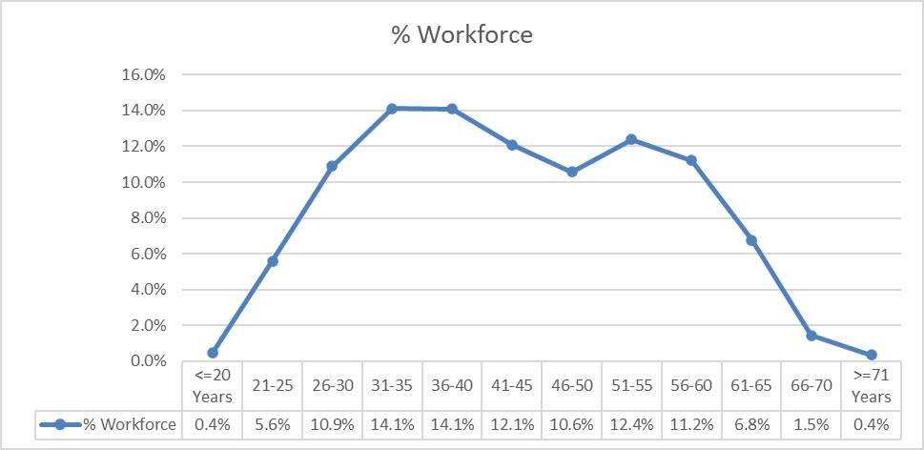

Figure 1: Age profile of all staff at the Trust.

Sex
Figure 2 below shows the distribution of the Trust’s workforce by Sex. The majority of staff across the Trust are women.

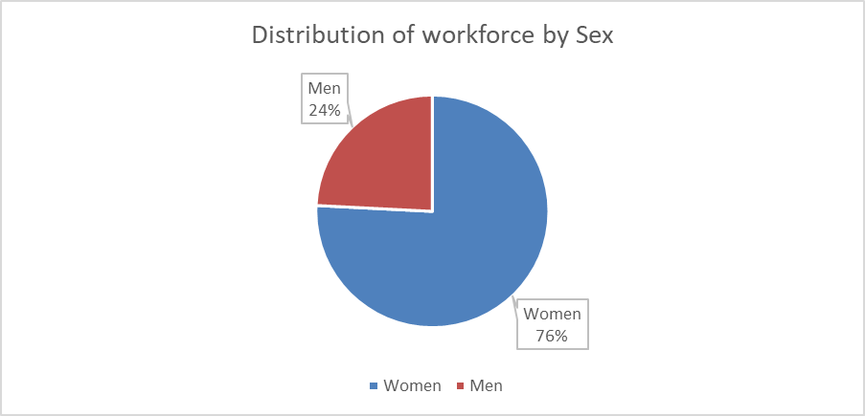

The chart below shows the distribution of men and women across the workforce, by AfC pay bands, and collectively the medical workforce. Whilst women represent the overwhelming majority of the workforce, nearly 60% of the medical workforce are men.

Figure 3: Distribution of men and women across the workforce
In addition to this report, the Trust is subject to the requirement to publish gender pay gap information, this data is provided under a separate report and will be published on the Trust web pages.
Ethnicity
The chart below shows the workforce composition by ethnicity. The majority of the workforce are White. There has been a small increase in the proportion of asian staff by 1.5% in the previous 12 months.
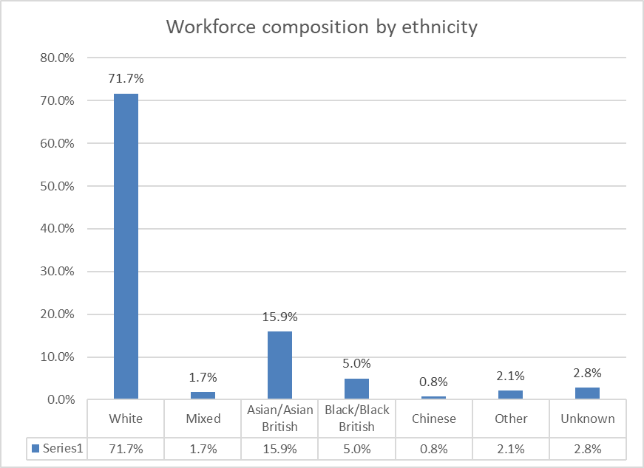
Figure 4: Workforce composition by ethnicity

Aggregating the data shows that 25.6 % of the workforce are from Black, Asian and Minority Ethnic groups, compared to 23.7% in the previous year.

 | % of workforce | % of Stockport population
BAME | 25.6% | 12.6%
White | 71.7% | 87.4%
Unknown | 2.8%
Data from the 2021 Census shows that there has been an increase in the local BAME population (Stockport) from 7.9% to 12.6%.
The differences observed between the BAME proportions of the workforce, compared to the local population are likely to be as a result of occupational segregation (primarily the proportion of BAME staff within the medical profession), as well as a result of international recruitment.
The chart below shows the distribution of white and BAME staff cross the AfC pay bands and medical grades.

Figure 5: Distribution of White and BAME staff across AfC pay bands and medical grades

The table below shows the change in the proportion of BAME staff in the previous 12 months. The increase at Band 5 is likely due to the impact of international recruitment. The increase at Band 3, is likely due to significant drives in recruitment for HCA roles. The decrease at band 4 is likely due to the numbers of pre-registration internally recruited nurses progressing to AfC Band 5.

Banding | % of BAME staff 2022 | % of BAME staff 2023 | Change
Band 1 | 19.1% | 20.0% | +0.9%
Band 2 | 28.8% | 29.0% | +0.2%
Band 3 | 11.3% | 19.4% | +8.1%
Band 4 | 11.9% | 5.6% | -6.3%
Band 5 | 34.8% | 40.1% | +5.3%
Band 6 | 15.7% | 15.6% | -0.1%
Band 7 | 9.2% | 10.1% | +0.9%
Band 8A | 6.4% | 5.3% | -1.1%
Band 8B | 12.3% | 10.0% | -2.3%
Band 8C | 3.5% | 0.0% | -3.5%
Band 8D | 0% | 0.0% | No change
Band 9 | 0% | 0.0% | No change
Medical/Dental | 47.4% | 51.7% | +3.3%

Disability

The chart below shows the proportion of disabled staff across the entire workforce.
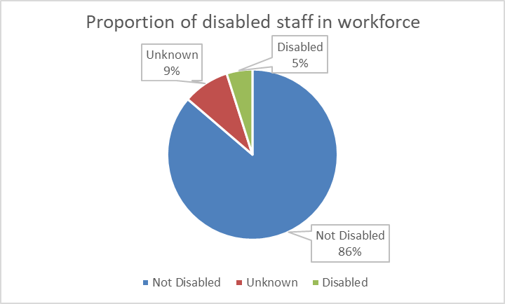

Figure 6: Composition of workforce by disability

There are 5% of staff at the Trust who have declared that they are disabled, an increase of 1% in the previous 12 months.
Whilst 5% of our workforce (316 staff), consider themselves to be disabled, 33.6% of respondents in the 2022 NHS staff survey self-defined as disabled (577 staff), compared to 28.7% in the previous year (464 staff).
The Census 2021 data shows that 18.1% of residents of Stockport consider themselves to be disabled or have a long term health condition.
The chart below shows the distribution of disabled staff across the AfC and medical pay bands.

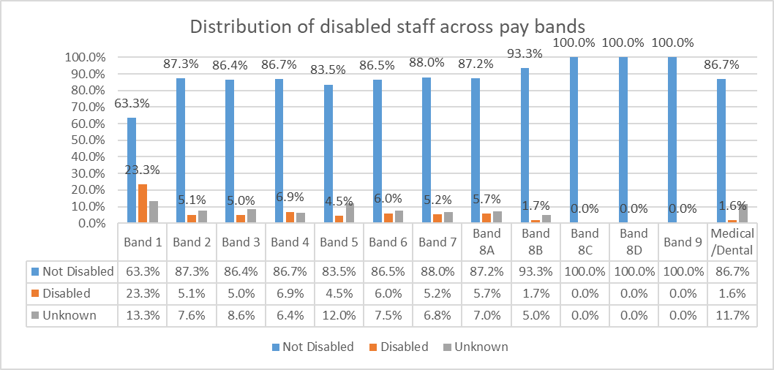Figure 7: Distribution of disabled staff across AfC and Medical pay bands

In the 12 months since the publication of last year’s Workforce Equality Monitoring Report, there have been some changes in the proportions of disabled staff across the AfC pay bands. The table below summarises the changes over the past 12 months.

Banding | % of disabled staff 2022 | % of disabled staff  2023 | Change
Band 1 | 19.1% | 23.3% | +4.2%
Band 2 | 4.4% | 5.1% | +0.7%
Band 3 | 5.4% | 5.0% | -0.4%
Band 4 | 4.2% | 6.9% | +2.7%
Band 5 | 3.4% | 4.5% | +1.1%
Band 6 | 4.4% | 6.0% | +1.6%
Band 7 | 2.6% | 5.2% | +2.6%
Band 8A | 3.7% | 5.7% | +2.0%
Band 8B | 1.8% | 1.7% | -0.1%
Band 8C | 0.0% | 0.0% | No change
Band 8D | 0.0% | 0.0% | No change
Band 9 | 0.0% | 0.0% | No change
Medical | 0.70% | 1.6% | +0.9%

Sexual Orientation
The chart below shows the distribution of sexual orientation across the workforce. 3% of the workforce identify as lesbian, gay or bisexual, which has not changed in the previous year.

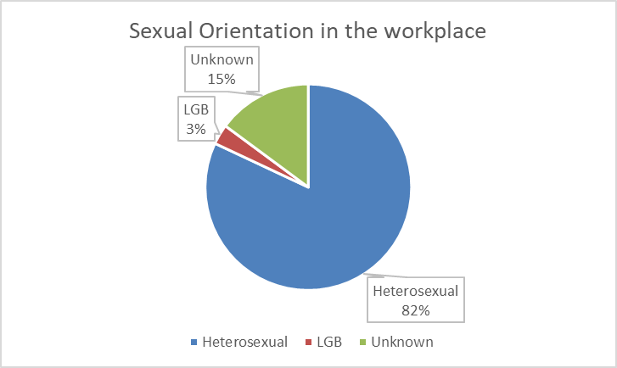
Figure 8: Workforce composition by sexual orientation

From the 2021 census data available for sexual orientation and gender identity, around 1.5 million people (3.2%) identified with an LGB+ orientation (“Gay or Lesbian”, “Bisexual” or “Other sexual orientation”). For Stockport this figure is 3.3%. Across England and Wales 7.5% of respondents did not answer the question and across Stockport this figure is 6.4%.
The chart below shows the distribution of staff by sexual orientation across the AfC pay bands and medical profession. Proportions remain similar to the previous 12 months.

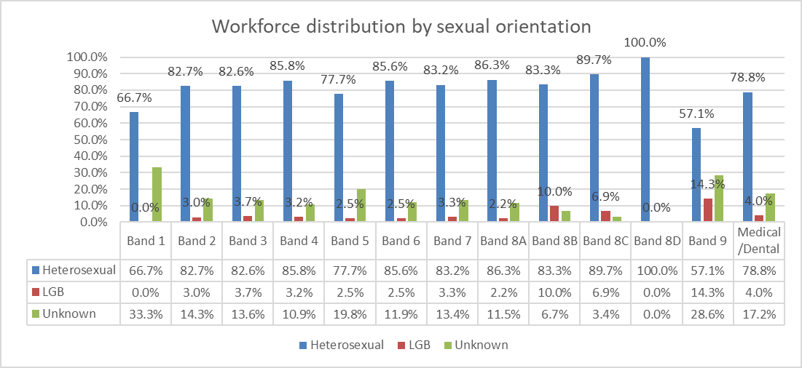

Figure 9: Distribution of sexual orientation across AfC bands and medical workforce

Religion or Belief
The chart below summarises the proportions of staff in each major religion. Half of the staff at the Trust identify as Christian. Of the other major world religions, 5.7% of staff are Muslim, 3.4 % Hindu, 0.5% Buddhist, 0.3% Jewish and 0.2% Sikh.

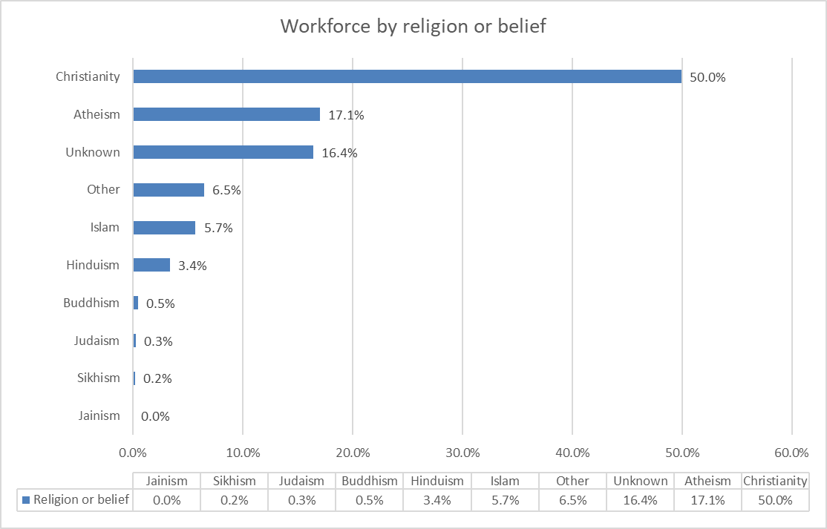
Figure 10: Distribution of workforce by religion or belief

3. Recruitment Data
Recruitment data is provided for vacancies held in the Trust’s recruitment system (Trac jobs) over a 12 month period. The following fields are provided:
- Number of applications
- Percentage of applications by relevant protected characteristic
- The number of candidates interviewed, and proportion of candidates interviewed as a percentage of applications
- The number of offers by relevant protected characteristic, and the proportion of offers made as a percentage of candidates interviewed
In total there were 37,562 applicants (compared to 16,102 in the previous year) of who 4,604 (2,892 last year) were shortlisted for interview and 553 successful candidates were successfully appointed (1051 in the previous year).
The following analysis shows the applications, shortlisting and successful appointments by equality demographics.

Age

Age | Applications | % of all applications | Interviewed | Proportion of applicants interviewed | Appointed | % of interviewed appointed
Under 20 | 457 | 1.2% | 99 | 21.7% | 9 | 9.1%
20 - 24 | 4143 | 11.0% | 484 | 11.7% | 76 | 15.7%
25 - 29 | 11149 | 29.7% | 858 | 7.7% | 95 | 11.1%
30 - 34 | 8850 | 23.6% | 847 | 9.6% | 100 | 11.8%
35 - 39 | 5533 | 14.7% | 723 | 13.1% | 105 | 14.5%
40 - 44 | 3342 | 8.9% | 506 | 15.1% | 64 | 12.6%
45 - 49 | 1885 | 5.0% | 385 | 20.4% | 43 | 11.2%
50 - 54 | 1085 | 2.9% | 321 | 29.6% | 26 | 8.1%
55 - 59 | 651 | 1.7% | 223 | 34.3% | 25 | 11.2%
60 - 64 | 393 | 1.0% | 139 | 35.4% | 8 | 5.8%
65+ | 70 | 0.2% | 16 | 22.9% | 1 | 6.3%
Not stated | 4 | 0.0% | 3 | 75.0% | 1 | 33.3%
Total | 37562 | 100.0% | 4604 | 12.3% | 553 | 12.0%
In total there were 37,562 applicants, of who 4,604 were shortlisted for interview, and 553 successful candidates were successfully appointed. The overall rate of shortlisting from application was 12.3%. The groups less likely to be shortlisted came from the younger age brackets, in spite of them making up larger proportions of applicants. Candidates aged 35+ were generally more successful at shortlisting stage.

Sex

Sex | Applications | % of all applications | Interviewed | Proportion of applicants interviewed | Appointed | % of interviewed appointed
Male | 15365 | 40.9% | 1517 | 9.9% | 149 | 9.8%
Female | 22108 | 58.9% | 3066 | 13.9% | 399 | 13.0%
I do not wish to disclose | 89 | 0.2% | 21 | 23.6% | 5 | 23.8%
Total | 37562 | 100.0% | 4604 | 12.3% | 553 | 12.0%

Women make up the majority of applications, although not quite the proportionate composition of the Trust workforce. Women were more likely to be shortlisted than men, however there was a minor difference in the rates of appointment between men and women.

Ethnicity

Ethnicity | Applications | % of all applications | Interviewed | Proportion of applicants interviewed | Appointed | Proportion of interviewed appointed
White | 7335 | 19.5% | 2149 | 29.3% | 274 | 12.8%
Asian/Asian British | 12966 | 34.5% | 1305 | 10.1% | 115 | 8.8%
Black/Black British | 13377 | 35.6% | 815 | 6.1% | 76 | 9.3%
Mixed Heritage | 1228 | 3.3% | 103 | 8.4% | 22 | 21.4%
Chinese | 464 | 1.2% | 62 | 13.4% | 8 | 12.9%
Other | 1684 | 4.5% | 96 | 5.7% | 20 | 20.8%
Unknown | 508 | 1.4% | 74 | 14.6% | 38 | 51.4%
Total | 37562 | 100.0% | 4604 | 12.3% | 553 | 12.0%
Despite all Black, Asian and other Minority groups accounting for 12.6% of Stockport population in the 2021 census, over 70% of applicants identify as either Asian/Asian British, or Black/Black British, compared with less than 20% identifying as White.
However, there is a significantly disproportionate percentage of those identifying as White who are chosen to progress to interview at nearly 30% of the total – nearly twice that of the other two groups combined.
This disproportionate trend continues in the proportion of those interviewed being appointed, albeit not to the same level with 12.8% of those white people interviewed, being appointed, versus 8.8% for Asian/Asian British and 9.3% for Black/Black British.
However, the Code of Practice for International Recruitment was updated on 2nd August 2022. With this update, rules were strengthened regarding the recruitment of individuals from red and amber list countries via different recruitment models. NHS Trusts and collaboratives are no longer able to recruit direct applicants from these countries on behalf of other NHS Trusts. This is likely to have contributed to an increase in direct applications from overseas candidates, in part leading to the increase in the number of Black/Black British candidates, appointed outside of the TRAC system and excluded from the numbers above.
The 2023/4 pay uplift for Agenda for Change (AfC) Staff increased the entry-point Band 3 salary from £20,330 to £21,730. This now exceeds the minimum salary requirement for sponsorship via the skilled worker route. Whilst other criteria must also be satisfied, this has significantly increased the volume of roles across the NHS, for which overseas candidates requiring sponsorship can apply.
To ensure a fair recruitment process, we have produced updated guidance for managers on the requirement to shortlist and interview candidates without bias related to a candidates Visa status or requirement for sponsorship. An analysis of Black/Black British applicants has confirmed that a significant number of this applicant group are from those countries referenced above, rather than domestic Black/Black British candidates.
Disability
Disabled | Applications | % of all applications | Interviewed | Proportion of applicants interviewed | Appointed | % of interviewed appointed
Non-Disabled | 36043 | 96.0% | 4219 | 11.7% | 478 | 11%
Disabled | 1120 | 3.0% | 313 | 27.9% | 36 | 12%
Prefer not to say | 275 | 0.7% | 56 | 20.4% | 13 | 23%
Not stated | 124 | 0.3% | 16 | 12.9% | 26 | 163%
Total | 37562 | 100.0% | 4604 | 12.3% | 553 | 12%
Disabled people make up 3% of the applicant pool. Disabled applicants are significantly more likely to be shortlisted than non-disabled applicants. This is a result of the guaranteed interview scheme throughout the Government’s Disability Confident Scheme. There is no significant difference in the appointment from interview between dis abled and non-disabled candidates.

Sexual Orientation
Sexual orientation | Applications | % of all applications | Interviewed | Proportion of applicants interviewed | Appointed | % of interviewed appointed
Heterosexual | 34837 | 92.7% | 4194 | 12.0% | 472 | 11.3%
Lesbian and Gay | 487 | 1.3% | 102 | 20.9% | 9 | 8.8%
Bisexual | 766 | 2.0% | 112 | 14.6% | 10 | 8.9%
Unknown | 1472 | 3.9% | 196 | 13.3% | 62 | 31.6%
Total | 37562 | 100.0% | 4604 | 12.3% | 553 | 12.0%

The proportion of LGB applicants was exactly in line with the 2021 census date for Stockport at 3.3%. Lesbian and gay applicants were significantly more likely to be shortlisted for interview than heterosexual applicants, with bisexual applicants at a marginally higher rate. However, the relative likelihood reverses at the appointment stage, the difference is marginal and the overall numbers are small and not likely to be significant.

Religion or Belief
Religion or belief | Applications | % of all applications | Interviewed | Proportion of applicants interviewed | Appointed | % of interviewed appointed
Atheism | 2524 | 6.7% | 672 | 26.6% | 87 | 12.9%
Buddhism | 616 | 1.6% | 64 | 10.4% | 5 | 7.8%
Christianity | 20194 | 53.8% | 2187 | 10.8% | 245 | 11.2%
Hinduism | 3348 | 8.9% | 249 | 7.4% | 19 | 7.6%
Islam | 7164 | 19.1% | 662 | 9.2% | 69 | 10.4%
Jainism | 35 | 0.1% | 1 | 2.9% | 0 | 0.0%
Judaism | 41 | 0.1% | 14 | 34.1% | 0 | 0.0%
Sikhism | 126 | 0.3% | 18 | 14.3% | 2 | 11.1%
Other | 1509 | 4.0% | 360 | 23.9% | 37 | 10.3%
Unknown | 2005 | 5.3% | 377 | 18.8% | 89 | 23.6%
Total | 37562 | 100.0% | 4604 | 12.3% | 553 | 12.0%
The overall rate of shortlisting is 12.3%. Those groups with a higher chance of being shortlisted include Atheists and Jewish applicants (although the numbers of Jewish applicants are small). At appointment, Atheists, Christians and Muslims applicants had a higher rate of appointment. Sikhs also had a similar proportion of appointments (although the numbers are very small). There does not appear to be any significant differences in the rate of appointment based on religion or belief.

4. Staff Leavers and Turnover
Age
The table below shows the number of employees within each age bracket, the number of leavers in the same age brackets, and the staff turnover for each group. The overall annual staff turnover for the Trust was calculated at 14.6%, compared to 15.2% in the previous annual report.

Age | No of Staff | Leavers | Turnover
<=20 Years | 29 | 19 | 65.5%
21-25 | 361 | 85 | 23.5%
26-30 | 702 | 141 | 20.1%
31-35 | 910 | 137 | 15.1%
36-40 | 908 | 115 | 12.7%
41-45 | 779 | 72 | 9.2%
46-50 | 682 | 66 | 9.7%
51-55 | 798 | 79 | 9.9%
56-60 | 722 | 90 | 12.5%
61-65 | 437 | 91 | 20.8%
66-70 | 94 | 45 | 47.9%
>=71 Years | 23 | 4 | 17.4%
TOTAL | 6445 | 944 | 14.6%

The rate of staff turnover is highest amongst the youngest age groups and the 66-70 age group, the former recognises the level of career mobility within these age groups, and the latter retirement.
Sex
The table below shows the number of men and women employed by the Trust and the number of leavers and staff turnover. There is no significant difference in the rate of turnover between men and women.

Sex | No of Staff | Leavers | Turnover
Women | 4886 | 710 | 14.5%
Men | 1559 | 234 | 15.0%
TOTAL | 6445 | 944 | 14.6%
Ethnicity
The table below shows the workforce by ethnicity, number of leavers and rate of staff turnover by group.
Ethnicity | No of Staff | Leavers | Turnover
Asian/Asian British | 1027 | 133 | 13.0%
Black/Black British | 322 | 85 | 26.4%
Chinese | 51 | 10 | 19.6%
Mixed Heritage | 112 | 21 | 18.8%
Other ethnic group | 136 | 30 | 22.1%
Unknown | 178 | 25 | 14.0%
White | 4619 | 640 | 13.9%
TOTAL | 6445 | 944 | 14.6%

The rate of turnover of staff from a Black/Black British heritage were the highest, whereas the turnover rate for Asian/Asian British staff was the lowest.
Disability
The table below shows the number of disabled staff, disabled leavers and turnover rate.
 | No of Staff | Leavers | Turnover
Disabled | 316 | 56 | 17.7%
Not Disabled | 5561 | 807 | 14.5%
Unknown | 568 | 81 | 14.3%
TOTAL | 6445 | 944 | 14.6%
The turnover rate for disabled staff was higher than that for non-disabled staff, at 17.7% compared to 14.5%.

Sexual Orientation
The table below shows all staff by sexual orientation, leavers and turnover rate. The data shows that the turnover rate for LGB staff is significantly higher than for heterosexual staff (21.2% compared to 14.3%).
Sexual Orientation | No of staff | Leavers | Turnover
Heterosexual | 5284 | 758 | 14.3%
LGB | 203 | 43 | 21.2%
Unknown | 958 | 143 | 14.9%
TOTAL | 6445 | 944 | 14.6%
Religion or Belief
The table below shows the workforce by religion or belief, number of leavers and rate of staff turnover by group.
Religion | No of staff | No of leavers | Turnover
Atheism | 1099 | 195 | 17.7%
Buddhism | 30 | 6 | 20.0%
Christianity | 3221 | 458 | 14.2%
Hinduism | 218 | 24 | 11.0%
Islam | 368 | 61 | 16.6%
Jainism | 1 | 0 | 0.0%
Judaism | 17 | 1 | 5.9%
Sikhism | 14 | 0 | 0.0%
Other | 419 | 56 | 13.4%
Unknown | 1058 | 143 | 13.5%
TOTAL | 6445 | 944 | 14.6%
The highest rate for turnover is Buddhist colleagues, although the numbers are very small. Other significant rates for turnover are Atheists and Muslim staff. Jains, Sikhs and Jewish have lower turnover rates than the Trust overall average, although the number of staff are very small.

5. EDI Activity during the Monitoring Period
The following section of this report summarises some of the equality, diversity and inclusion activity that has occurred over the last year at the Trust (this is not an exhaustive list):
- For the NHS Equality, Diversity and Human Rights Week, the Trust ran a week-long of activities, which included the presentation of masterclasses on inclusive recruitment practices, and taking an intersectional approach to EDI. The week was led by the Trust Chair.
- For National Inclusion Week, the Trust ran a week of activities, based on each of the daily themes. Activity included profiles from members of the various staff networks, provided signposting to various resources, the week was introduced by a video of the trust Chair promoting the benefits of inclusion.
- A Trust-wide review of the staff networks was undertaken, which established protected time for network members and chairs, Board level sponsorship for each network and a programme of listening events to better understand the lived experience of our staff.
- A Trust-wide EDI newsletter was launched in Winter 2023/24, and will be published on a quarterly basis.
- A joint event was facilitated between the recruitment teams at Stockport NHS FT and Tameside and Glossop IC NHS FT, with a particular focus on attracting and actively recruiting disabled talent.
- The Inclusion and Colleague Experience Team has recruited a permanent Disability Advisor to further accelerate and progress the Trust’s work in relation to disability equality. This is a collaborative post supporting both Stockport and Tameside and Glossop NHS Trusts.
- The Trust continues to celebrate significant EDI related celebrations and events, such as Black History Month, Disability History Month, LGBT History Month, promoting staff networks and signposting to useful information.
- The Trust launched a renewed Equality, Diversity and Inclusion Strategy, focused on four priority areas, based on evidence and that complements and works alongside the existing national and legal frameworks set out above. Our workforce data, and staff experience data shows us that our focus should be on and equitable recruitment process, focussing progression and promotion for underrepresented staff groups and the experience of our staff from minority groups, as captured in the NHS staff survey. Each of these are underpinned by our fourth priority of embedding and mainstreaming equality, diversity and inclusion:
- Inclusive Recruitment
- Career Progression For All
- Our Colleague Experience
- Embedding and Mainstreaming EDI
- The Trust’s EDI action plan has subsequently been supplemented with action in the National NHS EDI Improvement Plan and the NW BAME Assembly Anti-Racism Framework.
- As part of the Trust’s renewed EDI training offer, workplace adjustments masterclass training and equality impact assessment training have been rolled out from January 2024.
This annual monitoring report will continue to provide evidence for progress against our EDI actions and ambitions.

Ethnic group, England and Wales - Office for National Statistics (ons.gov.uk)

